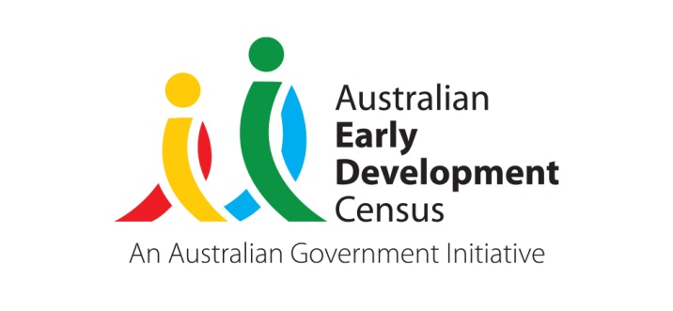 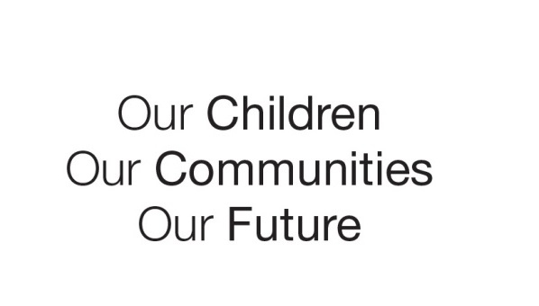

Australian Early Development Census

Community story

Community leading the change for better childhood outcomes

WA 2020

**About Connecting Community for Kids**

Connecting Community for Kids (CCK) is a collective impact initiative aimed at improving the well-being and development of children and families in the City of Cockburn and the City of Kwinana.

The initiative was formed through a State government and not-for-profit Partnership Forum in 2014. The CCK is funded by Woodside Development Fund and auspiced by Child Australia. Using a collective impact approach focused on early childhood, the Australian Early Development Census (AEDC) influences planning and actions to support the aspirations of community, families and children.

**What did the results show?**

While most children in Cockburn and Kwinana are developmentally on track on each of the developmental domains of the AEDC, some are not. Since 2009, the overall trend for these communities show there has been a decline in the percentage of children developmentally vulnerable, although Kwinana continues to have one of the highest proportions of children classfied as developmentally vulnerable in the Perth metropolitan area. In 2018, the AEDC results showed, 16.9% of children were developmentally vulnerable on one or more domains in Cockburn and 27.2% in Kwinana. This compares to the Western Australia average of 19.4%.

The 2018 AEDC results provided a further opportunity for the CCK team to bring together local knowledge, have shared conversations about changes in the community context and identify priority areas of need. The AEDC, linked to the CCK community priorities, identified the social competence and emotional maturity domains as two areas to have an indepth look at.

**Bringing about change**

The CCK team recognise the value and importance of community-led decision making and actions, partnerships and continious learning, as fundamental to creating transformational change for families and children (0-8 years) in Kwinana and Cockburn.

In line with the collective impact philosophy, the CCK team commenced a community engagement strategy in Cockburn and Kwinana and identified four themes to help address childhood vulnerability: child health; social isolation; financial strain; and safety. The team brought together a range of data to support their understanding of the community context, conducted research and consulted the community on the approaches to assist in creating social changes based on the four identified themes. With commuity support, five action teams were formed to commence implementing circuit breakers for change.

The actions of CCK continue to be focussed on safe, inclusive, and empowered communities to achieve the communities’ vision and outcomes:

* Children are on optimal development pathways through early intervention child health
* Parents are well supported during the early years of their child’s life
* Families are socially connected to others within the community
* Strong community spirit and cultural inclusion is celebrated.

**Achievements**

One of the strongest achievements of the initiative has been the empowerment of local families to drive change within their own community.

Capacity building is demonstrated through the Community Mothers Program. The program evolved following community collaboration, which identified a need for peer support for mothers in their parenting journey. Subsequently, the Community Mothers Program was co-designed with volunteer community champions and experts. Since the start of the program in 2018, 47 women have been trained as volunteer Community Mothers who provide support to families through home visits.

The Celebrate Culture Action Team (community champions and local service partners) has gone from strength to strength, creating opportunities to celebrate cultural diversity in the community through cultural story time, multicultural feasts, cultural cooking, and play-based learning activities for children. Recognising and celebrating cultural diversity has helped to break down barriers for families in community life, and supported socially isolated people to come to together.

The CCK team is leading a system change in early intervention for ear health, through the Ears2Learn program. It includes training for para-professionals to deliver ear screens in childcare and community settings, and provide support to parents accessing treatment pathways. The research and testing of models that informed Ears2Learn was undertaken in communities where the AEDC results showed higher proportions of children developmentally vulnerable on one or more domain.

**Partnerships**

Establishing partnerships across sectors and the community has been a key factor to create a safe space for community members to contribute with an equal voice to the initiative.

Leadership and action teams included community members from Cockburn and Kwinana, local services, government and non-government agencies including: City of Cockburn, City of Kwinana, Kwinana Early Years Servcies, Ngala, Meerilinga, Yangebup Family Centre, The Smith Family, Goodstart Early Learning, Western Australian Council of Social Services and the Departments of Social Services, Education, Communities and Health.

**Looking Ahead**

The CCK initiative was an initial five-year commitment to improve the development and wellbeing of children 0 – 8 years of age in the Cities of Kwinana and Cockburn. The collective impact approach will continue to focus on sustainable community capacity building practises, and strengthening community initiatives such as Community Mothers Program and Celebrate Culture. Social and system changes are long term goals, and the initiative is focussed on relationships that will support the next five years of work with the community.

|  |
| --- |
| “*We work closely with the community, service providers and government to drive social and system change”* Jane Miller, Connecting Community for Kids. |