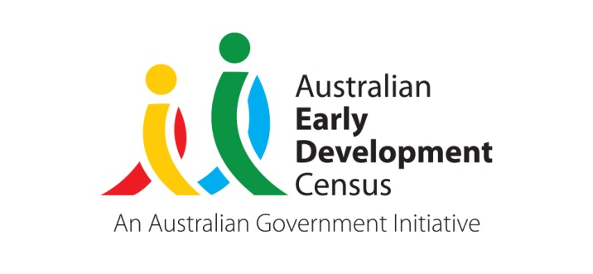 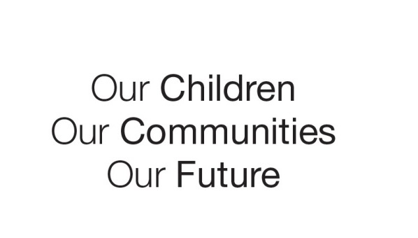

Australian Early Development Census

Community Story

KIDDO: Supporting schools and ECEC to improve physical health and wellbeing outcomes for young children

WA 2023

What did the results show?

Since 2009, in Western Australia nearly 20 per cent of children who started their first year of full time school have been identified as being developmentally at risk or developmentally vulnerable, as measured on the physical health and wellbeing domain of the Australian Early Development Census (AEDC).

Research through University of Western Australia’s (UWA) Play Spaces and Environments for Children’s Physical Activity and Health (PLAYCE) study, shows that less than 12% of children in Early Childhood Education and Care (ECEC) achieve the recommended level of daily physical activity. Research also shows that children are increasingly failing to develop fundamental movement skills (FMS) - the basic building blocks of movement including; running, throwing, catching, jumping and balancing. This is likely due to the lack of opportunity and instruction, and changing technological, housing and community landscapes.

Bringing about change

Many ECEC services have identified a need to improve their school and local community AEDC physical health and wellbeing domain results and implement sustainable change backed by the latest research.

In response, the UWA developed **KIDDO** ([www.kiddo.edu.au](http://www.kiddo.edu.au)), an evidence-based physical literacy program for schools, ECEC services and families. Developed with the support of Healthway, KIDDO is focussed on building the capacity of schools and ECEC staff to deliver physical literacy programs tailored to their context. The program is also designed to track the development of children’s motor skills and support parents to be engaged, and informed in the process.

Since 2014, KIDDO has been delivered via an interactive dashboard to more than 1,921 primary schools and 738 ECEC services across Western Australia and Australia.

Programs and resources are fully customisable, allowing educators to deliver effective and engaging physical literacy programs that suit their children, environment and needs.

Learning and development can continue at home through the KIDDO Parent Hub.

KIDDO’s online platform makes it accessible to all regardless of location. Across Western Australia, KIDDO is becoming the go-to resource for primary schools, ECEC services, and parents, making physical literacy fun and accessible to all.

Partnerships

UWA works in partnership with Healthway, Lotterywest, Australian Sports Commission, Goodstart Early Learning, Department of Education and the Department of Local Government, Sport and Cultural Industries, and draws on their expertise, networks, and practical advice to support the KIDDO project.

Achievements

Since launching its new website in 2023, the KIDDO platform has generated significant interest:

* 52,000 web users have accessed the program
* Funding from Healthway and Lotterywest has allowed all ECEC services in WA to access the KIDDO program at no cost with 764 services registering and engaging with the program
* Over 1,092 educators have completed, the Certificate of Physical Literacy, making a significant difference to the skills, knowledge and confidence of educators in WA to deliver programs in their setting
* KIDDO has been adopted as a resource for student teachers to use in teaching practicums by Notre Dame University, Curtin University, Edith Cowan University and the University of Western Australia

Several interstate organisations have licenced the KIDDO platform for delivery in their setting. This includes:

* GippSport – delivering the KIDDO Gippsland program through childcare services and community-based programs in regional Victoria since 2020
* Sport Education Northern Territory – deliver KIDDO to primary schools in the Northern Territory

The assessment of over 45,000 children’s Fundamental Movement Skills since 2020 demonstrates that KIDDO is making a major contribution to the health and well-being of Australian children in the early years.

[Research published](https://www.researchgate.net/publication/359843995_Primary_school_teacher_outcomes_from_online_professional_development_for_physical_literacy_A_randomised_controlled_trial) in April 2022 in the Psychology of Sport and Exercise Journal found that Primary School teachers and ECEC educators who completed KIDDO's Certificate of Physical Literacy:

* Had significantly higher physical literacy knowledge and application
* Were more confident to deliver physical literacy, valued physical literacy more and faced fewer barriers to delivering physical literacy programs

Looking ahead

Future plans involve promoting the program across all schools and ECEC services, and embedding KIDDO within teacher training programs at universities across Australia. It is envisaged that KIDDO will be offered through the Australian Sports Commission’s Sporting Schools program so that all schools and teachers have access to high quality professional development and evidence-based programs.

Further work to engage parents in their child’s physical development will continue, delivering simple and effective ways of encouraging confidence and skill development at home.

Future research to evaluate the impact of the KIDDO program will be undertaken. For example, evaluating the feasibility of implementing KIDDO in the ECEC environment to guide the rollout of the program nationally and research parents’ perceptions and understanding of physical literacy.

|  |
| --- |
| ***“Our whole pre-primary team have been using the resources from the KIDDO program. We decided on a set of outcomes and goals in relation to gross motor skills at the start of the year. These were based on assessments in the previous year. We then focussed on individual skills intensely for two to four week periods depending on skill achievement. The KIDDO program and resources made developing these sessions easy and extremely enjoyable for our students. “ Cailie Spencer, K/PP curriculum leader, Mt Hawthorn P.S.*** |

***“Since being involved with the initial pilot and by gaining a greater understanding of the AEDC data, we have embraced KIDDO across our ECEC centre. We identified that this provided an opportunity to promote physical development and literacy for our children as we were scoring below the national average. The KIDDO training and resources made developing these sessions easy and we have KIDDO Champions who assist the educators to implement the activities across the range of ages and developmental stages of our children. The children are enthusiastic participants and developing physical literacy skills and confidence to be active for life. The families are provided with information and a link to the KIDDO parent hub so that they can continue these activities at home. The uptake and feedback has been extremely positive.” Claire Stannard, Centre Director, Goodstart Tapping***

“© 2024 Commonwealth of Australia.

Since 2002, the Australian Government has worked in partnership with eminent child health research institutes, the Centre for Community Child Health at The Royal Children’s Hospital and the Murdoch Children’s Research Institute, Melbourne, and the Telethon Kids Institute, Perth to deliver the Australian Early Development Census program to communities nationwide. The Australian Government continues to work with its partners, and with state and territory governments to implement the AEDC.”