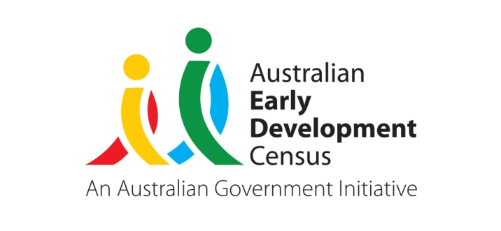 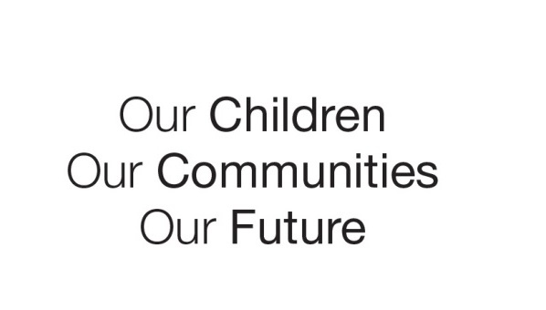

About the AECEDE Research Project

This fact sheet provides a general overview of the Australian Early Childhood Educational Development Experience Research Project

About the project

What is the AECEDE Research Project?

The purpose of the *Australian Early Childhood Educational Development Experience (AECEDE) Research Project* is to explore the impact of early learning experiences, both at home and in early education and care services, on children’s development and learning. The project is being conducted by the Australian Government Department of Education and Training and supported by the NSW Department of Education, the NT Department of Education and researchers from the Telethon Kids Institute and the Social Research Centre. The information obtained from this project will help policy makers understand how children’s education and care experiences in the years before full time school can be delivered in a way that best supports children’s development and learning using an Australian evidence base.

What is involved in the project?

The project involves the collection of child development data on the basis of teacher report, by using the Australian version of the Early Development Instrument (AvEDI). Data has been collected using the secure online data collection system used for the [Australian Early Development Census (AEDC)](https://www.aedc.gov.au/about-the-aedc) (https://www.aedc.gov.au/about-the-aedc).

The AvEDI consists of around 100 questions measuring five important areas or domains of early childhood development. For more information about the AvEDI, refer to the [Data Collection Tool: Australian version of the Early Development Instrument](https://www.aedc.gov.au/about-the-aedc/data-collection-tool-australian-version-of-the-early-development-instrument) page on the AEDC website (https://www.aedc.gov.au/about-the-aedc/the-aedc-checklist). To view the AvEDI refer to [resources for parents](http://www.aedc.gov.au/parents/resources-for-parents) on the AEDC website (http://www.aedc.gov.au/parents/resources-for-parents).

To add to this richness and build a picture of children’s activities outside school, parents and primary caregivers of children in their first year of full-time school in participating communities are invited to take part in a survey about the early childhood education and care history of their child, their parenting style and the child’s home environment. This ‘primary caregivers survey’ will take place in September – November 2018.

**Data collection**

What is required of schools

We are seeking your assistance to invite and facilitate primary caregivers of children in their first year of full-time school to complete a survey. If a primary caregiver survey is completed for at least 75% of children in their first year of full-time school, the school will receive a voucher to be spent on supplies for the school.

Participation

Why should schools participate?

The data collected through this project will be very useful for a wide variety of policy and research purposes and will have benefits for a range of stakeholders.

At the school level, the process of completing the AvEDI provides teachers with the opportunity to systematically reflect on all aspects of each child’s development. This process is likely to enhance teachers’ ability to support the needs of children in their care.

At the policy level, information on children’s development that shows the impact of different early education pathways on child outcomes will help inform early years planning, both in early childhood education and care services and in schools, to provide every child with the best possible start in life.

Reporting

How is the data reported?

In November 2018, schools will be provided with their AEDC school profile. The school profiles will provide information on the development of children across five key domains, including physical health and wellbeing; communication skills and general knowledge; social competence; emotional maturity and language and cognitive skills. The school profiles will not contain information that identifies the individual school, teacher or child.

What is the information used for?

Survey responses from primary caregivers will be linked to those from the AvEDI conducted through the AEDC earlier this year. Once the answers have been linked, all information that identifies the primary caregiver and their child will be removed.

Data from the project will be provided to relevant state or territory Departments of Education to inform a wide variety of policy, analysis and research.

The project may also link the data with information from other Commonwealth and state and territory Government agencies (such as health and education departments) to inform policy, practice and service provision for young children and their families.

Privacy

Will parents/carers get individual results for their child?

The data obtained from this project will not be examined at an individual level. Results for individual children will not be reported and an individual child report will not be produced.

For further information on privacy please refer to the [AEDC privacy statement](http://www.aedc.gov.au/parents/privacy-statement).

What if a parent does not want to participate in the project?

Participation in the AECEDE Research Project is voluntary.

Further information

Who should schools or parents/caregivers contact if they need further information about the project?

Any enquiries about operational aspects of the Primary Caregiver Survey should be directed to the AEDC team at [helpdesk@aedc.gov](mailto:helpdesk@aedc.gov).au or phone **1800 092 548**

Any enquiries about the research aims and project design should be directed to the Telethon Kids Institute at [AECEDEstudy@telethonkids.org.au](mailto:AECEDEstudy@telethonkids.org.au)

© 2017 Commonwealth of Australia