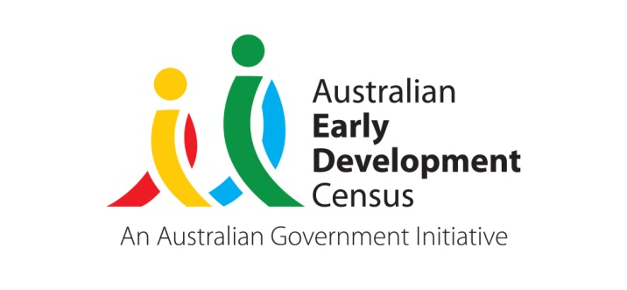 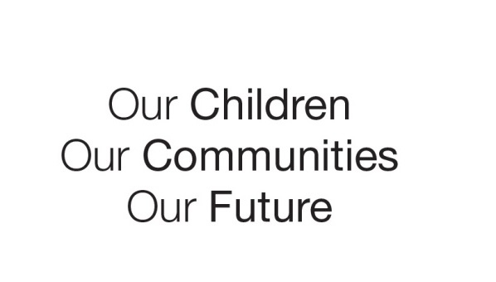

Australian Early Development Census

A new community playgroup in Gungahlin

Australian Capital Territory 2021

About Gungahlin

Gungahlin is an ACT region in Canberra’s far north. It is a rapidly developing area with the number of children in their first year of school growing across previous Australian Early Development Census (AEDC) cycles. In 2018, a total of 5,727 children in the ACT were included in the AEDC, of which 1,396 children were from the Gungahlin area. This represents 24.4% of the ACT total. Of the Gungahlin children included in the AEDC, 23 (1.7%) were Aboriginal and Torres Strait Islander while 401 (28.7%) had English as a second language.

What did the results show?

The AEDC is a national measure of child development. It measures five key areas or domains when a child starts school. The domains are: physical health and wellbeing; social competence; emotional maturity; language and cognitive skills (school based); communication skills and general knowledge.

In 2018, 24.8% of children in Gungahlin were vulnerable on one or more domain, similar to the ACT average (24.6%). There were 11.8% of Gungahlin children vulnerable on two or more domains, which is slightly lower than the ACT average (12.4%) although this percentage has increased significantly since 2015 (from 9.8%). Between 2015 and 2018 in Gungahlin, there were increases in vulnerability across all five domains, with the increases in the physical health and wellbeing and social competence being significant. This highlights a growing need for further early childhood development support in the region.

Bringing about change

In 2019, each of the Network Coordinators that work in four Canberra Regions (Gungahlin, Belconnen, Tuggeranong and Woden) received a grant for an AEDC Community Partnership Project from the ACT Community Services Directorate aimed at improving early childhood development outcomes in their regions. The Network Coordinator for Gungahlin (Barnardos) formed a partnership with ACT playgroups and the partnership developed a plan for an outdoor playgroup in the Gungahlin town centre area.

After a review of the available playgroups in the Gungahlin region, it was established that while there were several specialised playgroups with restricted memberships, there were very few community playgroups in the area. A new community playgroup was established and as part of the implementation of the playgroup, several community services were invited to come and talk about their programs and the support they offer to families. Services that attended included ACT Health, The Mingle Program, Feros Care and ACT Libraries also donated books for the playgroup.

Achievements

The 2020 playgroup sessions were impacted with COVID-19 restrictions. With careful planning Barnardos was able to get the playgroup up and running for nine weekly sessions from October till December 2020 without any interruptions. The playgroup was well attended, averaging around 18 families each week, many of them returning attendees.

The community services that visited spoke to families individually to discuss available supports, share information on services and make referrals and connections. The playgroup highlighted a gap in service provision for families who do not attend early education and care due to cost, lack of space to conduct community playgroups and the opportunity for an outdoor playgroup that was flexible so you could come and go at any time. The new playgroup demonstrated the power of bringing families together to connect with their children, each other and unfamiliar services. The playgroup enabled face to face contact and discussion in a relaxed setting, linking families to services and promoting inter-agency work.

Through the grant Barnardos were able to establish an ‘outreach trailer ‘of playgroup equipment that is available to services to use for other playgroups or activities. It is equipped will tables, chairs, BBQ, water, fridge/freezer and 12v power. The trailer holds fourteen boxes of playgroup equipment and will be available to book by interested groups without cost. This valuable resource will support other services looking to improve early childhood development in the Gungahlin region and wider Canberra.

Looking Ahead

There has been strong interest from families in continuing the playgroup in 2021. Services that support the Gungahlin Region have agreed to meet to discuss collaboration with Barnardos for an upcoming playgroup to start in September 2021, if restrictions allow. This help from community partners will ensure the playgroup can continue to support Gungahlin families in the future.

For more information contact

ACT AEDC Coordinator

Phone: 02 620​5 ​3542  
Email: [​](mailto:melanie.thompson@act.gov.au)[aedc@act.gov.au](mailto:aedc@act.gov.au)  
Web: [http://www.children.act.gov.au](http://www.children.act.gov.au/)

High

light table Heading