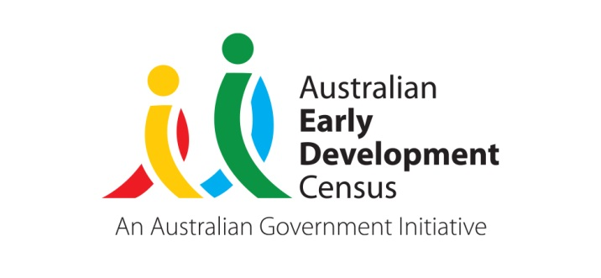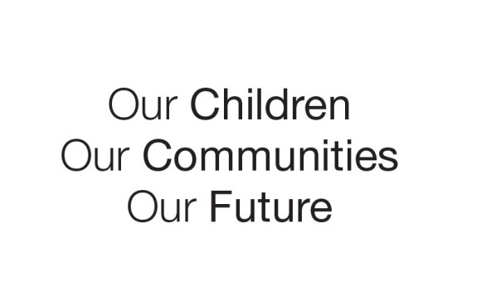
Australian Early Development Census
Community story
A focus on supported playgroups

South Austalia 2019

Supported playgroups helping improve outcomes for children in the Lower Mid North Education Partnership

About the Wakefield Community
The Lower Mid North Education Partnership is a group of Department for Education preschools and schools located mainly in the Wakefield region, about an hour from Adelaide in South Australia’s lower Mid North. The District Council includes the small townships of Balaklava, Port Wakefield, Hamley Bridge and Owen.
The region is largely a wheat growing area that has faced challenges over the past decade, with drought and the Pinery bushfire in 2015.
In 2016, the SEIFA Index of Disadvantage score was 926, which is a relatively high level of disadvantage compared to other South Australian regions and surrounding areas.

What did the results show?
The Australian Early Development Census (AEDC) is a national measure of child development. It measures five key areas or domains of a child in their first year of full-time school. The domains are: physical health and wellbeing; social competence; emotional maturity; language and cognitive skills (school-based); communication skills and general knowledge.
The 2012 results showed that 35.1% of children starting school in the Wakefield community were developmentally vulnerable on one or more domains.

Bringing about change

The 2015 AEDC results showed that the trend of higher than average developmental vulnerability had worsened across the Wakefield community. This prompted the Lower Mid North Education Partnership cluster of government preschools and schools to join together on a new multi-faceted project that began in 2017.

The aim of the project was to establish supported playgroups in the Education Partnership, recognising research showing that children who attend playgroup during early childhood have significantly better child development when they start school, and that the benefits of playgroup are seen across all domains of development as measured by the AEDC.

A scan of existing volunteer led playgroups and locations across the Education Partnership identified 5 playgroups for inclusion in the project. Key elements of the project included:
- The SA Department for Education provided funding for playgroup leaders in Balaklava, Saddleworth, Riverton, Port Wakefield and Hamley Bridge to deliver supported playgroups in schools, preschools and community venues.
- Professional development for the playgroup leaders was provided through termly face to face meetings during 2017, and training in using a consistent, age-appropriate curriculum approach based on the SA Department for Education Learning Together program and resources that support:
- children's oral language development
- children being read to at an early age
- the development of children's dispositions to learning
- the parent's role in supporting their children.
- Playgroup leaders were provided with access to a mentor to help embed the learnings and support operational aspects of the project.

Staff and leaders from across the Education Partnership preschools and schools, especially those involved in the early years, completed the Australian Research Alliance for Children and Youth’s (ARACY) The Common Approach training. The Common Approach provides professionals with a framework for having conversations with families that support early intervention for children and parents.

Other early childhood programs across the Lower Mid North Education Partnership also benefited from the project and a community outdoor playgroup at the local park was also established by Balaklava Community Children’s Centre.

Achievements

The 2018 AEDC data in the Wakefield region were heartening, showing a decrease in children developmentally vulnerable on one or more domains from 35.5% in 2015 to 22.2% in 2018, which is lower than the State average. Even more significant from 2015 to 2018, the proportion of children developmentally vulnerable on two or more domains reduced from 26.3% to 11.1%.

Partnerships
The focus on early child development in the Lower Mid North Education Partnership fostered improved collective planning and consistent approaches to supporting children’s early development, wellbeing and learning, across early childhood education and care services and schools in the region.

Looking ahead

The Lower Mid Norther Education Partnership continues to deliver and promote family engagement in playgroups to support improved children’s development, wellbeing and learning outcomes in the early years and throughout school.

For more information contact
Myléne Warman
State Coordinator, AEDC
Department for Education
South Australian Government
Email: Education.AEDCTeam@sa.gov.au
Web: www.AEDC.gov.au

“One parent was discussing the financial stress of her child constantly outgrowing clothes, so we set up a swap day at playgroup. Everyone that wanted to could bring clothing, toys, shoes etc. It was a huge success. We are now looking at doing it once a term.”
Playgroup leader

