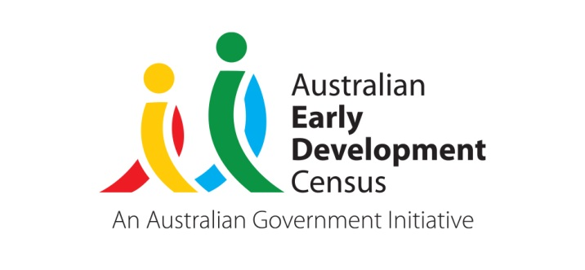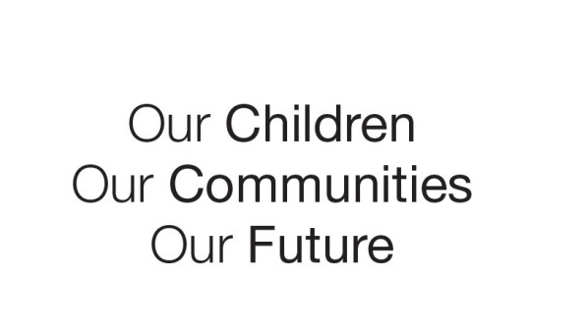
Australian Early Development Census
Community story
Strengthening parent participation in children’s early development

South Austalia 2019

Balaklava Community Children’s Centre uses results to facilitate change in the community

About the Balaklava community
The Department for Education’s Balaklava Community Children’s Centre is in the Lower Mid North Education Partnership. This group of department preschools and schools located is mainly in the Wakefield region, about an hour from Adelaide. The District Council includes the small townships of Balaklava, Port Wakefield, Hamley Bridge and Owen.
The region is largely a wheat growing area that has faced challenges over the past decade, with drought and the Pinery bushfire in 2015.
In 2016, the SEIFA Index of Disadvantage score for Balaklava was 926, which is a relatively high level of disadvantage compared to other South Australian regions and surrounding areas.

What did the results show?
The Australian Early Development Census (AEDC) is a national measure of child development. It measures five key areas or domains of a child in their first year of full-time school. The domains are: physical health and wellbeing; social competence; emotional maturity; language and cognitive skills (school-based); communication skills and general knowledge.
The AEDC results for the Balaklava local community increased in developmental vulnerability on one or more domains from 31.6% in 2009 to 54.2% in 2012.

Bringing about change
In 2011, the Balaklava Community Children’s Centre formed a community group in response to the 2009 data. The group is currently known as Our Community Our Children (OCOC).
The steering committee/community group has mainly been chaired by the Director of Balaklava Community Children’s Centre with consistent members representing the Balaklava Primary School, Australian Breastfeeding Association Chair - Balaklava group and a parent. Additional members have participated for shorter tenures.
Since commencing, the group has developed a number of objectives and goals to support families and early child development in response to their AEDC results in 2009, 2012 and 2015. These included:
- advocating for a new playground for children aged 0-2 years
- developing an information resource for young families
- advocating for change facilities to be installed in Balaklava’s public toilets
- raising community awareness and understanding of children’s development and learning.

Achievements and partnerships
The Our Community Our Children committee has supported the focus on early child development in Balaklava by bringing together community and government partners and aligning their efforts toward achieving the key objectives agreed to in response to the AEDC results. Achievements include:
- a community email group established with the support of the local Child and Family Health Service nurse with parents electing to receive an Early Years Calendar of events by email
- guest speakers including Literacy Australia, a speech pathologist and the Fraser Mustard and Telethon Kids Institute invited to provide free parent workshops aimed at strengthening parent participation in their child’s early development
- Balaklava Community Children’s Centre focus on nature play as a key parent engagement strategy since 2015
- accessing funding for a community nature playground which commenced development early 2019
- supporting delivery of a playgroup held in the community playground
- establishing a strong partnership between OCOC, Balaklava Community Children’s Centre, Balaklava Community Library and Wakefield Regional Council resulting in free community events e.g. Early Years Expo, Discover Your Own Backyard, Teddy Bears Picnic and Family Fun Days at the Rocks during Reconciliation week
- Balaklava Community Children’s Centre has strengthened both universal and targeted strategies across the site to improve early childhood development.

During this time staff at the Balaklava Community Children’s Centre have undertaken professional development including the ARACY Common Approach and occupational therapy. These principles of practice and learnings are being used to inform their parent engagement and planning for children’s learning.

The 2018 AEDC results show an improvement over time in children’s development in the Balaklava local community with a decrease in developmental vulnerability on one or more domains from 52.9% in 2015 to 23.8% in 2018, and a significant decrease in developmental vulnerability on two or more domains from 41.2% in 2015 to 14.3% in 2018.

Looking ahead
The Balaklava Community Children’s Centre and community stakeholders will continue to prioritise early child development. A significant capital works project has enabled the Centre to expand and offer more places for children and more outdoor play space, one community playgroup and one supported playgroup continue to operate and staff will continue to use the ARACY Common Approach principles to inform their professional practice.

For more information contact
Myléne Warman
State Coordinator, AEDC
Department for Education
South Australian Government
Email: Education.AEDCTeam@sa.gov.au
Web: www.AEDC.gov.au

“The AEDI/AEDC was a crucial microscope into the future wellness of our community's children and while it didn't make for pleasant reading some 10 years ago, it did instigate some of our town's best educators and thinkers to take action.
Since 2011 I have reported on the concerning AEDC trends, helping the Balaklava Community Children’s Centre Director raise awareness about the results, and have seen the impact the Our Community Our Children committee and the centre director have had in driving change.
As a local parent with children all under school age, seeing the dramatic improvement in the Balaklava community 2018 AEDC results invoked both emotions of relief and pride.
The results are startling but heartwarming, knowing the efforts of this group to establish local initiatives and develop parent resources that would directly target early development.
The recent expansion of the children’s centre is one of the initiatives I expect to positively impact the future of our children, an enormous benefit to Balaklava and surrounding areas. We have a wonderful community here.”
Les Pearson, Senior Journalist, Plains Producer

