## Our Children



Our Communities

Our Future

An Australian Government Initiative

JUNE 2024

AEDC summary indicators

The Australian Early Development Census (AEDC) has three summary indicators which can be used to describe children’s development (Figure 1).

Figure 1 – AEDC summary indicators

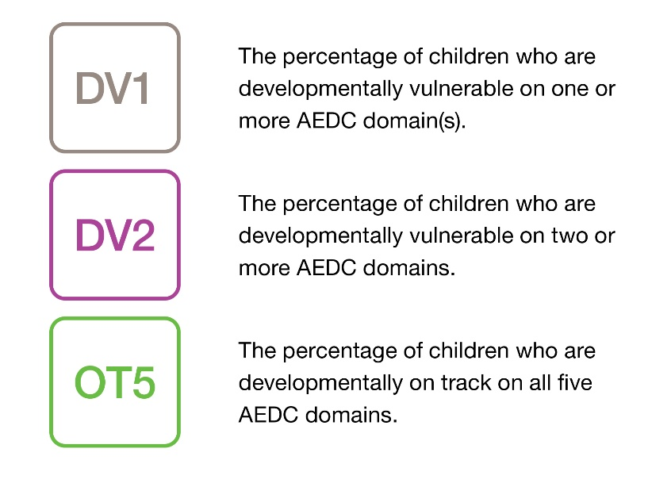

See the [About the AEDC domains fact sheet](http://www.aedc.gov.au/abtdom) for a detailed description of the developmental vulnerability categories (developmentally on track, at risk, and vulnerable) for

each domain.

DV1 and DV2 can be used to identify schools and communities experiencing the greatest

developmental vulnerability. OT5 reflects children’s developmental strengths and recognises the importance of holistic development. It can help to identify where things are working well to support children’s development.

The summary indicators can be used to identify trends in developmental vulnerability, where additional support may be needed, and to evaluate the impact of policies and programs over time. OT5, for example, was selected as the key target in the [National Agreement on Closing the Gap](https://www.closingthegap.gov.au/national-agreement/targets), Outcome 4: Children thrive in their early years.

# How children’s scores are classified

For each of the five domains, children’s scores are classified into the following categories (Figure 2):

* developmentally on track (scoring above the 25th percentile or in the top 75 per cent of the 2009 scores)
* developmentally vulnerable (scoring below the 10th percentile or in the lowest 10 per cent of the 2009 scores)
* developmentally at risk (children who are neither developmentally on track nor vulnerable).

AEDC summary indicators | JUNE 2024 [**www.aedc.gov.au**](http://www.aedc.gov.au)

Figure 2 – Definition of developmentally vulnerable, at risk and on track on AEDC domains

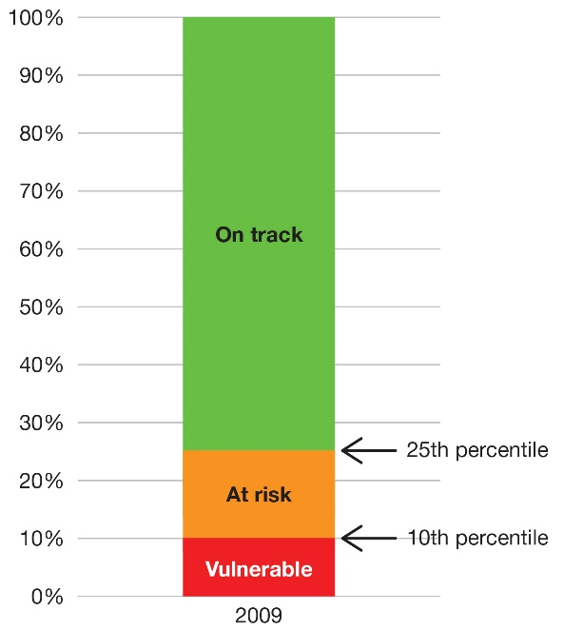

These benchmark scores, established using data from the first AEDC data collection in 2009, provide a reference point against which later AEDC results can be compared over time.

For further information about how children’s scores are calculated, see the [Understanding the data](https://www.aedc.gov.au/resources/detail/understanding-the-data-(hd)) video.

# How to interpret the summary indicators

Children classified as developmentally vulnerable on one or more domains (DV1) cannot be classified as on track on five domains (OT5). However, these summary indicators are not the opposite of each other. For example, some children may not be classified as DV1 or OT5 as they may be developmentally on track on some domains and at risk on others. As such, the percentage of children classified as OT5 and DV1 will not equate to 100 per cent.

Other children may be classified as both DV1 and DV2 – for example, if they are developmentally vulnerable on three domains. For this reason, the percentage of children classified as DV1 and DV2 should not be totalled.

Choosing policies, programs and services which can positively influence children’s development in more than one domain increases the likelihood of improving the percentage of children classified as OT5.

If a new policy or program improves one aspect of children’s development, such as physical health and wellbeing, but has no positive impacts on other domains, this may not translate to improvements on the OT5 summary indicator. As such, it is important to consider the factors that support holistic development, and to explore trends in the percentage of children who are on track on each of the five AEDC domains over time.

Additional resources

[A new summary indicator: Developmentally on track on](https://www.aedc.gov.au/resources/detail/a-new-summary-indicator-developmentally-on-track-on-five-domains-(ot5)-aedc-2021-data-story) [5 domains (OT5) - AEDC 2021 Data story](https://www.aedc.gov.au/resources/detail/a-new-summary-indicator-developmentally-on-track-on-five-domains-(ot5)-aedc-2021-data-story) - an overview of OT5 including why it was developed, how it can be used, and trends over time.

[Understanding the results fact sheet](https://www.aedc.gov.au/resources/detail/understanding-the-results) - outlines the approach taken to analysing and reporting AEDC results.



© 2024 Commonwealth of Australia.

Since 2002, the Australian Government has worked in partnership with eminent child health research institutes, the Centre for Community Child Health at The Royal Children’s Hospital and the Murdoch Children’s Research Institute, Melbourne, and the Telethon Kids Institute, Perth to deliver the Australian Early Development Census program to communities nationwide. The Australian Government continues to work with its partners, and with state and territory governments to implement the AEDC.