





**AEDC Key Findings 2024**

## Our Children

Our Communities

Our Future

The Australian Early Development Census (AEDC) is a national measure of children’s development as they enter their first year of full-time school. Data has been collected nationally since 2009, making it one of the most comprehensive data collections on early childhood development in the world.

# The 2024 collection

**When children thrive in their early years, they have a strong foundation for lifelong learning, health, development, and wellbeing. By revealing trends in early childhood development, the AEDC can indicate what is**

**working well to support children, and where opportunities exist for further action.**

The 2024 collection was the sixth national AEDC data collection. It took place between 1 May and 31 July 2024, and involved children, teachers and schools throughout Australia (Figure 1).

**Figure 1** – 2024 AEDC participation



**288,483**

**children**

**16,723**

**teachers**

**94.6%**

**7,368**

**schools**

**of children in**

**t f**

**heir first year o**

**full-time school\***

*94.6% of children from in-scope schools only. 

**Accessible file format statement**

This is an accessible text version of the document **AEDC National Report 2024**. This document is saved in DOCX file format. A copy of this document is also available in PDF file format. Readers are advised that the PDF version of this document may contain some features that some users find less accessible than the DOCX version.



AEDC Key Findings 2024

# National results

[**www.aedc.gov.au**](http://www.aedc.gov.au/)

## AEDC domains

The percentage of children developmentally vulnerable has increased across all five AEDC domains in 2024 (Figure 2).

**Figure 2** – Developmental vulnerability on AEDC domains in 2024



**Physical health and wellbeing**

**10.0%**

of children are developmentally vulnerable on this domain, an increase of 0.2

percentage points

since 2021.

**Social competence**

**10.7%**

of children are developmentally vulnerable on this domain, an increase of 1.1

percentage points

since 2021.

**Emotional maturity**

**10.0%**

of children are developmentally vulnerable on this domain, an increase of 1.5

percentage points

since 2021.

**Language and cognitive skills (school-based)**

**7.7%**

of children are developmentally vulnerable on this domain, an increase of 0.4

percentage points since 2021.

**Communication skills and general knowledge**

**8.9%**

of children are developmentally vulnerable on this domain, an increase of 0.5

percentage points since 2021.

## AEDC summary indicators

The percentage of children developmentally on track on five domains (OT5) has decreased, while the percentage of children developmentally vulnerable on one or more domains (DV1) and developmentally vulnerable on two or more domains (DV2) has increased in 2024 (Figure 3).

**Figure 3** – Changes in AEDC summary indicators from 2021 to 2024

The percentage of

children who are

**OT5** developmentally

on track on five

AEDC domains.

**2021**

**2024**

**52.9%**

**54.8%**

The percentage of

children who are

**DV1** developmentally

vulnerable on one or

more AEDC domains.

**2021**

**2024**

**22.0%**

**23.5%**

The percentage of

children who are

**DV2** developmentally

vulnerable on two or

more AEDC domains.

**2021**

**2024**

**11.4%**

**12.5%**



[**www.aedc.gov.au**](http://www.aedc.gov.au/)

AEDC Key Findings 2024

# Indigenous iconspeech bubbles icon with different languagesPriority groups

### First Nations children Language diversity

**OT5**

**The percentage of First Nations children^ developmentally on track on five domains stabilised, with a non-significant decline, from 2021 to 2024.**

**2021**

**2024**

**33.9%**

**34.3%**

**OT5**

**The percentage of children with a language background other than English (LBOTE) who are developmentally on track on five**

**domains decreased from 2021 to 2024.**

**2021**

**2024**

**48.0%**

**50.3%**

**Geographic location Socio-economic status**



**OT5**

**The percentage of children developmentally on track on five domains decreased across major cities, inner/outer regional areas, and remote/very remote areas from 2021 to 2024.**

**2021 2024**

**Major cities**



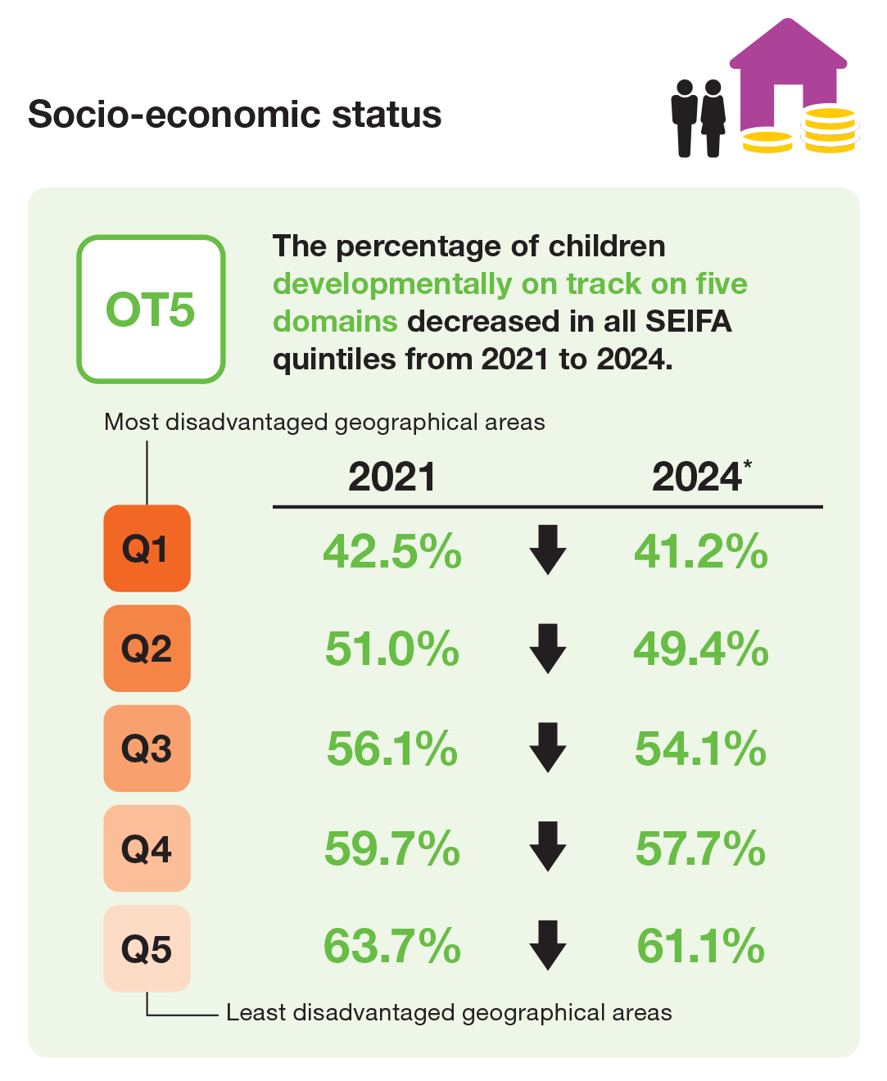

|  |  |
| --- | --- |
| **56.0%** | **54.0%** |
| **Inner/Outer regional**  **52.2%** | **50.5%** |
| **Remote/Very remote**  **44.1%** | **43.1%** |

^ The 2024 Australian version of the Early Development Instrument (AvEDI) and its supporting materials used the term ‘Aboriginal and Torres Strait Islander children’ when referring to First Nations children.



**For more information see the** [**AEDC National**](http://www.aedc.gov.au/data-hub/public-data/2024-national-report)[**Report 2024**](http://www.aedc.gov.au/data-hub/public-data/2024-national-report) **or visit the** [**AEDC website**](http://www.aedc.gov.au/)

* In 2024 AEDC data was updated to reflect the most recent area-based SEIFA at the time of data collection. This applies to all collection cycles. In previous collections, SEIFA was applied retrospectively. This means previously published AEDC SEIFA results may differ from those published in 2024.

© 2025 Commonwealth of Australia.

Since 2002, the Australian Government has worked in partnership with eminent child health research institutes, the Centre for Community Child Health at The Royal Children’s Hospital and the Murdoch Children’s Research Institute, and The Kids Research Institute Australia to deliver the Australian Early Development Census program to communities nationwide. The Australian Government continues to work with its partners and with state and territory governments to implement the AEDC.