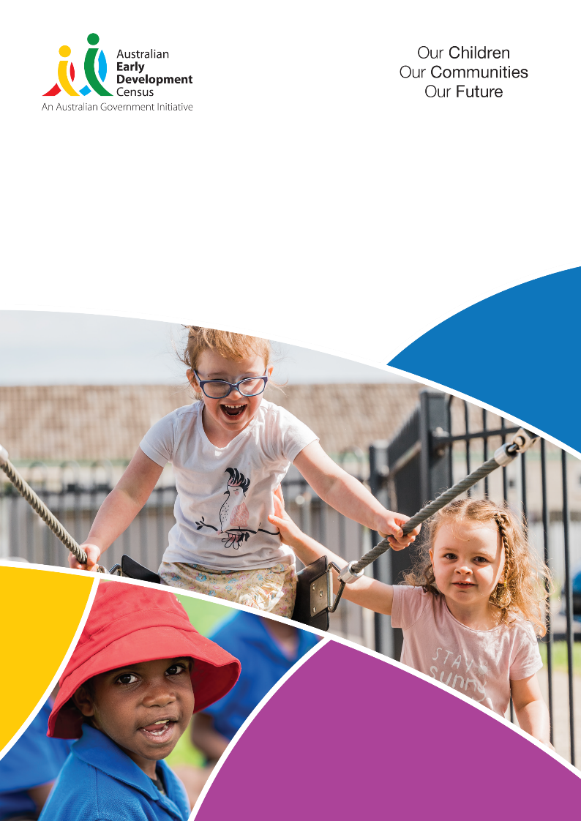

AEDC National Report 2024
Early childhood development in Australia
Accessible file format statement
This is an accessible text version of the document AEDC National Report 2024. This document is saved in DOCX file format. A copy of this document is also available in PDF file format. Readers are advised that the PDF version of this document may contain some features that some users find less accessible than the DOCX version.

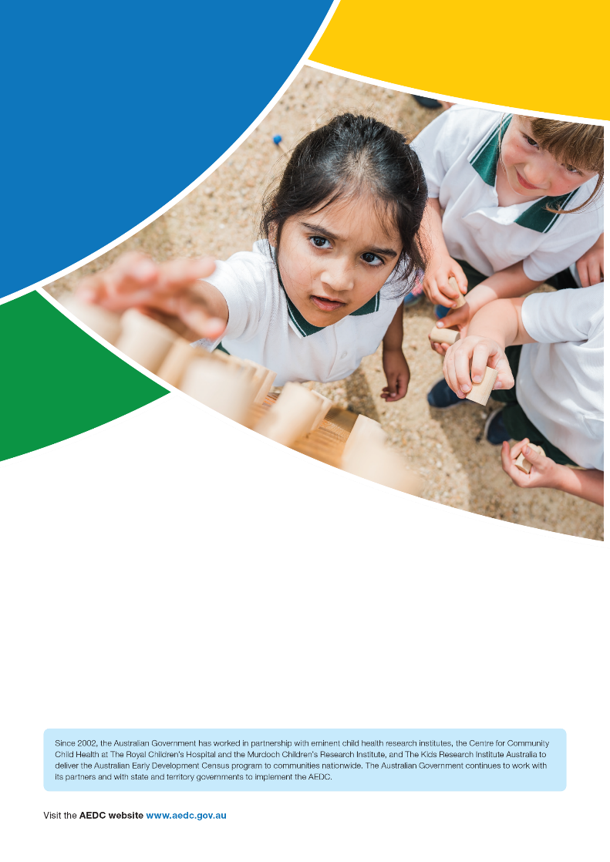

© 2025 Commonwealth of Australia.
This work has been produced by the Department of Education on behalf of the Australian Government.

With the exception of the Commonwealth Coat of Arms, the Department’s logos, any material protected by a trade mark and where otherwise noted, all material presented in this document is provided under a
Creative Commons Attribution 4.0 International licence (https://creativecommons.org/licenses/by/4.0/).
The details of the relevant licence conditions are available on the Creative Commons website (accessible using the links provided) as is the full legal code for the Creative Commons Attribution 4.0 (https://creativecommons.org/licenses/by/4.0/legalcode).

This document must be attributed as the Australian Early Development Census National Report 2024. ISSN 2206-284X (Online).

Comments and suggestions regarding this publication are welcomed and should be forwarded to the Department of Education: aedc@education.gov.au.
Published by the Department of Education, GPO Box 9880 Canberra, ACT 2601, Australia.
www.education.gov.au



Contents

Executive summary 2
The Australian Early Development Census 2
The 2024 AEDC collection 2
2024 AEDC results 3
National results 4
The AEDC children 4
Participation in the AEDC 4
Demographic snapshot 5
Trends in development 6
The AEDC domains 6
National trends: AEDC domains 8
Physical health and wellbeing 8
Social competence 9
Emotional maturity 10
Language and cognitive skills (school-based) 11
Communication skills and general knowledge 12
The AEDC summary indicators 13
National trends: AEDC summary indicators 14
Priority groups 15
First Nations children 15
Language diversity 19
Geographic location 23
Socio-economic status 28
State and territory results 34
New South Wales 35
Victoria 36
Queensland 37
Western Australia 38
South Australia 39
Tasmania 40
Australian Capital Territory 41
Northern Territory 42
Resources 44
Glossary 46


AEDC National Report 2024

Executive summary

The Australian Early Development Census
When children thrive in their early years, they have a strong foundation for lifelong learning, health, development and wellbeing.
The AEDC reveals trends in early childhood development. It can indicate what is working well to support children, and
where opportunities exist to take further action.

The Australian Early Development Census (AEDC) is a national measure of children’s development as they enter their first year of full-time school. Data has been collected nationally every three years since 2009. This makes the AEDC one of the most comprehensive data collections on early childhood development in the world. The 2024 AEDC is the sixth national data collection.
AEDC results can help to identify and monitor trends in how children in Australia are developing by the time
they begin their first year of full-time school. It highlights what is working well and what needs to be improved or developed to support children and their families. The regular collection of AEDC data enables governments, educators, researchers, and communities to better support the wellbeing of children and families.
Each successive collection provides unique insights into the early life experiences of cohorts of children and how these are changing over time. Together, the developmental outcomes of successive cohorts tell the story of how children’s development over the first five years of life
is influenced by local, state or territory, national and international circumstances.

The 2024
AEDC collection

The 2024 AEDC took place between 1 May 2024 and 31 July 2024. It included 288,483 children and 16,723 teachers in 7,368 schools. The children captured in the 2024 AEDC were mostly born in 2018 and 2019.
Around 300,000 children are included in each collection of the AEDC, totalling over 1.7 million children since the AEDC began.

Executive summary AEDC National Report 2024

2024 AEDC results

Domains
The percentage of children developmentally vulnerable has increased on all five AEDC domains.
10.0% of children are developmentally vulnerable on the physical health
and wellbeing domain, an increase of
0.2 percentage points since 2021.

10.7% of children are developmentally vulnerable on the social competence domain, an increase of 1.1 percentage points since 2021.
10.0% of children are developmentally vulnerable on the emotional maturity domain, an increase of 1.5 percentage points since 2021. This represents the largest increase in developmental vulnerability across all domains.

7.7% of children are developmentally vulnerable on the language and cognitive skills (school-based) domain, an increase of
0.4 percentage points since 2021.

8.9% of children are developmentally vulnerable on the communication skills and general knowledge domain, an increase of
0.5 percentage points since 2021.

Summary indicators

52.9% of children are developmentally on track on five domains (OT5), a decrease of 1.9 percentage points since 2021.
OT5

23.5% of children are developmentally vulnerable on one or more domains (DV1), an increase of 1.5 percentage points since 2021.
DV1

12.5% of children are developmentally vulnerable on two or more domains (DV2), an increase of 1.1 percentage points since 2021. This result is the highest level of developmental vulnerability on two or more domains across all six AEDC collections.
DV2

Priority groups
First Nations children
The percentage of First Nations children developmentally on track on five domains (OT5) stabilised in 2024 with a non-significant decline of 0.4 percentage points from 34.3 per cent in 2021 to 33.9 per cent in 2024.

The percentage of First Nations children developmentally vulnerable on one or more domains (DV1) and two or more domains (DV2) has also remained stable. Developmental vulnerability has decreased on two domains: language and cognitive skills (school-based), and communication skills and general knowledge, contrasting with the national trend.
Language diversity

The percentage of children with a language background other than English (LBOTE) who are on track on five domains (OT5) decreased from 50.3 per cent in 2021 to 48.0 per cent in 2024. The percentage of children with an LBOTE who are developmentally vulnerable on one or more domains (DV1) increased from 25.3 per cent in 2021 to 27.4 per cent in 2024, and the percentage of children developmentally vulnerable on two or more domains (DV2) increased from
13.1 per cent in 2021 to 14.7 per cent in 2024.

Geographic location
The percentage of children developmentally on track on five domains (OT5) has decreased for children living in major cities, inner/outer regional areas, and remote/ very remote areas since 2021. The largest shift was in major cities (2.0 percentage point decrease), followed by inner/outer regional locations (1.7 percentage point decrease), and children living in remote/very remote communities (1.0 percentage point decrease).
Socio-economic status

The percentage of children developmentally on track on five domains (OT5) has decreased for children living in all Socio- Economic Indexes for Areas (SEIFA) quintiles since 2021. The decrease has
been smaller for children living in the most disadvantaged communities (1.3 percentage points) and larger for children living in the least disadvantaged communities (2.6 percentage points).



AEDC National Report 2024

National results

The AEDC children

Participation in the AEDC
The Australian Early Development Census (AEDC) is a national measure of children’s development as they enter their first year of full-time school. Data has been collected nationally every three years since 2009.

Each cycle, data is collected on over 90 per cent of Australian children in their first year of full-time school, making the AEDC one of the most comprehensive collections of early childhood development data in the world. Figure 1 provides a snapshot of the number of children, teachers and schools that contributed to the 2024 AEDC.
Figure 1 – 2024 AEDC participation

288,483
children
16,723
teachers
94.6%
7,368
schools
of children in their first year of full

full-time school*

* 94.6% of children from in-scope schools only.

Demographic snapshot
The AEDC provides important insights into the demographic characteristics of the children captured in the 2024 collection. Figure 2 highlights key demographic characteristics and the diversity of the population of children in Australia.

Figure 2 – Demographic characteristics of children who participated in the 2024 AEDC

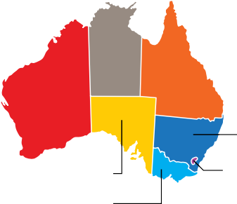
Geographic location
Age/gender
48.5%
Girls
51.5%
Boys
Mean age: 5 years 7 months
NT 1.0%
WA 12.0%

SA 6.7%
VIC 23.3%

QLD 21.8%

NSW 31.4%
ACT 1.9%
TAS 2.0%


Language diversity
24.1%
LBOTE † –
Proficient in
English
3.6%
LBOTE –
Not proficient in English
72.2%
English only
Preschool attendance
93.3%^
of children attended a preschool program in the year before
full-time school


Cultural diversity
7.5%
First Nations children
6.4%
Children born overseas
Support needs
6.7%
Children with special needs*
20.5%
Children requiring further assessment#

^ Although teachers are well-placed to report on the development of children, the extent to which teachers know about children's preschool/kindergarten experience varies. If teachers indicate they 'don't know' this information, these cases are excluded from the reporting figure. 'Don’t know' was selected for 9.6% of children.
† Language background other than English.
* Children requiring special assistance because of chronic medical, physical, or intellectually disabling conditions based on a medical diagnosis. Children may be included in both 'special needs' and 'requiring further assessment'.
# Children who are currently being assessed or who have been identified by a teacher as needing further assessment.

Trends in development

The AEDC domains
The AEDC captures data on five key areas or ‘domains’ of early childhood development that have been shown to predict later mental health, wellbeing and educational outcomes. Figure 3 describes the AEDC domains.

Figure 3 – AEDC domain descriptions



Physical health and wellbeing
Children’s physical readiness for the school day, physical independence and gross and fine motor skills.
Social competence
Children’s overall social competence, responsibility and respect, approach to learning, and readiness to explore new things.
Emotional maturity
Children’s pro-social and helping behaviours, and absence of anxious and fearful behaviour, aggressive behaviour, hyperactivity and inattention.

Language and cognitive skills (school-based)
Children's interest and skills in literacy and numeracy, and memory.
Communication skills and general knowledge
Children’s communication skills and general knowledge based on broad developmental competencies and skills.

For more information see the About the AEDC Domains fact sheet

How children’s scores are classified
Children receive a score (0-10) for each of the five AEDC domains. These domain scores are then classified into one of three groups using benchmarks that were developed from the first AEDC collection in 2009. These categories are: developmentally on track, at risk or vulnerable (Table 1).

Table 1 – Definitions of developmentally vulnerable, at risk and on track on the AEDC domains

Developmentally on track  Scores above the 25th percentile or in the top 75 per cent of the 2009 scores | Children are developing well.
Developmentally at risk  Scores between the 10th and 25th percentile | Children are facing challenges in some aspects of their development.
Developmentally vulnerable  Scores below the 10th percentile or in the lowest 10 per cent of the 2009 scores. | Children are facing some significant challenges in their development.

Understanding significant change
With the 2024 AEDC being the sixth collection since 2009, results can be compared to past collections to identify shifts in children’s development over time.
The AEDC uses ‘critical difference’ methodology to indicate whether changes in results between two collections represent a ‘significant change’ in children’s development.
For more information see the Comparing Results Over
Time fact sheet

National trends: AEDC domains



Physical health and wellbeing

The percentage of children developmentally vulnerable on the physical health and wellbeing domain progressively increased from 9.3 per cent in 2009 to 9.8 per cent in 2021. This trend continued in 2024 with a small increase of 0.2 percentage points to 10.0 per cent. The percentage of children developmentally
on track on this domain increased slightly in 2018 and 2021, followed by a small decrease of 0.3 percentage points in 2024.

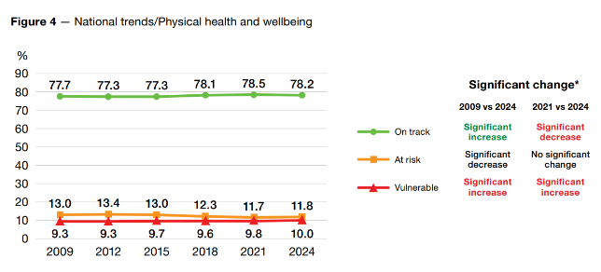

Developmentally on track | Developmentally at risk | Developmentally vulnerable
Children can almost always physically cope with the school day, are generally independent, have excellent motor skills, and have adequate energy levels. | Children experience some challenges that interfere with their ability to physically cope with the school day e.g. dressing inappropriately, or frequently late, hungry or tired. Children may also show poor coordination, fine and/ or gross motor skills, or poor to average energy levels. | Children experience several challenges that interfere with their ability to physically cope with the school day e.g. dressing inappropriately, or frequently late,  hungry or tired. Children are usually clumsy and may have fading energy levels.

National trends: AEDC domains



Social competence

The percentage of children developmentally vulnerable on the social competence domain fluctuated over time within a
0.6 percentage point range from 2009 to 2021. In 2024, there has been an increase in developmental vulnerability by 1.1 percentage points to 10.7 per cent - the largest shift since the AEDC collection began. This has coincided with an increase of
0.9 points in the percentage of children developmentally at risk in 2024 (to 15.3 per cent), and a decrease in the percentage of children on track by 1.9 points to the lowest it has been across all six collections (to 74.0 per cent).

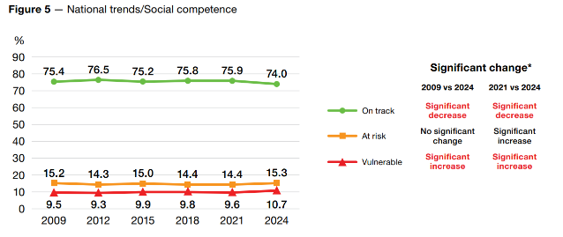

Developmentally on track | Developmentally at risk | Developmentally vulnerable
Children almost never have problems getting along with others, are respectful to adults, self-confident, can follow class routines, and can help others. | Children experience some challenges in areas such as getting along with others (children or teachers), playing cooperatively with a variety of children, showing respect for others and for property, following instructions and class routines, taking responsibility for their actions, working independently, and exhibiting self-control and self- confidence. | Children experience several challenges and have poor overall social skills e.g. regularly have challenges getting along with other children, do not accept responsibility for actions, and have difficulty following rules and class routines. Children may be disrespectful of others and their property, have low self-confidence and self-control, do  not adjust well to change, and usually unable to work independently.

National trends: AEDC domains



Emotional maturity

The percentage of children developmentally vulnerable on the emotional maturity domain remained stable over previous AEDC collections ranging from 8.4 to 8.5 per cent from 2015
to 2021. In 2024, developmental vulnerability has increased by
1.5 percentage points (to 10.0 per cent) – the largest increase in developmental vulnerability across all domains in this collection. The percentage of children developmentally at risk has also increased by 0.7 percentage points in 2024 (to
15.2 per cent). The percentage of children developmentally on track fluctuated over time from 75.6 per cent in 2009 to 77.0 per cent in 2021. In 2024 at 74.8 per cent, the percentage of children developmentally on track is the lowest rate across all six collections.

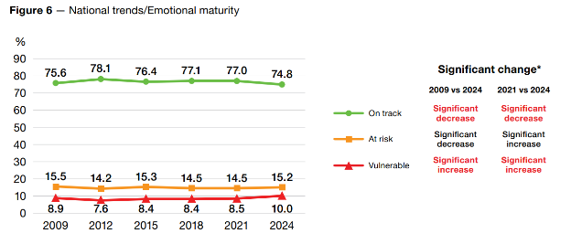

Developmentally on track | Developmentally at risk | Developmentally vulnerable
Children almost never  show aggressive, anxious or impulsive behaviour. Children have good concentration and will often help other children. | Children may sometimes experience problems with anxiety, aggression, temper tantrums, or problems with inattention or hyperactivity.  Children experience some challenges in areas such as helping others who are hurt, sick or upset, inviting others to join in, being kind to others, and turn-taking. | Children experience several challenges in emotional regulation e.g. aggression, prone to disobedience, easily distracted, inattentive, and impulsive. Children usually do not help others and are sometimes upset when left by their caregiver.

National trends: AEDC domains


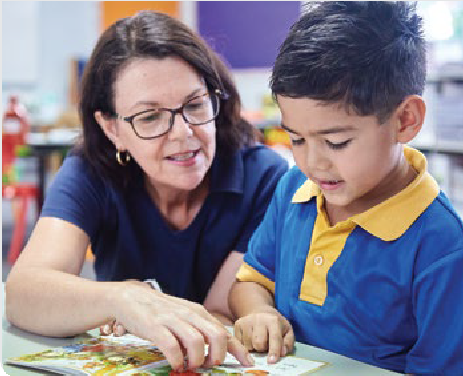

Language and cognitive skills (school-based)

The language and cognitive skills (school-based) domain showed large improvements between 2009 and 2012 with results peaking in 2015. Over the last three collections (2018 to 2024), there was an increase in the percentage of children who were developmentally vulnerable and at risk, and a decrease in the percentage of children developmentally on track. These
shifts were largest from 2018 to 2021 and reduced in size from 2021 to 2024. For example, the percentage of children developmentally vulnerable increased by 0.7 percentage points from 2018 to 2021, compared with 0.4 percentage points from 2021 to 2024. While developmental vulnerability has risen since 2015, it has significantly decreased since the baseline set in 2009.
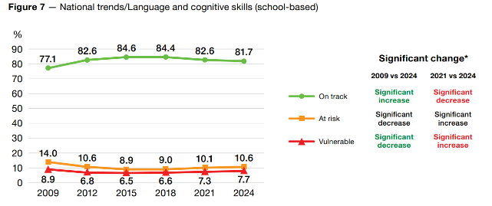

Developmentally on track | Developmentally at risk | Developmentally vulnerable
Children are interested in books, reading and writing, and basic math.  Children can read and write simple sentences and complex words, and can count and recognise numbers and shapes. | Children have mastered some literacy and numeracy skills but not all e.g. identify and attach sounds to some letters, aware of rhyming words, knows writing directions, able to write their own name, count to 20, recognise shapes and numbers, compare numbers, sort and classify, and understand simple time concepts. Children may have memory difficulties, are disinterested in books, reading and numbers, and may not have mastered more advanced literacy skills such as reading and writing simple words or sentences. | Children experience several challenges in reading/writing and numbers e.g. unable to read and write simple words, often unable to attach sounds to letters, difficulties with memory, counting to 20, recognising and comparing numbers, disinterested in reading and numbers.

National trends: AEDC domains



Communication skills and general knowledge

In the communication skills and general knowledge domain, the percentage of children developmentally vulnerable decreased steadily from 9.2 per cent in 2009 to 8.2 per cent in 2018. However, this trend reversed in 2021 with an increase of 0.2 percentage points, followed by a larger increase of 0.5
percentage points in 2024 (from 8.4 per cent in 2021 to 8.9 per cent in 2024). In 2024, the percentage of children who were developmentally on track has decreased by 1.2 points (from
77.1 per cent in 2021 to 75.9 per cent).

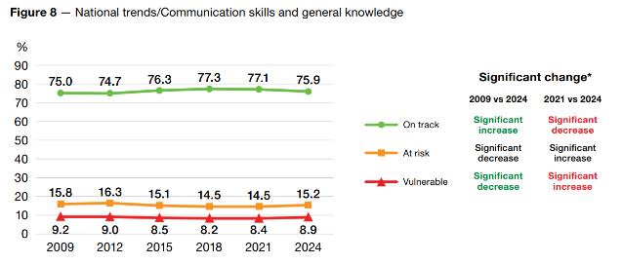

Developmentally on track | Developmentally at risk | Developmentally vulnerable
Children have excellent communication skills, can tell a story and communicate easily with both children  and adults, and have no problems with articulation. | Children have mastered some communication skills but not all e.g. listening, understanding and speaking effectively in English, clear articulation, able to tell a story and to take part in imaginative play. Children may not have some basic general knowledge about the world e.g. leaves fall in autumn, an apple is fruit, dogs bark. | Children have poor communication skills and articulation. They may have limited command of English (or the language of instruction), difficulties talking to others, understanding, and being understood, and have poor general knowledge.

The AEDC summary indicators

The AEDC has three summary indicators that collectively can be used to monitor trends in children’s development.
On track on five AEDC domains (OT5) reflects children’s developmental strengths and recognises the importance of holistic development. It can help identify where things are working well to support children’s development.
Developmentally vulnerable on one or more AEDC domains (DV1) and developmentally vulnerable on two or more AEDC domains (DV2) can be used to identify trends in children’s developmental vulnerability over time, and indicate where additional support might be needed at a community level.
The summary indicators can be used to help evaluate the impact of policies and programs over time (Figure 9).
OT5 has been selected as an indicator in the National Agreement on Closing the Gap, Outcome 4: Children thrive in their early years.
Figure 9 – AEDC summary indicators

The percentage of children who are developmentally on track on five AEDC domains.
OT5

The percentage of children who are developmentally vulnerable on one or more AEDC domains.
DV1

The percentage of children who are developmentally vulnerable on two or more AEDC domains.
DV2

For more information see the AEDC Summary Indicators fact sheet
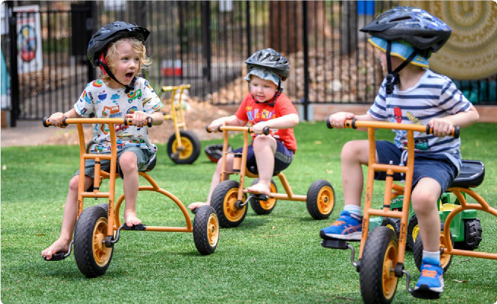

National trends: AEDC summary indicators

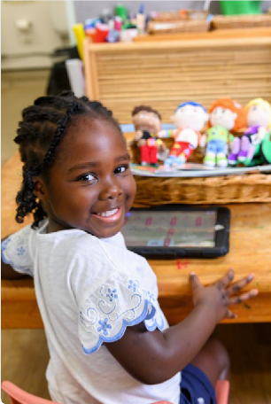

OT5

DV1

DV2

The percentage of children who were OT5 increased steadily from 2009 to 2018, where it peaked at 55.4 per cent. In 2021, this decreased by 0.6 percentage points, a trend that accelerated in 2024 with a further decrease of 1.9 percentage points (to 52.9 per cent).
The percentage of children who were DV1 decreased from 2009 to 2018. This was followed by a small increase of 0.3 percentage points in 2021 and a larger increase of 1.5 percentage points in 2024 which returns DV1 to baseline level.
A similar increase (1.1 percentage points) occurred in the percentage of children who are DV2 in 2024 (12.5 per cent). The 2024 result is the highest level of developmental vulnerability on two or more domains across all six AEDC collections.

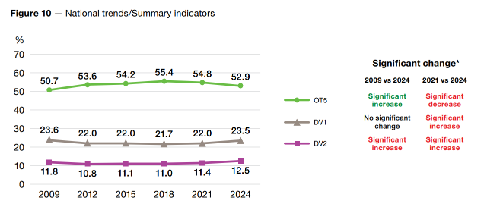

* Significant change text is colour coded green for a positive change and red for a negative change.

Priority groups
The Australian state and territory governments, through the Closing the Gap initiative, have set a target to increase the percentage of Aboriginal and Torres Strait Islander children who are on track on five domains to 55 per cent by 2031
33.9%
55%
2024
2031

First Nations children
The AEDC data provides insight into the developmental outcomes of First Nations children. This data is vital
for identifying whether national and local initiatives are contributing to improving First Nations children’s development over time.
Improving early development for First Nations children is a priority of the National Closing the Gap partnership. By identifying the percentage of children who are developmentally on track on five domains, AEDC data
contributes to measuring progress against Outcome 4 of the National Agreement on Closing the Gap: Aboriginal and Torres Strait Islander children thrive in their early years.
AEDC data is available to First Nations communities and researchers to empower them to lead the national research agenda for First Nations children.
OT5
The percentage of First Nations children
developmentally on track on five domains stabilised, with a non-significant decline, from 2021 to 2024.
2021
2024
33.9%
34.3%
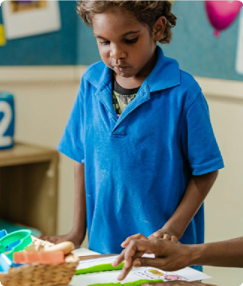

7.5%
of children in the 2024 AEDC
are First Nations children

For more information on the AEDC and First
Nations children visit the AEDC website
Note: The 2024 Australian version of the Early Development Instrument (AvEDI) and its supporting materials use the term ‘Aboriginal and Torres Strait Islander children’ when referring to First Nations children.

National trends: First Nations children
Physical health and wellbeing
The percentage of First Nations children developmentally on track on the physical health and wellbeing domain increased from 60.6 per cent in 2009 to 62.9 per cent in 2021. This is followed by a small non-significant increase of 0.2 percentage points in 2024. The percentage of First Nations
children developmentally vulnerable on the physical health and wellbeing domain has remained stable over time with no significant change in 2024, or since baseline set in 2009.

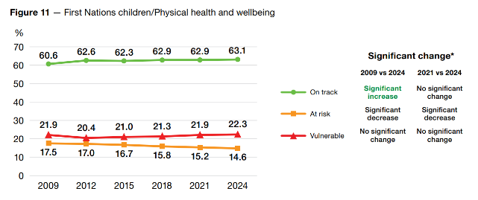

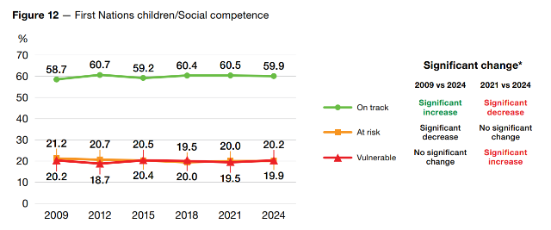
Social competence
The percentage of First Nations children developmentally vulnerable on the social competence domain increased by 0.7 percentage points to 20.2 per cent, back to levels equivalent to baseline. This occurred alongside a decrease of 0.6 percentage points in the percentage of First Nations children developmentally on track on this domain.

National trends: First Nations children
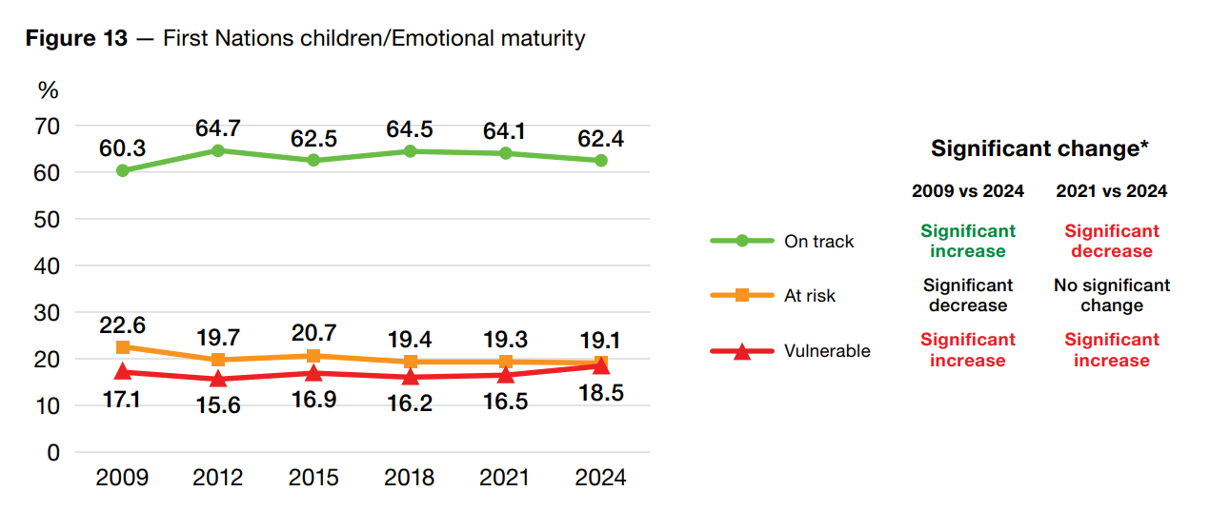
Emotional maturity
Consistent with the national trend, shifts in the emotional maturity domain in 2024 have also been the largest among all developmental domains for First Nations children. The percentage of First Nations
children on track on the emotional maturity domain has increased by 2.1 percentage points since baseline, but has decreased by 1.7 percentage points since 2021. The percentage of children developmentally vulnerable on the
emotional maturity domain decreased by 0.6 points from 2009 to 2021, followed by an increase of 2.0 points in 2024.


Language and cognitive skills (school-based)
First Nations children showed improvements on the language and cognitive skills (school-based) domain in 2024, with a significant drop in developmental vulnerability by 0.6 percentage points, reversing the trend of
increasing developmental vulnerability evident from 2015 to 2021. This improvement in language and cognitive skills for First Nations children contrasts the national trend of increases in developmental vulnerability on all five domains.

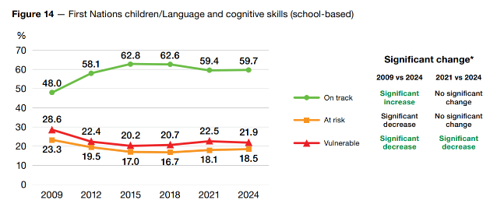

National trends: First Nations children
Communication skills and general knowledge
The percentage of First Nations children developmentally vulnerable on the communication skills and general knowledge domain has decreased in each collection cycle from 21.3 per cent in 2009 to 17.3 per cent in 2024, including a significant 0.8 percentage point decrease in 2024. The percentage of First Nations children developmentally on track on this domain increased from 55.9 per cent in 2009 to 62.5 in 2021, and has remained stable in 2024 (62.7 per cent).

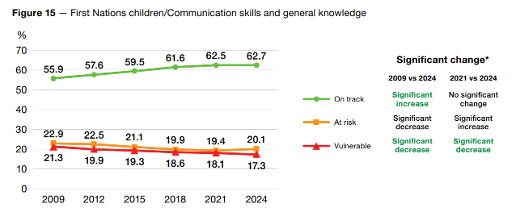

Summary indicators
OT5 DV1 DV2
OT5 – The percentage of First Nations children who were OT5 increased from 26.3 per cent in 2009 to peak at 35.2 per cent in 2018. It decreased by 0.9 percentage points in 2021 and stabilised in 2024 with a non-significant decline of
0.4 percentage points.
DV1 and DV2 – While rates of developmental vulnerability increased nationally in 2024, the percentage of First Nations children who are DV1 and DV2 has remained stable.

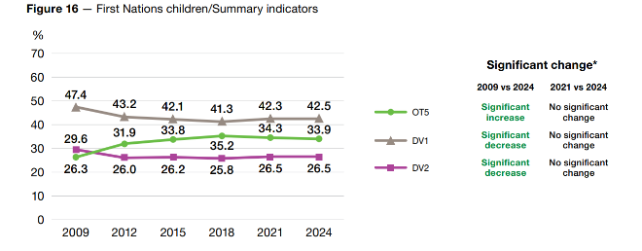

Language diversity
The Australian population is one of the most culturally and linguistically diverse in the world, and this is reflected in the children included in the AEDC.
OT5
The percentage of children with a language background other than English (LBOTE) who are developmentally on track
on five domains decreased from 2021 to 2024.
2021
2024
48.0%
50.3%
In the AEDC, children are considered to have a language background other than English (LBOTE) if they speak a language other than English at home or if they have English as a second language (ESL) status.
Children who begin school with limited English proficiency can face additional challenges in keeping pace academically while simultaneously learning the English language.
In communities where many children speak a language other than English at home, there are important considerations when working to understand and interpret AEDC results. AEDC data can tell us about the skills
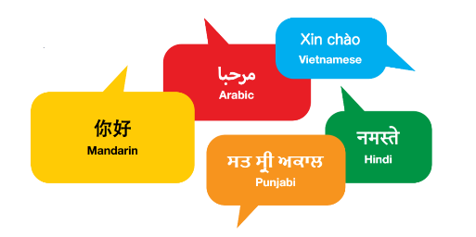
and competencies that children demonstrate in English and in their school setting. The results do not capture the language capacities children display at home or in other contexts where their first language and literacy skills may be stronger. The top five non-English language
backgrounds in 2024 were Mandarin, Arabic, Punjabi, Hindi and Vietnamese.



For more information see the Language Diversity and the AEDC fact sheet

National trends: Language diversity
Physical health and wellbeing
The percentage of children with an LBOTE who were developmentally on track on the physical health and wellbeing domain increased steadily from 2009 to 2021, followed by a small decrease of
0.3 percentage points in 2024. The percentage of children with an LBOTE who are developmentally
vulnerable on this domain has been stable since 2012.

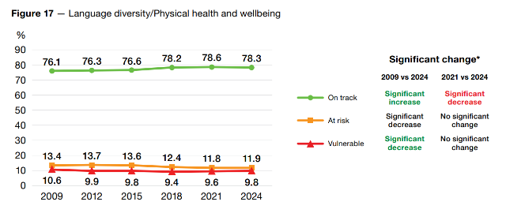

Social competence
The percentage of children with an LBOTE who are developmentally vulnerable on the social competence domain increased by 1.4 percentage points in 2024, and the percentage of children on track decreased by 2.0 percentage points.

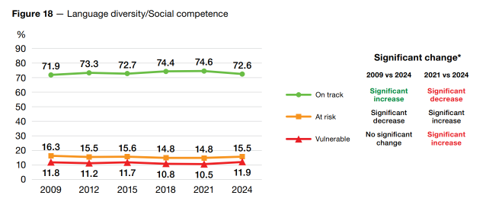

National trends: Language diversity
Emotional maturity
Similar to the results for the social competence domain, the percentage of children with an LBOTE who are developmentally vulnerable on the emotional maturity domain increased by 1.5 percentage points in 2024, and the percentage of children on track decreased by 1.7 percentage points.

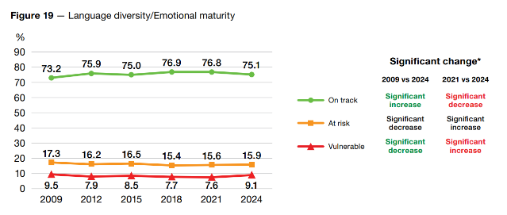


Language and cognitive skills (school-based)
Developmental vulnerability on the language and cognitive skills (school-based) domain increased by
1.2 percentage points in 2024 for children with an LBOTE. The percentage of children with an LBOTE who are developmentally on track on this domain decreased by 2.5 percentage points in 2024.
.

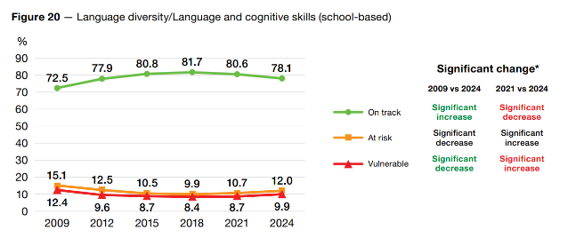

National trends: Language diversity
Communication skills and general knowledge
Since baseline, there were steady improvements in the percentage of children with an LBOTE who were on track on the communication skills and general knowledge domain from 59.8 per cent in 2009 to 67.4 per
cent in 2021. This trend reversed in 2024 with a decrease of 2.1 percentage points to 65.3 per cent. The percentage
of children developmentally vulnerable on this domain increased by 1.3 percentage points in 2024 to 15.6 per cent.

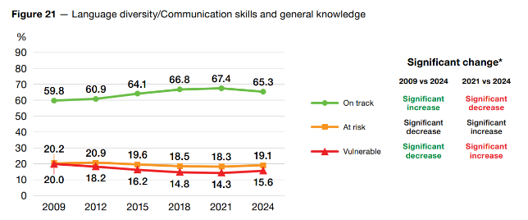

Summary indicators
OT5 DV1 DV2
OT5 – The percentage of children with an LBOTE who were OT5 increased steadily from 42.1 per cent in 2009 to
50.3 per cent in 2021, before declining by 2.3 percentage points to 48.0 per cent in 2024.
DV1 and DV2 – The percentage of children with an LBOTE who were DV1 reduced steadily over time from 32.2 per cent in 2009 to 25.3 per cent in 2021. In 2024 it increased for the first time since baseline by 2.1 percentage points to
27.4 per cent. The same pattern can be observed for the DV2 summary indicator.

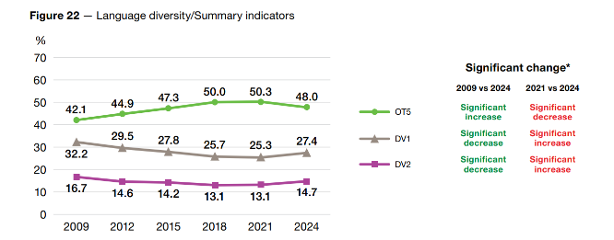

Geographic location
Geographic location can affect access to early years services that are crucial to early childhood development and family wellbeing. The AEDC sheds light on how development varies across geographic locations in Australia, and where changes are needed to ensure
all families have access to support during the critical early years.
The classification of geographic location for the AEDC is based on the Australian Statistical Geographical Standard (ASGS) Remoteness Areas classification. This was developed by the Australian Bureau of Statistics (ABS) to classify places in relation to their geographical remoteness.
The ASGS divides Australia into five classes of remoteness based on their relative access to services

The five classes of remoteness are:
- Major cities: relatively unrestricted accessibility to a wide range of goods and services and opportunities for social interaction.
- Inner regional: some restrictions to accessibility of some goods, services and opportunities for social interaction.
- Outer regional: significantly restricted accessibility of goods, services and opportunities for social interaction.
- Remote: very restricted accessibility of goods, services and opportunities for social interaction.
- Very remote: very little accessibility of goods, services and opportunities for social interaction.


This report presents AEDC data using three categories: major cities, and by combining ‘remote’ with ‘very remote’ and ‘inner regional’ with ‘outer regional’.
OT5
The percentage of children developmentally on track on five domains decreased across all three AEDC geographic categories from 2021 to 2024.
2021
2024
Major cities

56.0%
Inner/Outer regional
52.2%

Remote/Very remote
44.1%
54.0%
50.5%

43.1%


72.7%
of children live in major cities
25.1%
2.2%

of children live in inner/outer regional areas

For time series data tables by remoteness area visit the AEDC website
of children live in remote/very remote areas

National trends: Geographic location

Physical health and wellbeing
Developmental vulnerability on the physical health and wellbeing domain has shown a small increase of
0.2 percentage points for children living in major cities and was stable for children living in inner/outer
regional communities. However, developmental vulnerability increased by 1.9 percentage points for children living in remote/very remote Australia between 2021 and 2024. Since 2009, developmental vulnerability on the physical health and wellbeing domain increased for children living in major cities, inner/outer regional areas, and remote/ very remote Australia. In 2024, the increase was largest for children living in remote/very remote Australia.
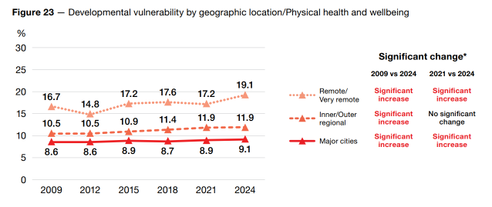

Social competence
Developmental vulnerability on the social competence domain has increased for children living in major cities, inner/outer regional and remote/very remote areas in 2024. It increased by 1.1 percentage points for children living in major cities and inner/outer regional communities, and by 0.5 percentage points for children living in remote/very remote communities.

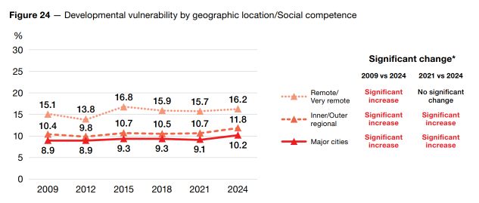

National trends: Geographic location
Emotional maturity
Children living in major cities, regional and remote areas of Australia all experienced increases in developmental vulnerability on the emotional maturity domain in 2024. Increases in developmental vulnerability ranged from 1.8 percentage points for children living in remote/very remote communities to 1.5 percentage points for children living in major cities.

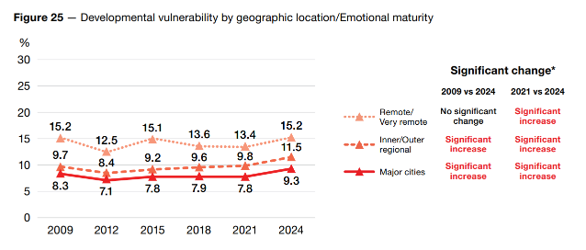


Language and cognitive skills (school-based)
The gap in developmental vulnerability between children living in major cities and remote/very remote communities is largest for the language and cognitive skills (school-based) domain, with a difference of
14.2 percentage points in 2009. In 2024, developmental vulnerability increased for children living in major cities (0.5 percentage points) and decreased for children in remote/very remote communities (0.8 percentage points), with the gap reducing to 12.2 percentage points.
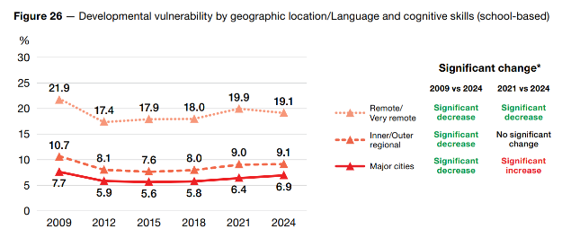

National trends: Geographic location
Communication skills and general knowledge
Communication skills and general knowledge is the domain with the smallest gap in developmental vulnerability between children living in major cities and in inner/outer regional communities. In 2024, developmental vulnerability increased by 0.7 percentage points in major cities and by 0.1 percentage points in regional communities, reducing the gap to 0.1 percentage point (8.8 per cent major cities;
8.7 per cent inner/outer regional). In contrast, developmental vulnerability on this domain in remote/very remote communities increased by 1.0 percentage point in 2024 to 15.0 per cent and remains markedly higher than seen in major cities and regional communities.
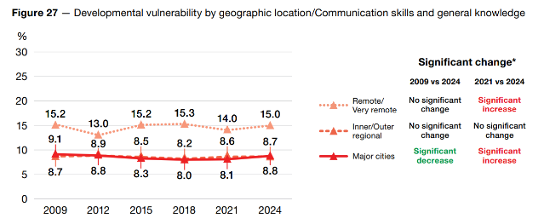

Summary indicators
OT5

OT5 – In 2024, the largest shift in the percentage of children who are OT5 was seen in major cities (2.0 percentage point decrease), followed by inner/outer regional areas (1.7 percentage point decrease), and finally children living in remote/very remote communities (1.0 percentage point decrease). The gap between those living in major cities and remote/very remote locations on OT5 was largest in 2009 (15.2 percentage points) and has reduced over time to the lowest level of all six collections in 2024 (10.9 percentage points).
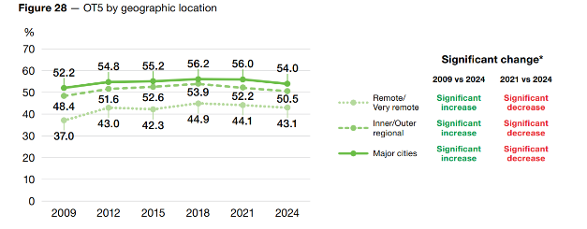

National trends: Geographic location

Summary indicators
DV1
DV2

DV1 and DV2 – In all AEDC collections, children living in major cities had the lowest levels of DV1 and DV2, followed by children living in inner/outer regional areas of Australia. These differences are sizable. For example, in 2024, the percentage of children who are DV1 varied from 22.5 per cent in major cities to 35.8 per cent in remote/very remote communities (a 13.3 percentage point gap).
In 2024, the increase in DV1 has been largest for children living in major cities (1.7 percentage points), followed by children living in remote/very remote communities (1.4 percentage points), and finally children living in inner/ outer regional Australia (1.1 percentage points). The increase in DV2 was similar across locations ranging from
1.2 percentage points in major cities to 0.8 percentage points in inner/outer regional areas.
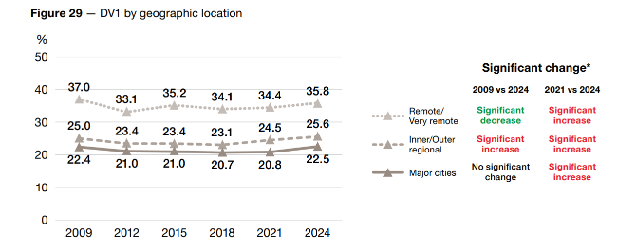

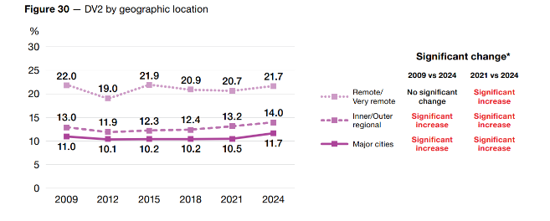

Socio-economic status
The Socio-Economic Indexes for Areas (SEIFA) is a set of indexes developed by the Australian Bureau of
Linking SEIFA with AEDC data provides insight into the relationship
between socio-economic disadvantage and children’s developmental vulnerability.
Statistics to measure the socio-economic characteristics of geographical areas. They consider factors such as education, employment, income and housing.
The AEDC uses the SEIFA Index of Relative Socio- Economic Disadvantage (IRSD), which ranks areas based on their relative disadvantage. Through the IRSD, geographic locations are separated into five groups of equal size - quintiles - that correspond to decreasing
levels of socio-economic disadvantage. Quintile 1 includes the locations with the highest level of disadvantage.
Quintile 5 includes the locations with the lowest levels of disadvantage. There may also be pockets of advantage and disadvantage within a single area.

Approximately 20% of children live in each of the SEIFA quintiles
OT5
The percentage of children developmentally on track on five domains decreased in all SEIFA quintiles from 2021 to 2024.
Most disadvantaged Least disadvantaged

Q1
Q2
Q3
Q4

Q5

 | 2021 | 2024*
Q1 | 42.5% | 41.2%
Q2 | 51.0% | 49.4%
Q3 | 56.1% | 54.1%
Q4 | 59.7% | 57.7%
Q5 | 63.7% | 61.1%


* Note: In 2024 AEDC data was updated to reflect the most recent area-based SEIFA at the time of data collection. This applies to all collection cycles.

For time series data tables by SEIFA quintile visit the AEDC website
In previous collections, SEIFA was applied retrospectively. This means previously published AEDC SEIFA results may differ from those published in 2024.

National trends: Socio-economic status
Physical health and wellbeing
In 2024 there have been small increases in developmental vulnerability on the physical health and wellbeing domain for children living in all SEIFA quintiles. The gap in development for children living in the least and most socioeconomically disadvantaged communities widened over time from 6.8 percentage points in 2009 to 10.1 percentage points in 2024.

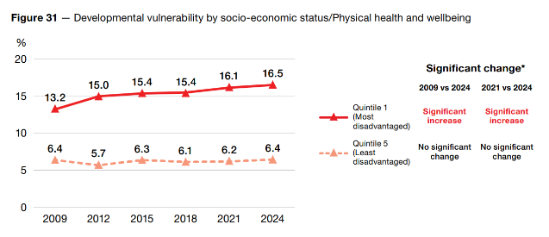

Social competence
In 2024 there have been increases in developmental vulnerability on the social competence domain in all SEIFA quintiles. The gap in development for children living in the least and most socioeconomically disadvantaged communities widened over time from 6.9 percentage points in 2009 to 8.9 percentage points in 2024.

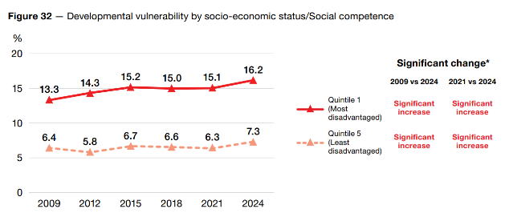

National trends: Socio-economic status
Emotional maturity
While there are socio-economic inequalities in emotional maturity, the gap in developmental vulnerability between children in the most and least disadvantaged communities is smallest on the emotional maturity domain (6.8 percentage points in 2024). In 2024 there has been an increase in developmental vulnerability on this domain for children living in all SEIFA quintiles.

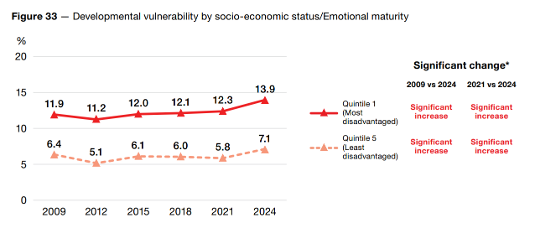

L anguage and cognitive skills (school-based)
The gap in developmental vulnerability between children living in the least and most socio-economically disadvantaged communities in Australia is largest on the language and cognitive skills (school-based) domain. In 2024, increases in developmental vulnerability have been larger for children living in the
most disadvantaged communities (0.9 percentage points) compared to children living in the least disadvantaged communities (0.4 percentage points), widening the gap in development between the two groups (15.0 versus 3.5 percent) to 11.5 percentage points.
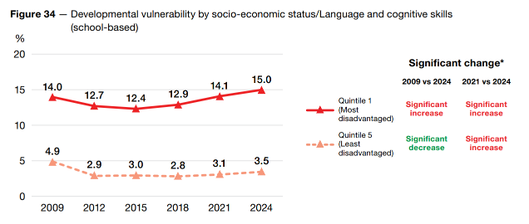

1

National trends: Socio-economic status
Communication skills and general knowledge
In 2024 there have been small increases in developmental vulnerability on the communication skills and general knowledge domain in all SEIFA quintiles. Communication skills and general knowledge is the only domain where there has been a small narrowing of the gap in developmental outcomes for children living in the least and most socio-economically disadvantaged communities (10.3 per cent in 2018,
10.2 per cent in 2021 and 10.1 per cent in 2024).
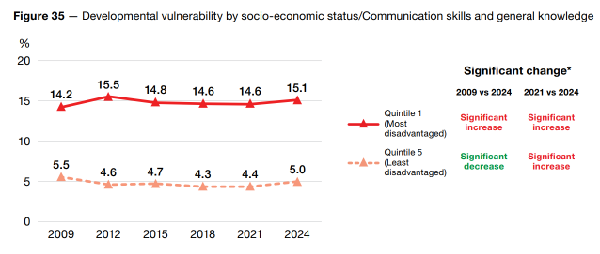

Summary indicators
OT5 – The percentage of children who are OT5 decreased in 2024 in all SEIFA quintiles. However, this decline is smallest for children living in the most disadvantaged communities (1.3 percentage points) and largest for
children living in the least disadvantaged communities (2.6 percentage points). As such, the gap in developmental outcomes for children living in the least and most socio-economically disadvantaged communities has reduced by
1.3 percentage points in 2024.
OT5

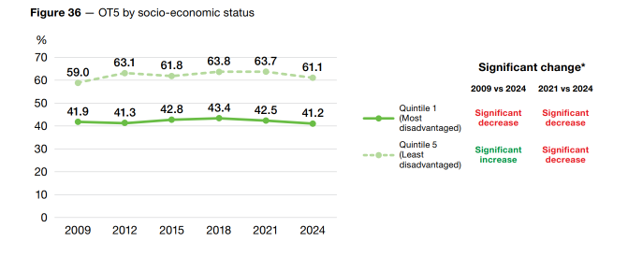

National trends: Socio-economic status

Summary indicators
DV1
DV2

DV1 and DV2 – In 2024, the gap in DV1 between children growing up in the most disadvantaged communities (34.7 per cent) and least disadvantaged communities (16.2 per cent) was 18.5 percentage points.
In 2024, DV1 increased similarly for children in all SEIFA quintiles (1.4 to 1.6 percentage points). A similar pattern emerged for DV2 with increases in all SEIFA quintiles (1.1 to 1.2 percentage points).

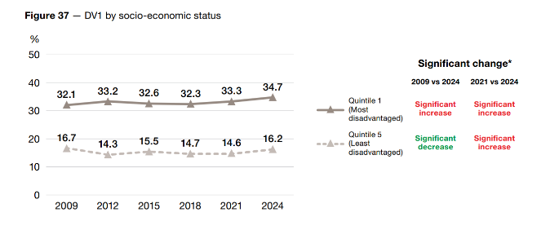

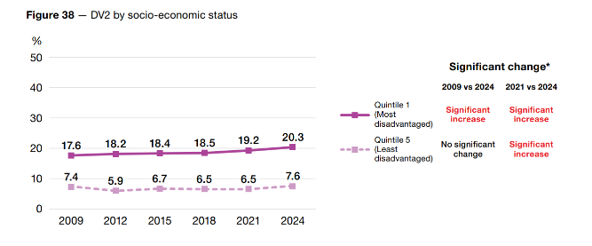
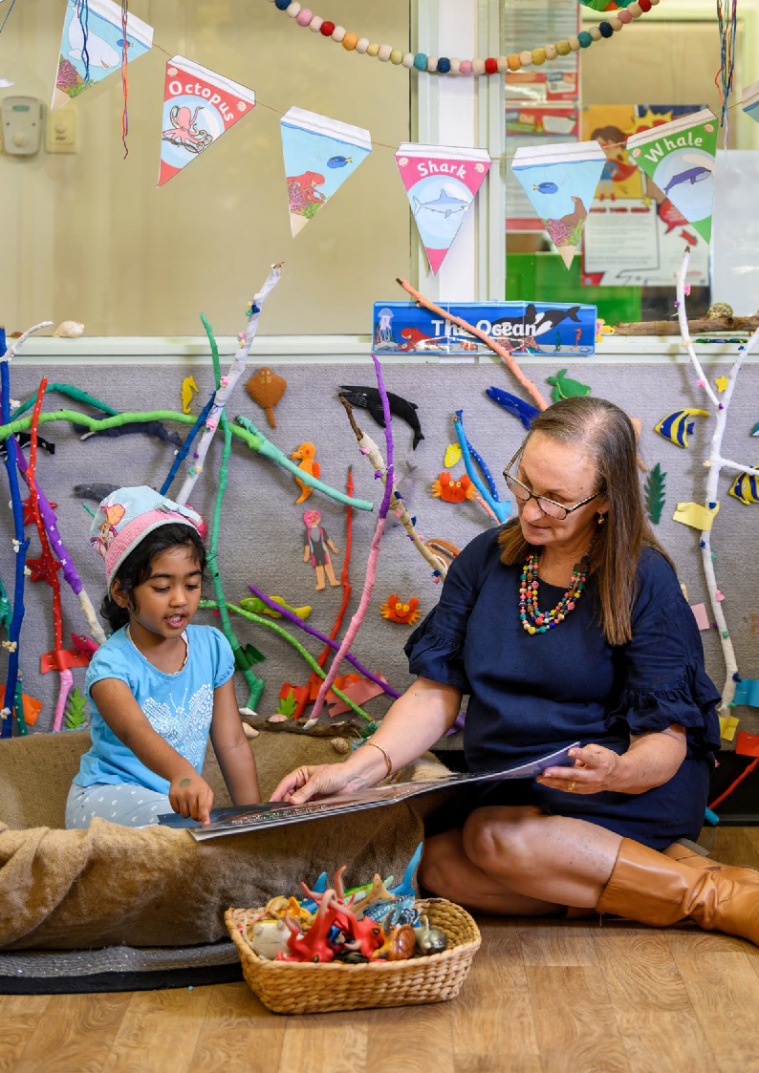

33



AEDC National Report 2024

State and territory results

The AEDC provides insight into the extent to which children’s development varies across Australia. This provides opportunities to identify different approaches to supporting children and families in the early years.
Each cycle, AEDC State and Territory Coordinators (STCs) engage with communities and promote the importance of the AEDC. Details on STCs and regional resources are available on the AEDC website.


For state and territory AEDC results, including significant change tables, visit the AEDC website


New South Wales
90,700
children
5,439
teachers
2,301
schools

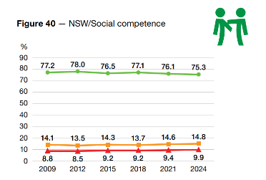
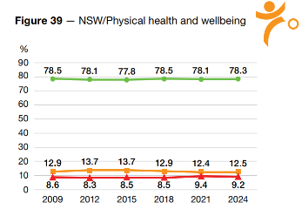
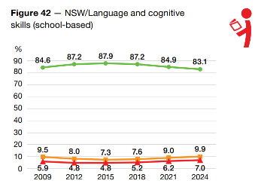
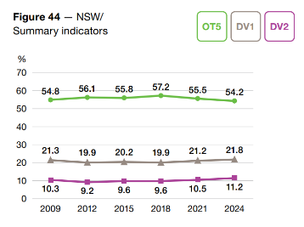
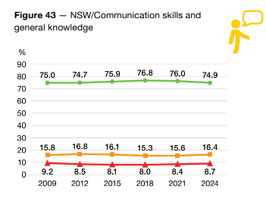
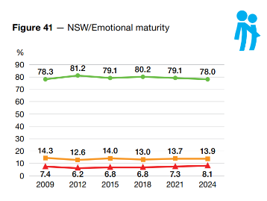


Victoria
67,231
children
3,841
teachers
1,611
schools

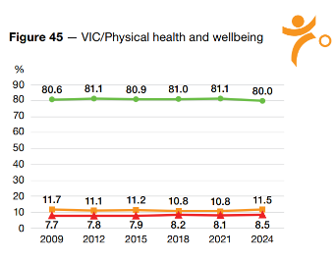
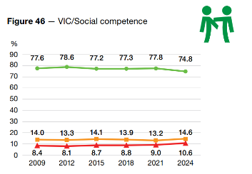

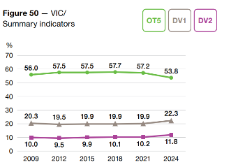
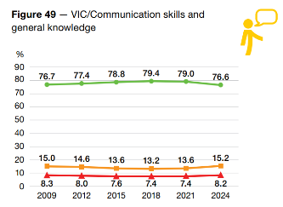
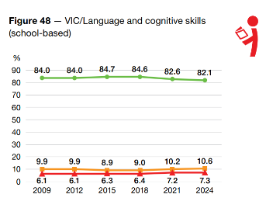
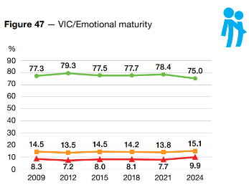


Queensland
62,749
children
3,368
teachers
1,434
schools
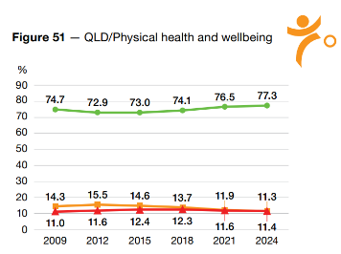
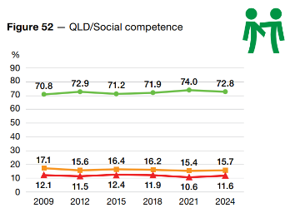

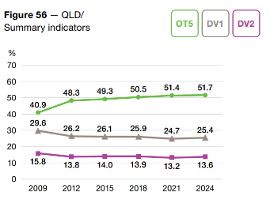
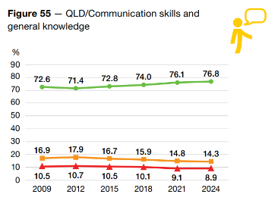
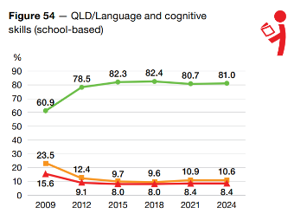
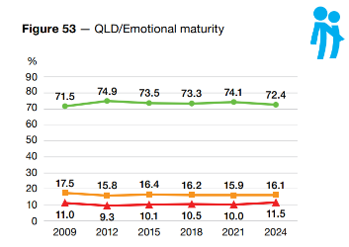


Western Australia
34,549
children
1,845
teachers
951
schools

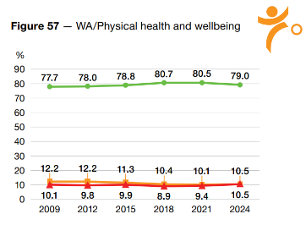
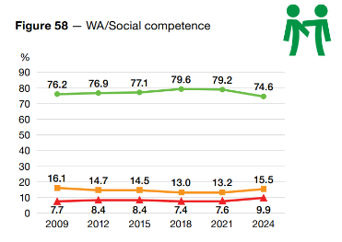

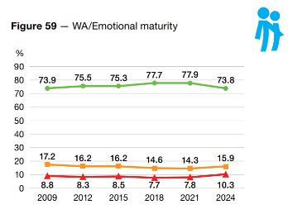
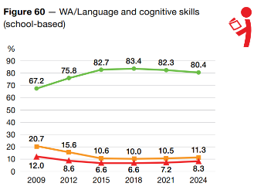

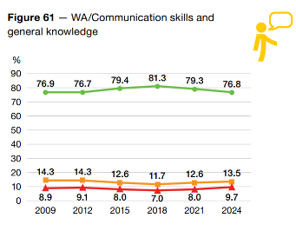
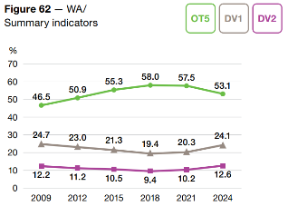


South Australia
19,191
children
1,332
teachers
609
schools

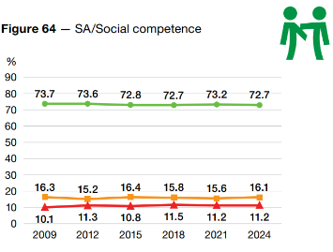
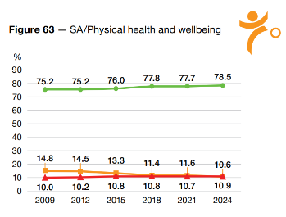

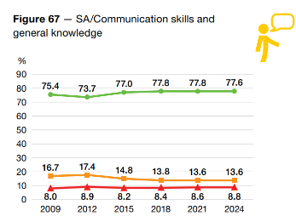
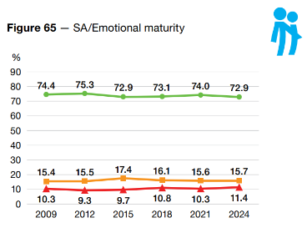

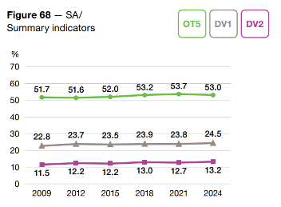
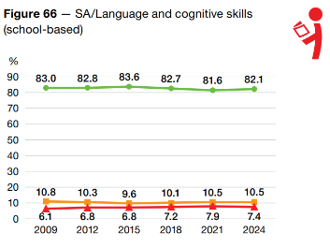


Tasmania
5,733
children
347
teachers
212
schools

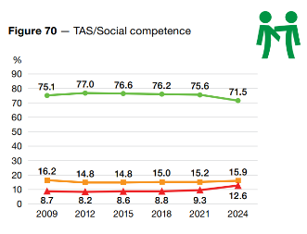
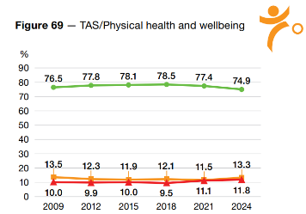
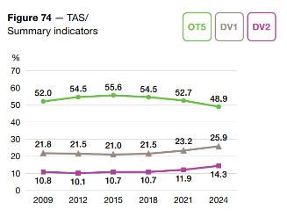
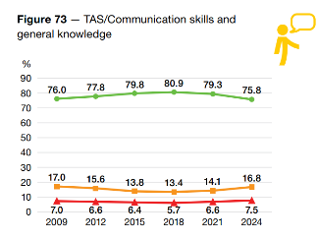
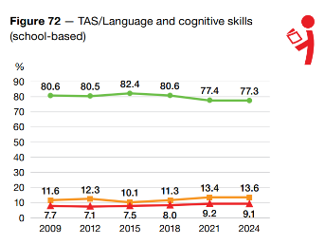
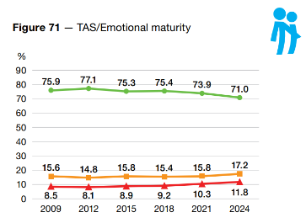

5,339
children
320
teachers
110
schools

Australian Capital Territory

Figure 75 — ACT/Physical health and wellbeing Figure 76 — ACT/Social competence

% %
90 90
76.3
72.6 72.7
70.0 70.4
68.7
74.9 75.5 74.5
72.4
70.3 70.5
80 80
70 70
60 60
50 50
40 40
30 30
14.3
16.9
16.4
17.8
16.8 17.4
20 20 16.3 15.9 16.2 15.3 17.5 17.9
8.9
8.6
9.4
12.3
12.2 11.5
9.4 | 10.6 | 10.9 | 12.1 | 12.8 | 13.8
2009 | 2012 | 2015 | 2018 | 2021 | 2024

10 10
0 0

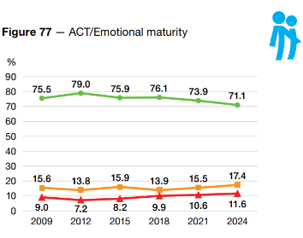
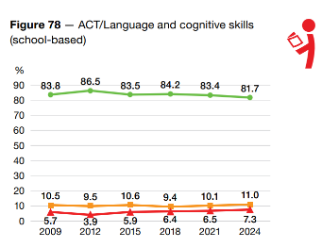

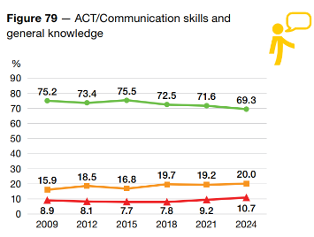
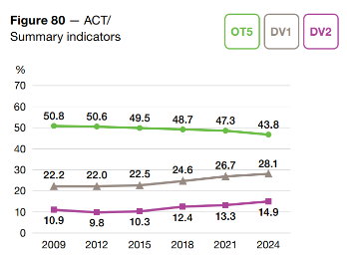


Northern Territory
2,991
children
231
teachers
140
schools

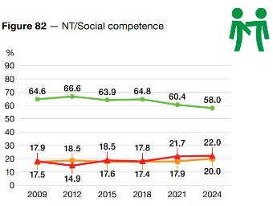
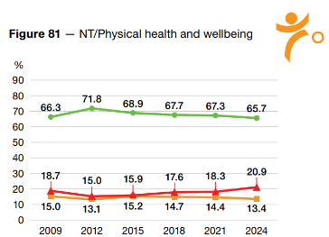

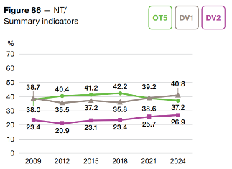
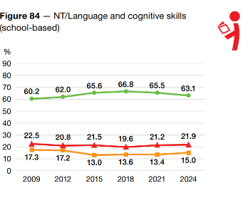

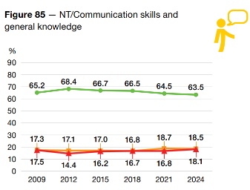
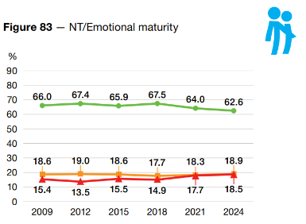


43



AEDC National Report 2024

Resources

About the AEDC

Australian Early Development Census
A fact sheet summarising the AEDC.
www.aedc.gov.au/aedcsumm

About the AEDC Data Collection
A fact sheet with information about how the AEDC collects data on children in their first year of full-time school.
www.aedc.gov.au/abtdata

About the AEDC Domains
A fact sheet summarising the key characteristics of each AEDC domain.
www.aedc.gov.au/abtdom

AEDC Summary Indicators
A fact sheet providing an overview of the three summary indicators used to describe children's development - OT5, DV1 and DV2.
www.aedc.gov.au/abtsumm

Definition of AEDC Terms
A fact sheet defining the key terms used in the AEDC program and resources.
www.aedc.gov.au/defterm

Introduction to the AEDC
A short video explaining the AEDC.
www.aedc.gov.au/vidintro

For more resources to help understand and use the data visit the
AEDC website

Resources AEDC National Report 2024

Accessing AEDC data

Community Data Explorer
The Community Data Explorer is a searchable online data tool available through the AEDC website. Data from each AEDC collection can be viewed at four different levels: local community, community, state/territory and national. Data is available to download in report, table, chart and map formats.
www.aedc.gov.au/cde

Public data tables
Time series data tables are available for download for all AEDC data collections by Local Government Area (LGA), Statistical Area Levels 2, 3 and 4 (SA2, SA3, SA4), Greater Capital City Statistical Areas (GCCSA), Remoteness
and SEIFA.
www.aedc.gov.au/dataproducts

Community Profiles
Community Profiles present AEDC results from geographic areas, usually equivalent to an LGA. They also include information that provides context for the AEDC results such as demographics and the characteristics of children in
the area.
www.aedc.gov.au/communityprofiles

Data Guidelines
The principles and protocols governing the management, access, use, disclosure and dissemination of AEDC data are outlined in the AEDC Data Guidelines. This includes the process for accessing data that is not publicly available.
www.aedc.gov.au/dg

Using AEDC data

User Guides
AEDC User Guides are designed to help educators, communities, policymakers, and researchers understand and use AEDC data effectively. The user guides outline the principles and practices for local action and solutions that work for the children and families that make up communities and jurisdictions.
www.aedc.gov.au/userguides

Informing Your Planning
A video describing how the AEDC can be used to improve the provision of services and supports to children
and families.
www.aedc.gov.au/vidinform

Understanding the Data
A video explaining how the AEDC data is collected and used to calculate AEDC results at a community level.
www.aedc.gov.au/vidunders

Community Stories
A series of stories developed to showcase how communities across Australia are using AEDC data to support early childhood development.
www.aedc.gov.au/commstories

School Stories
A series of stories developed to showcase how schools are using the AEDC to inform curriculum planning and support children’s development.
www.aedc.gov.au/schoolstories



AEDC National Report 2024

Glossary

AEDC domains | The AEDC measures five key areas, or domains, of early childhood development:  - physical health and wellbeing  - social competence  - emotional maturity  - language and cognitive skills (school-based)  - communication skills and general knowledge  These areas have been shown to predict later mental health, wellbeing and educational achievement.
Australian Early Development Census (AEDC) | The AEDC is a population measure of early childhood development. Teachers of children in their first year of full-time school complete an instrument, the Australian version of the Early Development Instrument (AvEDI), for each child in their class. The instrument collects data relating to five key areas of early childhood development referred to as ‘domains’ (see AEDC domains). Data is collected for individual children and then reported for groups of children at a community, state/territory and national level. Prior to 1 July 2014, the AEDC was known as the Australian Early Development Index (AEDI).
Australian version of the Early Development Instrument (AvEDI) | The AvEDI is an adaptation of the Canadian Early Development Instrument (see Early Development Index).
Baseline | Results from the first national collection in 2009 are considered 'baseline'.

Glossary AEDC National Report 2024

Closing the Gap | All Australian governments are working with Aboriginal and Torres Strait Islander people, their communities, organisations and businesses to implement the new National Agreement on Closing the Gap at the national, state and territory, and local levels.  The objective of the National Agreement on Closing the Gap (the National Agreement) is to enable Aboriginal and Torres Strait Islander people and governments to work together to overcome the inequality experienced by Aboriginal and Torres Strait Islander people, and achieve life outcomes equal to all Australians (National Agreement on Closing the Gap).  Access to culturally safe and responsive early childhood education is essential for the holistic development and identity of Aboriginal and Torres Strait Islander children (SNAICC 2022; SNAICC et al. 2023). The Coalition of Peaks recognised the Australian  Early Development Census (AEDC) as a valuable dataset to track how well Aboriginal and Torres Strait Islander children and families were supported in the early years and selected a summary indicator with a strengths-based focus, the percentage of children on track on five domains of development.  Target 4 of the National Agreement, Aboriginal and Torres Strait Islander children thrive in their early years, aims to increase the proportion of Aboriginal and Torres Strait Islander children assessed as developmentally on track in all five domains of the AEDC to 55% by 2031 (Productivity Commission).
Community | AEDC Communities are a geographic area, usually equivalent to a Local Government Area (LGA). They are made up of ‘Local communities’ (see Local community).
Community Profiles | Community Profiles are data products that report AEDC results at community and local community levels.
Critical difference | The critical difference is the minimum percentage point change required between two collection cycles for the change to be considered significant. Results beneath the critical difference may be attributed to factors other than changes in children's development.  For more information see the Comparing AEDC Results Over Time fact sheet.
Cut-off scores | When the AEDC was first completed in 2009, a series of cut-off scores for each AEDC domain were established. The cut off scores provide a reference point against which later AEDC results can be compared.
Developmentally on track on five domains (OT5) | OT5 is one of three summary indicators. OT5 represents the percentage of children who are classified as developmentally on track on five AEDC domains. It was first introduced as a strengths-based national AEDC summary indicator in 2021.
Developmentally vulnerable on one or more domains (DV1) | DV1 is one of three summary indicators. DV1 represents the percentage of children who are developmentally vulnerable on one or more AEDC domains.
Developmentally vulnerable on two or more domains (DV2) | DV2 is one of three summary indicators. DV2 represents the percentage of children who are developmentally vulnerable on two or more AEDC domains.
Early Development Instrument (EDI) | The Early Development Instrument (EDI) was developed in Canada by Magdalena Janus and Dan Offord at the Offord Centre for Child Studies at McMaster University (Janus & Offord, 2007) to measure the developmental health and wellbeing of young children. The AEDC uses an Australian adaptation of the EDI (see Australian version of the Early Development Instrument [AvEDI]).  Janus, M., & Offord, D. R. (2007). Development and psychometric properties of the Early Development Instrument (EDI): A measure of children's school readiness. Canadian Journal of Behavioural Science 39(1), 1.

AEDC National Report 2024 Glossary

English as a Second Language (ESL) | Children are considered to have ESL status where English is not their first language, they are either conversational but not yet proficient in English, and/or require additional instruction in English.
Further assessment | ‘Further assessment’ is an item in the AvEDI which allows teachers to identify a child who needs further assessment, or if a child is currently being assessed.
Language background other than English (LBOTE) | Children are considered to have an LBOTE if they speak a language other than English at home, or if they speak English at home but are still considered to have ESL status.
Local community | A Local community is small area locality, usually a suburb or town. For results to be reported, a Local community must have a minimum of 15 children and two teachers. Results are not reported if more than 20 per cent of children are identified as having special needs.
Proficient in English | For the AEDC, children are considered proficient in English if teachers answered ‘average’ or ‘good/very good’ to the AvEDI question: ‘How would you rate this child’s ability to use language effectively in English?’
Quintiles | Quintiles are five equal groups dividing a population. They are used for the Socio-Economic Indexes for Areas (SEIFA) (see SEIFA) to divide the population into five categories of socio- economic disadvantage. Quintile 1 represents the most socio-economically disadvantaged areas. Quintile 5 represents the least socio-economically disadvantaged areas.
Remoteness Areas | Geographic location for the AEDC is based on the Australian Statistical Geographical Standard (ASGS) Remoteness Areas classification. This was developed by the Australian Bureau of Statistics (ABS) to classify places of geographical remoteness.
Socio-Economic Indexes for Areas (SEIFA) | The AEDC classifies socio-economic status according to the Socio-Economic Indexes for Areas (SEIFA) developed by the ABS. The AEDC uses the Index for Relative Socio-Economic Disadvantage (ISRD), which considers Census information such as income, educational attainment and employment. Every geographical area in Australia is given a SEIFA score that ranks the disadvantage of an area, compared with other areas in Australia.
Summary indicators | Summary indicators combine information from all five domains to provide a summary of children’s strengths and vulnerabilities. The AEDC has three summary indicators:  - Developmentally vulnerable on one or more domains (DV1)  - Developmentally vulnerable on two or more domains (DV2)  - On track on five domains (OT5).

For more information see the Definition of AEDC Terms fact sheet



