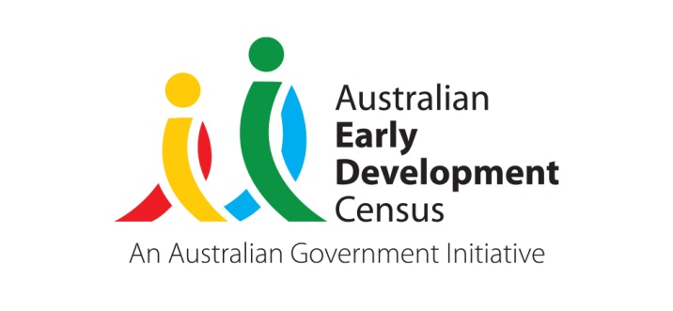 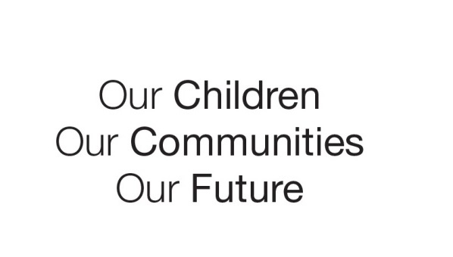

Australian Early Development Census

‘Connect and Grow’ playgroup in Westfield Belconnen

Australian Capital Territory 2020-2021

About Belconnen

The Australian Early Development Census (AEDC) is a national measure of child development. It measures five key areas or domains when a child starts school. The domains are: physical health and wellbeing; social competence; emotional maturity; language and cognitive skills (school based); communication skills and general knowledge.

Belconnen is a large region in Canberra’s north west. It is an established area with the number of children in their first year of school remaining stable across recent AEDC cycles. Of the 1,322 Belconnen children included in the 2018 AEDC cycle, 2.6% were Aboriginal and Torres Strait Islander, while 21.7% had English as a second language.

The vast majority (97.9%) of Belconnen children attended preschool in the year prior to school. Kindergarten teachers reported that most children in Belconnen (95.2%) were adapting to school and had parents actively engaged in supporting their child’s learning (93.9%). This community story will examine the AEDC results for Belconnen and compare them to the ACT average, allowing further exploration of how this cohort of children have developed in the years before starting school.

What did the results show?

In 2018, Belconnen was the ACT region with the third highest percentage of children considered to be developmentally vulnerable on one or more domains (26.4% or 333 children), and with the second highest percentage of children developmentally vulnerable on two or more domains (14.3% or 180 children). There was a significant increase in children considered to be developmentally vulnerable on two or more domains between 2012 and 2015 (10% to 12.1%) and then again between 2015 to 2018 (12.1% to 14.3%). This emerging trend highlights a need for further early childhood development support in the region.

When compared to the ACT average, Belconnen displayed a higher percentage of children developmentally vulnerable across all domains. Significant increases between 2015 and 2018 in the percentage of Belconnen children developmentally vulnerable in the social competence and emotional maturity domains demonstrates a rising need for supports in these developmental areas for the children of Belconnen.

Bringing about change

In 2019, Capital Region Community Services (CRCS), formerly Belconnen Community Service, received a grant for an AEDC Community Partnership project as part of an ACT AEDC initiative aimed at improving early childhood development outcomes in the Belconnen region and supporting parents to engage with their children to promote their development.

The AEDC grant allowed CRCS to begin a weekly Connect and Grow playgroup in the Westfield Belconnen mall, providing a range of play-based experiences for children and families in the Belconnen region and the broader Canberra community. The playgroup commenced in March 2020, holding one session prior to the ACT’s first COVID-19 lockdown. The mall then had COVID-19 restrictions in place for the remainder of 2020 which did not allow external parties to hold events. In March 2021 the playgroup was able to recommence as COVID-19 limitations had relaxed, and it ran for 16 sessions.

Each playgroup session ran for two hours with between 15-35 children attending and many of the families returning each week. Most families travelled from Belconnen and surrounding regions; some attendees resided quite a distance from the local area, which demonstrated the potential reach of a playgroup based within an accessible public space with easy access to public transport.

Multidisciplinary early childhood professionals were available during each session to support the children and their families. The playgroup provided support and education in a range of topics including: hygiene, nutrition, physical skills, identity, emotions, self-protection, preschool readiness and play skills. Educators utilised their knowledge of early years approaches to guide interactions and role modelling with families. Physiotherapists and Speech Pathologists from the University of Canberra Good Start in Life Project and Therapeutic Practitioners from the CRCS Family Foundations Program assisted in the playgroup interactions. ACT’s Early Childhood Early Intervention partner EACH attended and were able to write referrals directly to EACH for families who were concerned about their child’s development.

The playgroup embraced opportunities for children aged 0-5 years to explore the early year’s themes through: storytelling and book discussions; conversations with children and their families, providing information about early years organisations and government agencies in the local area and involvement and connection with these services at the playgroup.

Achievements

The educators role modelled play-based learning styles and demonstrated using sustainable resources that were recycled or repurposed. As a result of the playgroup sessions, parents advised that they learnt ways to engage and play with their children without having to purchase expensive resources.

The playgroup successfully attracted a diverse group of families and ensured they felt comfortable to attend regularly. Many of the families came from culturally and linguistically diverse backgrounds and weren’t currently attending Early Education Centres. Due to the diversity of the families attending, CRCS ensured they had educators attend who were bilingual, and were able to communicate and engage with the families.

The playgroup was supported by multidisciplinary professionals and the collaboration created a safe and relaxed environment for families to access support they otherwise may not have received due to a lack of knowledge of community supports, time commitments and difficulty with transport. They then had the opportunity to witness play strategies with tips on supporting their child’s development using easy to follow guidance. Families communicated that they were thankful for the opportunity to access these professionals within a playgroup setting.

Outcomes achieved by the playgroup included:

* Families equipped with information to access early years supports within their local area;
* Children and families expanding their knowledge and skills by participating in playgroup activities;
* Partnerships established amongst University of Canberra, CRCS and Westfield Belconnen; and
* CRCS developing increased awareness of the community’s needs in areas including learning development milestones, parenting and behaviour, and access to education and care.

Looking Ahead

Families communicated that their children looked forward to attending the playgroup each week and expressed their interest in the program continuing beyond the end date. CRCS has acknowledged the success of this playgroup including the feedback from families and the importance this has played in connecting families with each other within the community.

Due to this CRCS and Westfield have now invested resources to continue to playgroup. The latter has provided support through marketing, resources and storage space for the Connect and Grow playgroup, which continued throughout 2021 with enrolments of between 20-40 families per session until COVID-19 restrictions came into place in the ACT in August 2021. The playgroup is planned to resume in Term 1, 2022.

CRCS continues to partner with Westfield Belconnen in exploring further opportunities to support families in the Belconnen region and the broader Canberra community.

For more information contact

ACT AEDC Coordinator

Phone: 02 620​5 ​3542  
Email: aedc@act.gov.au  
Web: [http://www.children.act.gov.au](http://www.children.act.gov.au/)