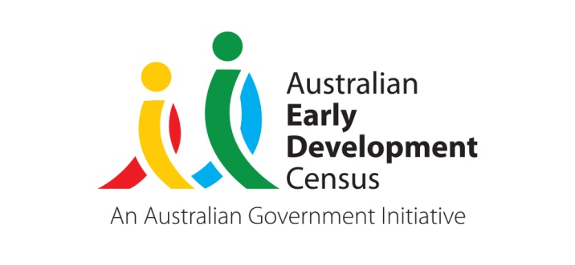 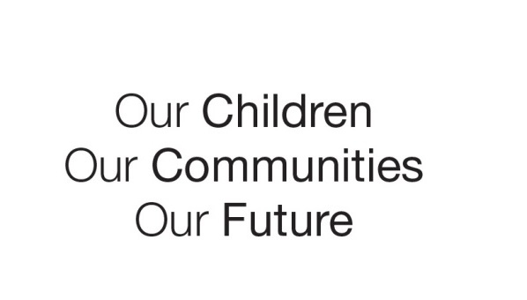

Australian Early Development Census

Communities leading positive change

Queensland 2021

**A deep dive into three Queensland communities**

The value of AEDC data for communities

*“The early years are crucial for setting the foundations for later health, success, wellbeing and educational attainment for children. The pathways set in the early years create the structures on which all later learning happens.” - Yasmin Harman-Smith, Deputy Director - Child Health, Development and Education,  Telethon Kids Institute.*

Australian Early Development Census (AEDC) data is an effective tool for identifying communities where things are going well for children and families. These communities might be facing similar hardships to other communities; however, children are developing on track at a greater rate. AEDC data helps to identify communities where families are supported in the right way at the right time to overcome the challenges in their lives. Through evaluations of services in these communities, families often describe feeling respected and valued, that their beliefs and culture were understood, and that they were able to connect with service providers and form relationships that supported them to be the parents that they wanted to be.

Three Queensland communities

Exploring what has occurred in communities that have experienced an improvement in AEDC data over time helps to identify common themes that exist across these communities, despite differing contexts. Promoting actions taken in communities that have seen a positive shift in data and sharing their practices and learnings can provide insights and information that may assist others as they seek to improve outcomes for children in the early years and beyond.

Queensland communities, Rocklea–Acacia Ridge, Deception Bay and Jondaryan have experienced a significant shift in AEDC data over all four collections to date (2009, 2012, 2015 and 2018). Throughout this time, all three communities have faced complex community factors and contextual challenges. On average, these communities have experienced a decrease of 18.6% of children developmentally vulnerable on one or more domain (DV1) over the past decade.

For example, in 2009 Rocklea–Acacia Ridge 59.3% of children were developmentally vulnerable on one or more domain of the AEDC. By 2018, this figure had decreased to 30.6%, a decrease of almost half across the past decade (see Figure 1).

**Figure 1: DV1 AEDC Rocklea-Acacia Ridge community data across all collections to date**

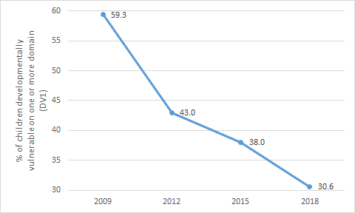

Common themes from communities experiencing improvements

In order to identify common factors that may have contributed to better outcomes for children, contact was made with community members working in schools, early childhood services and community organisations. Through these conversations, the following common factors were identified across the three communities.

* Effective partnerships and cross-sector collaboration
  + collaboration across various community organisations, schools, early childhood services and government organisations to fill gaps and meet community needs
  + common community goals and shared practices.
* Evidence-based planning and research informed approaches
  + data informed practices
  + innovative outreach to target vulnerable families using a combination of approaches that include place-based work, broad community engagement and cross-sector collaboration.
* Community engagement
  + a combination of broad community engagement activities and targeted outreach to reach as many families as possible and provide appropriate supports and services
  + representation of evidence-based services and supports important for early development at community engagement events/activities such as; antenatal care, Early Childhood Education and Care (ECEC) and school
  + targeting supports and services at both parents and children with a focus on families experiencing high vulnerability.

**Effective partnerships and cross-sector collaboration**

A common element across the three communities has been the sharing of practices and working towards community driven goals. This has involved communities developing a shared language across their networks and collaboratively organising community focused professional development. This approach has allowed community networks to develop a shared understanding about what they value in the early years. The community takes a partnership approach and works collectively across a range of strategies. Building the capacity of families in these communities is a core focus of partnerships and networks, which aims to provide children with the experiences they need to develop and thrive in the early years of life.

Strong leadership emerged as a common element that enabled the development of a connected network of services and supports. Creating this connection facilitated the development and maintenance of intentional referral pathways across services in the communities. By bringing people together, it improved awareness of what is available within each community, and formed the basis for the development of intentional referral pathways between services.

**Evidence-based planning and research informed approaches**

Across all three communities, AEDC data has been used to develop a holistic view of local children and families, identify where children might be starting to fall behind, gain insight into gaps in service delivery, as well as understand the strengths of each community.

Service networks and partnerships have worked together to explore what is going well for children and families. AEDC data has supported communities to reflect on what services are used and valued and where further developments can be made to strengthen service delivery to better align with community needs. Collaborative reflection on services and building a shared vision, has helped develop a connected and uniform approach that ensures families have access to services and supports that meet their needs at the time they need it. This approach has also identified where staff may require additional support to connect with and support families. Additionally it has helped staff to increase their understanding of areas of vulnerability as well as strengths, contexts and lived experiences of families in these communities.

Coming together as a network of service providers has allowed the three communities to create place-based solutions. Place-based solutions are fit for the specific context and encompass the culture, the beliefs, and the value systems of families. These solutions have ensured that families experience continuity of services across the early years. Families in turn are supported at crucial transitions in the same way across the community. The strong links have enabled services to provide early intervention, which has led to positive impacts on children's learning trajectories. By ensuring robust planning practices and co-design processes are utilised, members of these networks and partnerships have been given a voice and ownership over strategies. These processes have also given a voice to families to ensure strategies meet their needs.

“When a parent is, for instance, attending a playgroup and is able to incidentally chat to a speech therapist about a concern they might have about their child's early language development and the speech therapist provides some advice or guidance around enriching the child's early language environment, that can set that child on the right path and the right trajectory and negate the need for more intensive, more costly services later on.” Yasmin Harman-Smith, Deputy Director — Child Health, Development and Education, Telethon Kids Institute.

Community engagement

Communities that have experienced an improvement in AEDC data appear to have utilised a combination of broad community engagement activities paired with targeted outreach to reach as many families as possible. Being responsive to the needs of families, has assisted in targeting supports to those that may require additional assistance. Community service staff are aware of families that may require support, understand what is happening in the community and can identify what may need adjusting within their service network to respond to needs effectively. Responsive and proactive services have ensured staff are well placed to connect with and advocate for families, helping them to feel valued and respected within the service network.

Community members participate collectively in events and activities to reach families, promote messaging, provide supports and enable referral to services. Events and activities are held in shared community spaces and are regularly reviewed and adapted to cater to the needs of families and targeted towards those experiencing high vulnerability. At community engagement events, representation is sought from evidence-based services and supports critical to early development, such as antenatal care, sustained nurse home visiting, parenting programs, Early Childhood Education and Care and schools.

In services that have successfully met the needs of the community, families have expressed the importance of feeling welcomed, not feeling judged, and feeling that their beliefs and culture are reflected. Anecdotal evidence suggests that when services effectively fit the community context they are much more likely to be accessed and utilised by families.

Leading by example and sharing learnings

Children grow up in the context of their families and communities. Communities provide vital supports to parents and families and have the ability to connect them with services, supports and social connection. Providing relevant and effective support helps give families the tools they need to help their children thrive. Reflections from families, living in communities that have been successful in decreasing developmental vulnerability, highlight the importance of providing support in a child's early years and maintaining that connection at important times for children's development.

The Deception Bay, Rocklea–Acacia Ridge and Jondaryan community stories highlight the strategies and innovative solutions that have been developed and implemented in order to meet the needs of children and families in each community. The three communities have been successful in promoting and leveraging protective factors for child development through contextualised supports and services for parents and families. Sharing learnings and common themes across varying community contexts can assist communities facing a variety of challenges to develop strategies that support their children and families, improving outcomes into the future.

For more information contact

Madeline Hagon

State Coordinator, AEDC

Department of Education

Queensland Government

[aedc@qed.qld.gov.au](mailto:aedc@qed.qld.gov.au)

[www.aedc.gov.au](http://www.aedc.gov.au)

|  |
| --- |
|  |