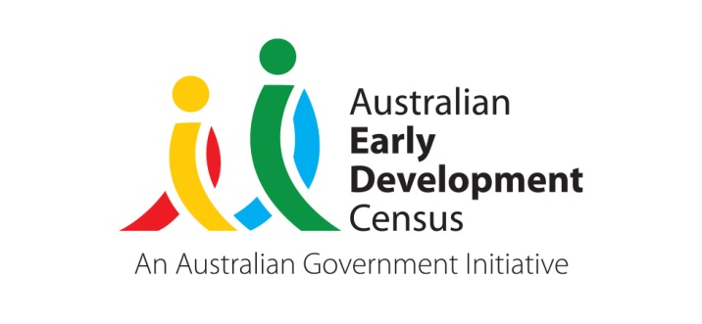 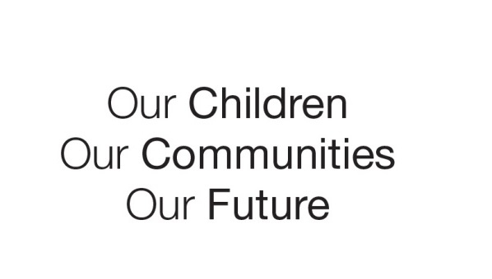

Australian Early Development Census

Community story

All young children thriving and learning in South Australia by 2031

South Australia 2022

A 10-year Early Learning Strategy recognising the importance of early childhood learning and development

About the children and early years system in South Australia

In 2020, almost 98,000 children in South Australia were between the age of 0 and 4 and approximately 21,000 of these children were 4 years old[1]. Most of these children (74%) were living in metropolitan areas; 22% were living in rural areas and almost 4% were living in remote areas[2].

The term ‘early years system’ refers to universal (for everyone) and targeted (directed to specific groups) government and non-government policies, programs, services and supports for South Australian children from birth to 5 years, and their families. These include child health, parent support, education, childcare, community services and child protection. In South Australia, these are offered through the Child and Family Health Service (CaFHS), government and non-government education and care services, supported and community playgroups, community libraries, local health networks, and specific parenting programs and initiatives.

The South Australian Department for Education has a strong history of providing universal preschool education in the year before school. In 2020, 83% of childen who had enrolled in a preschool program accessed a government preschool[3].

The department delivers preschool through various models. Some sites are integrated services providing both education and care, including occasional care or long day care. There are also additional services and supports available such as bilingual and inclusive education supports and access to allied health practitioners and support services.

What was the AEDC data showing?

The 2018 AEDC results showed almost a quarter of South Australian children (23.9% compared with the national average of 21.7%) were developmentally vulnerable on one or more domains when starting school. This proportion has increased from 22.8% in 2009. The AEDC data also showed that developmental vulnerability in South Australia is spread across all socioeconomic levels and geographic areas.

AEDC data also showed higher proportions of developmental vulnerability in the the physical health and wellbeing, social competence and emotional maturity domains for children in South Australia, with 10.8%, 11.5% and 10.8% respectively in the 2018 AEDC results.

Bringing about change

Aligned to collective actions across Australia driving responses to the need for better quality child development support and early childhood education, the South Australian Government began development of an early learning strategy in early 2020.

The key themes and future directions of the strategy were shaped by evidence-based research; experience in other jurisdictions and feedback from parents, community members, teachers and other early education and care workers; and leaders and experts in education, child development and health.

In June 2021, the South Australian Department for Education launched the new 10-year [Early Learning Strategy 2021 to 2031: All Young Children Thriving and Learning](https://www.education.sa.gov.au/sites/default/files/early-learning-strategy-2021-to-2031-all-young-children-thriving-and-learning.pdf) (ELS), which recognises the importance of early childhood learning and development during the early years of life (birth to 5 years of age).

The ELS seeks to:

* expand the reach, frequency and number of child development checks;
* give parents easy access to tips and resources to support their child’s development;
* provide teachers with new resources to build on the high-quality learning and development in every public preschool, and share learning with the broader sector; and

provide strategic vision and direction across the early years system in South Australia through a new Office for the Early Years in the department.

This ELS forms part of the department’s broader reforms to achieve world-class education in South Australia by 2031. It has two streams of focus: ‘Growing Learners – strengthening universal services’ and ‘World-Class Government Preschools’. Their goals are:

* strong partnerships across government and non-government sectors to increase the proportion of children developmentally ‘on track’, regardless of background or location, with additional specific support for Aboriginal children and children in complex situations;
* well-supported parents who are highly engaged with their children, so children can learn and reach their potential; and

high-quality educational preschool programs underpinned by excellence in teaching and learning.

Achievements

In October 2021, the South Australian Government established the new Office for the Early Years within the Department for Education. The Office for the Early Years will lead responsibility for early childhood and will ensure that agencies are acting in concert to deliver an integrated and effective universal early years system.

The South Australian Government committed an initial $50.1 million over four years to deliver the Early Learning Strategy and increase universal coverage for child development checks. Implementation has also commenced to deliver key short term initiatives outlined in the ELS under the ‘pillars’ of:

* readily accessible quality universal support for child development;
* responsive local programs and services supporting community priorities;
* strong support for families as their children’s first teachers;
* reduced barriers and increased participation in early childhood education and care services;
* quality teaching and learning in preschools;
* consistent strategic leadership; and

responsive system support.

Partnerships

To deliver the ELS’s goals, engagement activities have started towards building strong partnerships with a range of key South Australian stakeholders including:

* Child and Family Health Services **(**[CaFHS](https://www.cafhs.sa.gov.au/)**)**
* [Playgroups SA](https://www.playgroupsa.com.au/)
* [Wellbeing SA](https://www.sahealth.sa.gov.au/wps/wcm/connect/public+content/sa+health+internet/about+us/wellbeing+sa/wellbeing+sa)
* [Local Government Association SA](https://www.lga.sa.gov.au/)
* [Raising Literacy Australia](https://raisingliteracy.org.au/)
* government and non-government organisations

early childhood education and care sector

Looking ahead

Early childhood education is a worthwhile investment, with children, families, communities, businesses and governments all reaping the rewards.

The ELS will complement other reviews and reforms underway nationally and in South Australia, such as:

* National Agreement on Closing the Gap
* Child Development Council Outcomes Framework in SA
* Parent Engagement in Learning Strategy in SA
* Country Education Strategy in SA

By 2031, South Australia aims to be recognised as a leader in child development and early education, with services showcasing best practice in partnering with communitities, parents, families and carers to deliver services that meet their needs.

Indicators to measure the ELS’s success include:

* increasing the proportion of South Australian children classified as developmentally ‘on track’ across all AEDC domains;
* reducing the proportion of South Australian children classified as developmentally vulnerable on 1 or more AEDC domains;
* increasing the number of South Australian children accessing child development screenings; and
* increasing the enrolment and attendance rates of 3 and 4 year old Aboriginal children and children in care accessing preschool.

Initiatives and responses to the key themes identified in the ELS will continue to be refined in coming years and will adapt to reflect opportunities for shared areas of work across government and in partnership with community stakeholders.

For more information contact

Myléne Warman   
State Coordinator, AEDC

Department for Education  
South Australian Government

**Email:**[Education.AEDCTeam@sa.gov.au](mailto:Education.AEDCTeam@sa.gov.au)

**Web:** [www.education.sa.gov.au/aedc](http://www.education.sa.gov.au/aedc)

|  |
| --- |
| **“There is a definite rise in the number of children reaching Preschool who have some sort of undiagnosed developmental delay… we need to find ways to identify these developmentally vulnerable children sooner and to engage, support and educate families about childhood development and where to access support when needed… A more unified service between health and education from an early age would be helpful.”**  Response via YourSAy dashboard  **“The most important thing in the life and learning of young children is their family, their parents, their home. If we want to be effective we need to support families and children in families.”**  Response via YourSAy dashboard |

1. Source: Quarterly Population Estimates (ERP), by State/Territory. Sex and Age – Sept 2020 ABS website
2. Source: ABS Estimated Resident Population (ERP) for 30 June 2020. This data uses 30 June 2020 ERP and borrows the ‘remoteness area’ distribution from the previous year 2019, based on regional population by age and sex (cat. no. 3235.0)
3. Source: Department for Education, 2020, Annual Census of Early Childhood Services Data Collection