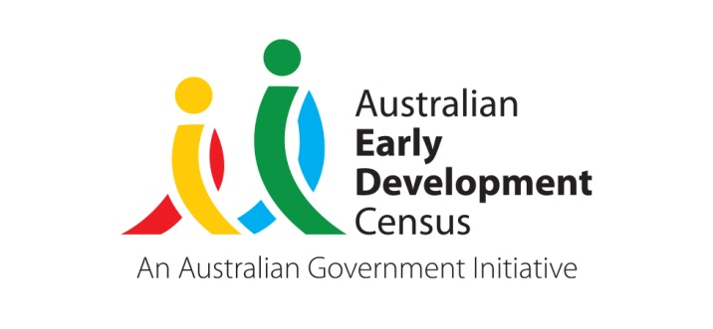 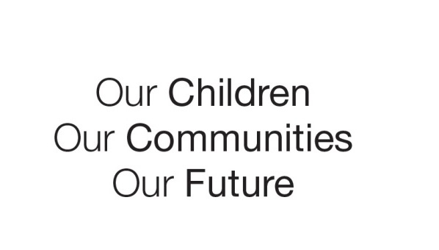

Australian Early Development Census

Community story

Community Skills 4 Kids Café

Tasmania

About

The Waverley Community Skills 4 Kids Café, funded through a grant from the AEDC, was created to bring together members of the Waverley community in Tasmania to support the development of its young people. By providing community members of all ages with the tools and confidence to share skills with children about healthy food, physical activity, arts and story-telling – all in a café-style environment – Waverley’s children would in turn see improvements in language development and physical health and wellbeing.

The arrival of Covid-19 meant that the collective impact organisation behind the Skills 4 Kids Café, the Northern Early Years Group (NEYG), had to find new ways to support children in the Waverley community. From here, the idea of a “cooking box” came to life. These bundles of food basics, fresh produce, and recipes provided families with the supplies needed to cook together at home and were delivered to local families with young children.

During the period of the project a Waverley Community Co-Op Facebook page was established which provided opportunities for families to share stories and images of how they used the provided resources, attracting more than 20,000 views. A community food and resource sharing site was established to support local families during the peak of the 2020 Covid outbreak, and native understory shrubs were planted at Waverley Primary School, both with support from the AEDC grant. The project continues to seed benefits in the Waverley region.

A **video** of this story can be viewed on the [Tasmanian Department of Education website, under AEDC – Grants.](https://youtu.be/nrm8BspZg4c)

For more information contact

Jeannine Otto

Tasmanian Coordinator – Australian Early Development Census (AEDC)