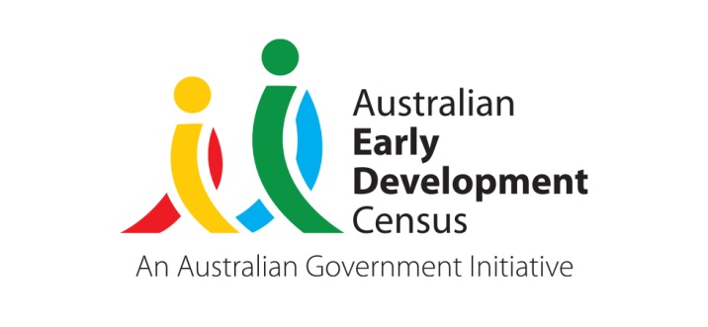 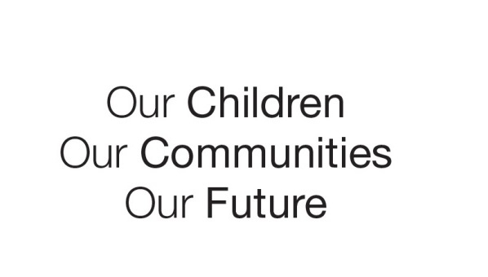

Australian Early Development Census

A Village for Every Child Belconnen

Australian Capital Territory 2022-2023

About Belconnen

The Australian Early Development Census (AEDC) is a national measure of child development. It measures five key areas or domains when a child starts school. The domains are physical health and wellbeing; social competence; emotional maturity; language and cognitive skills (school-based); communication skills and general knowledge.

Belconnen is a large region (AEDC Community) in Canberra’s northwest, containing 28 suburbs (AEDC Local Community). It is largely an established area with the number of children in their first year of school remaining stable across recent AEDC cycles, with Lawson and Strathnairn being the most recently developed areas. Of the 1,276 Belconnen children included in the 2021 AEDC cycle, 5.3% were Aboriginal and Torres Strait Islander, while 20.1% had English as a second language.

The vast majority (97.7%) of Belconnen children attended preschool in the year prior to school. Kindergarten teachers reported that most children in Belconnen (96.2%) were adapting to school and had parents actively engaged in supporting their child’s learning (93.6%). Most Belconnen children were also read to at home (88.4%).

What did the results show?

In 2021, Belconnen was the ACT region with the highest percentage of children considered to be developmentally vulnerable on one or more domain(s) (30.5% or 368 children). It was also the region with the highest percentage of children developmentally vulnerable on two or more domains (16.7% or 201 children). Between 2018 and 2021 there was a statistically significant increase in children considered to be developmentally vulnerable on one or more domain(s) (26.4% to 30.5%) and a statistically significant increase in children developmentally vulnerable on two or more domains (14.3% to 16.7%). This emerging trend highlighted an urgent and increasing need for improvements in early childhood development supports in the region.

When compared to the ACT average, Belconnen displayed a higher percentage of children developmentally vulnerable across all AEDC domains. Additionally, there were statistically significant decreases between 2018 and 2021 in the percentage of Belconnen children developmentally on track in all domains, showing a rising need for supports across all areas of child development. During the same period there were statistically significant increases in the percentage of Belconnen children developmentally vulnerable in the physical health and wellbeing and social competence domains, demonstrating a critical need for supports in these developmental areas.

Bringing about change

A Village for Every Child (Village) is a placed based collective impact initiative that aims to identify issues facing young families and transform early childhood systems across Belconnen (ACT). Aligned to a typical collective impact structure, a Leadership Group, several Working Groups, and a Backbone Team support the work of Village. Village vision and structure flourished from 2021, with the Backbone Team funded by the ACT Education Directorate (ACT Government) since 2018 and the Federal Department of Education, Skills, and Employment (Connected Beginnings) since 2022. The Village initiative is supported by local community services, Early Childhood Education and Care services and the ACT Government. By working together using a collective impact framework the community is stronger, more connected, and better placed to meet the needs of children and families. It is hoped that by focussing collectively on supporting children and their families in this region that the trend of increasing developmental vulnerability in Belconnen can be reversed.

Achievements

After the 2021 AEDC results were released the ACT Community Services Directorate (CSD) held a series of AEDC regional forums focused on sharing the 2021 results for specific areas of Canberra with local stakeholders from education, early childhood education and care, community organisations and government. CSD partnered with Village backbone to deliver a series of Belconnen AEDC regional workshops in June and July 2022. The purpose of the workshops was to inform the community about the outcomes of the 2021 AEDC data with a specific focus on Belconnen, to discuss why the outcomes were trending as they were and identify opportunities respond to the data. It also provided a networking opportunity, bringing together services (government and non-government), schools and Early Childhood Education and Care (ECEC) services.

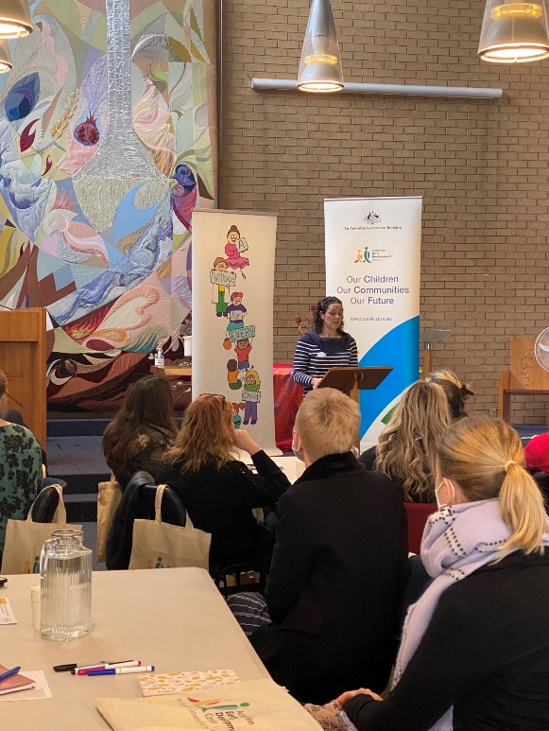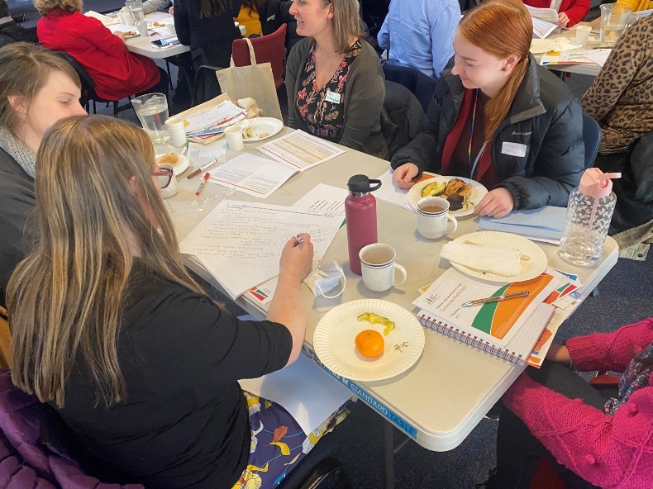Village saw the AEDC as a first step in sharing regional level data with their community. It was also Village’s first exposure to the broader community, an opportunity for Village to gain wider exposure and begin engaging the community in conversations about Belconnen.

AEDC Belconnen Workshop 2: Village partners & other community & government

The workshops were well attended, with 77 participants attending across the 3 workshops, with workshop findings documented in a [report](https://belconnenvillage.com.au/wp-content/uploads/2023/05/AEDC-Workshops-Report.pdf) provided back to participants. The evaluation confirmed the workshops:

* successfully attracted members of the target audience
* participants reported the presentation and group activity were highly useful
* participants embraced the networking opportunity with very positive feedback, including *becoming aware of other services*, *connection*, *sharing ideas* *and experiences*.

The workshops were a valuable opportunity for stakeholders to hear about the AEDC results for the Belconnen region, discuss how the data could be used to drive change, opportunities for responses, as well as providing a forum to encourage connections across services and sectors.

The key findings from the AEDC workshops highlighted the opportunities for ECECs, schools, services and government across the ACT to utilise AEDC data; provide programs, services and supports for children and families; and possible system approaches to improve child development. All 3 workshops highlighted the need for further advocacy for access to local disaggregated Belconnen data; consolidation of information and training opportunities in child development for ACT stakeholders, educators, service providers and parents; develop opportunities to bring cross sector services together, alongside families, to further explore responses to child development in the ACT, specifically the Belconnen region where there is a trend of high levels of developmental vulnerability; and continued promotion of Village, encouraging stakeholders and residents to join a Village Working Group or discuss other opportunities with Village members.

Looking ahead

Since the AEDC workshop series in June and July 2022, Village has worked to respond to the findings:

* Milestones achieved towards building and releasing the Belconnen Community profile, which will showcase a range of Belconnen and ACT data, providing a platform from which the usefulness of regional ACT data can be demonstrated and advocacy for further disaggregated data can be driven.
* Meeting the practical need to address systems barriers through the launch of the Belconnen Child and Family Service Directory.
* Development of a child development campaign, aligned with Child Health and Development checks (Blue Book). The campaign will provide developmental information to families, through communication products including videos, posters and handouts shared through local networks and early childhood education and care services across Belconnen and the wider ACT. A poster for parents about developmental milestones and development checks referring to the ACT Child Health Blue Book, with significant interest from partners and stakeholders since its release.
* Growing of existing relationships and establishing new relationships to enable practical collective actions to connect with the implementation of strategies, including the Future of Education Strategy, the Best Start Strategy, the ACT Wellbeing Framework, and the proposed actions in the Draft Preventative Health Action Plan. Village is uniquely positioned to align objectives and create synergies between local actions and goals of relevant ACT Government Directorates.
* Village, Capital Region Community Services (CRCS) and CSD have partnered to establish an Early Years Community of Practice (CoP) which had the inaugural meet in Belconnen in August 2023. Around 40 attendees from across the early years sector, including service providers, ECEC educators, community services and government representatives. The engagement and feedback received during the event will directly influence how the Early Years CoP evolves in its design and operation.

For more information contact

ACT AEDC Coordinator

Phone: 02 620​5 ​3542 Email: aedc@act.gov.au

Web: <https://www.communityservices.act.gov.au/ocyfs/children/australian-early-development-census>

© 2022 Commonwealth of Australia

Since 2002, the Australian Government has worked in partnership with eminent child health research institutes, The Centre for Community Child Health at The Royal Children’s Hospital, Melbourne, and the Murdoch Children’s Research Institute, Melbourne, and the Telethon Kids Institute, Perth to deliver the Australian Early Development Census program to communities nationwide. The Australian Government continues to work with its partners, and with state and territory governments to implement the AEDC.