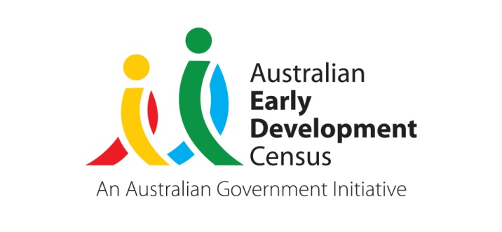 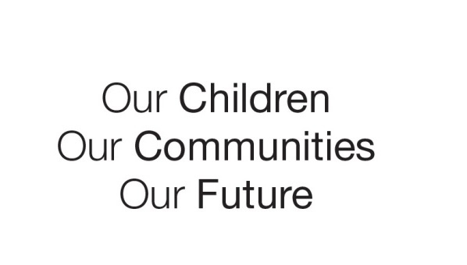

Australian Early Development Census

Southside Initiative

Australian Capital Territory 2023

About Canberra’s South

The Australian Early Development Census (AEDC) is a national measure of early childhood development. It measures 5 key areas, referred to as domains, when a child starts school. The domains are physical health and wellbeing; social competence; emotional maturity; language and cognitive skills (school-based); and communication skills and general knowledge.

Southern Canberra is a large area that incorporates the AEDC communities (ACT regions) Molonglo, South Canberra, Woden, Weston Creek and Tuggeranong.

Of the Southern Canberra regions, all except Tuggeranong have a lower percentage of children developmentally vulnerable on one or more domain(s) than the ACT average of 26.7%. However, all Southern Canberra regions except for Weston Creek have a higher percentage of children developmentally vulnerable on one or more domain(s) than the national average of 22.0%.

**Developmental vulnerability on one or more domain(s) in South Canberra regions, 2021** (%)

|  |  |  |  |  |  |  |
| --- | --- | --- | --- | --- | --- | --- |
| **Molonglo** | **South Canberra** | **Tuggeranong** | **Weston Creek** | **Woden** | **ACT** | **Australia** |
| 26.1 | 25.8 | 30.1 | 20.0 | 22.7 | 26.7 | 22.0 |

In Canberra’s south, Tuggeranong is notably the region with the highest level of need. It is an established area of Canberra, with the number of children in their first year of school remaining stable across recent AEDC cycles. Of the 1,178 Tuggeranong children included in the 2021 AEDC cycle, 4.2% identify as Aboriginal and/or Torres Strait Islander, while 17.7% had a language background other than English (LBOTE). In this cohort there were 52.7% male and 47.3% female children.

Similarly, to the ACT, the vast majority (98.2%) of Tuggeranong children attended preschool in the year prior to school. Kindergarten teachers reported that most children in Tuggeranong (96.3%) were adapting well to school and had parents that actively engaged in supporting their child’s learning (93.3%).

The majority of children in Canberra’s south were regularly read to and encouraged in their reading. However, Molonglo and Tuggeranong, both in Canberra’s south had the lowest measured encouragement and home reading across all ACT regions, (84.6% and 86.2% respectively). Molonglo also has the highest percentage of children from a Language Background other than English of all the Canberra regions (48.9%), representing almost 1 in 2 children.

What did the results show?

Of the regions of Southern Canberra, Tuggeranong in particular displays a high level and increasing trend of developmental vulnerability. In 2021, Tuggeranong was the ACT region with the second highest percentage of children developmentally vulnerable on one or more domain(s) (30.1% or 339 children), and with the second highest percentage of children developmentally vulnerable on two or more domains (14.9% or 168). Tuggeranong had the second lowest percentage of children on track on five domains (44.7% or 504) of all the ACT regions. When comparing Tuggeranong AEDC results from 2018 to 2021, the percentage of children developmentally vulnerable on one or more domain(s) increased significantly from 27.0% to 30.1%; developmentally vulnerable on two or more domains increased from 13.9% to 14.9%; and developmentally on track on five domains reduced significantly from 47.6% to 44.7%. These emerging trends highlight an increasing need for early childhood development supports in the Tuggeranong region.

When compared to the ACT average in 2021, Tuggeranong displayed a higher percentage of children developmentally vulnerable across all AEDC domains. Significant increases between 2018 and 2021 were evident in the percentage of Tuggeranong children developmentally vulnerable in the social competence and emotional maturity domains, and the communication skills and general knowledge domain. The results indicate a rising need for initiatives to support these developmental areas for the children of Tuggeranong.

Between 2018 to 2021, the percentage of children developmentally on track on five domains reduced significantly in the Southern Canberra regions of Weston Creek and Woden from 62.7% to 56.1% and 54.3% to 50.4% respectively. This shows a lower percentage of children developing well across all domains in these Southern Canberra regions over time.

Conversely there were some encouraging trends between 2018 and 2021 in Southern Canberra, with a decrease in the percentage of children developmentally vulnerable on two or more domains in South Canberra (from 15.9% to 11.3%) and an increase in the percentage of children on track on five domains in Molonglo (from 43.8% to 52.8%).

Bringing about change

After the 2021 AEDC results were released the ACT Community Services Directorate (CSD) held a series of AEDC regional forums focused on sharing the 2021 results for specific areas of Canberra with local stakeholders from education, early childhood education and care, community organisations and government. CSD partnered with local Regional Network Coordinators to deliver the forums, which were well attended and a valuable opportunity for stakeholders to hear about the results for their region as well as form connections across services and sectors.

As a result of the southern Canberra forums involving Tuggeranong, Woden, Weston Creek, South Canberra and Molonglo a working group named the Southside Initiative was formed by a number of interested and motivated key stakeholders. The Southside Initiative was developed by Woden Community Service, YWCA Canberra, Community Services #1, and Communities at Work, with the aim of bringing together stakeholders from across the southside of Canberra to collaborate in developing and trialling community-based activities aimed at improving life outcomes for children 0-8 years and their families.

Achievements

Southside Initiative Forum

The Southside Initiative offers an in-person forum once a term to provide participants an opportunity to hear from various speakers about relevant early years topics including initiatives of ACT Government, schools using AEDC results to address community needs, ACT’s AEDC coordinator, local services and entrepreneurs aimed to improve the wellbeing and development of children. The forums target sectors and themes each quarter and promote the sharing of support opportunities for southside families amongst members networks.

Parent and Carer Course Directory

As a result of the needs expressed at the forums, the Southside Initiative collated a list of Parent and Carer Courses and Family Support Services into an online directory. Updated each term, this provides easy and centralised access to see what Parent and Carer Courses and Family Support Services are on offer.

Parent education and support

One consistent issue raised at forums was long waitlists and the shortage of allied health professionals, an experience felt across Australia. Southside Initiative offered two programs to address this identified need.

Look Who’s Talking program is an early literacy program for parents to teach them how to encourage their children's language development from 0 – 4 years. This program was developed by a Speech Pathologist and Play Therapist/Early Educator for the Tasmanian Department of Education. The Southside Initiative provided free facilitator training to enable community organisations to run the 8 week Look Who’s Talking program to parents. EACH, the NDIS partner delivering the Early Childhood Approach in the ACT, is using this program to address developmental concerns, as well as hosting a community of practice for facilitators.

The Southside Initiative partnered with ACT Playgroups and an NDIS provider to run drop in Loose Parts playgroups in Woden Westfield shopping centre. An allied health professional is available for parents who have concerns about their child’s development. There is no booking required, providing an easy, friendly way for parents to talk to a professional and get warm referrals to community and government services.

Capacity Building of Teachers and Early Childhood Educators

Marymead Catholic Care Group (MCCG) have been running Circles of Security (COS) in Canberra for over 16 years. The Southside Initiative is working with MCCG to bring COS Classroom to Canberra through pilots in an early childhood school and ECECs. COS C teaches participants the central role relationship plays in early learning and how to respond to children’s behaviours in ways that enhance security in the relationship. Early feedback indicates that this training is useful in the early childhood sector.

Website

The Southside Initiative now has a webpage within The Healthy Schools Network ACT website which it uses as a platform to promote its activities and provide relevant information to stakeholders. [Southside Initiative - Healthy Schools Network ACT (healthyschoolsact.com.au)](https://www.healthyschoolsact.com.au/southside-initiative).

Looking ahead

An Inaugural Early Years Community of Practice was held in north Canberra lead by a partnership between A Village for Every Child, Canberra Region Community Service (CRCS) and the ACT Government including AEDC. Southside Initiative is exploring a duplicate opportunity for southside services and schools. Southside Initiative is seeking to support facilitator training of COS C for the community sector, improving access to allied health professionals and advocating for increased co-location of services across the ACT. With the success of Woden Westfield Loose Parts playgroup plans are underway to offer a Loose Parts Playgroup in the Tuggeranong shopping centre, addressing the AEDC identified needs in Tuggeranong.

For more information contact

ACT AEDC Coordinator

Phone: 02 620​5 ​3542  
Email: aedc@act.gov.au  
Web:  <https://www.communityservices.act.gov.au/ocyfs/children/australian-early-development-census>