 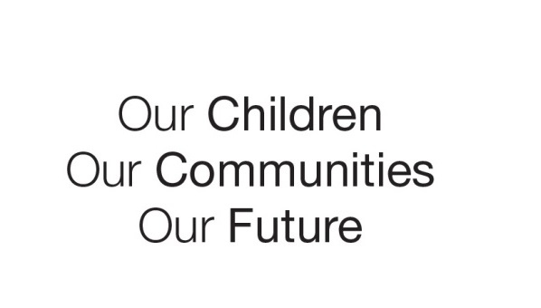

Australian Early Development Census

Deception Bay AEDC Community Story

Queensland 2021

A collaborative community working together to improve early childhood outcomes

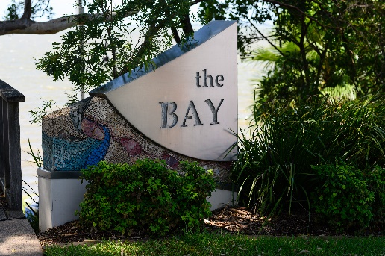About the Deception Bay community

The coastal community of Deception Bay is located in the Moreton Bay region, approximately 32 kilometres north of Brisbane. Deception Bay has a population of 23,214 people as at 2018 ([ABS](https://itt.abs.gov.au/itt/r.jsp?RegionSummary&region=313041373&dataset=ABS_REGIONAL_ASGS2016&geoconcept=ASGS_2016&measure=MEASURE&datasetASGS=ABS_REGIONAL_ASGS2016&datasetLGA=ABS_REGIONAL_LGA2018&regionLGA=LGA_2018&regionASGS=ASGS_2016)) and experiences some transience with neighbouring communities of Morayfield and Caboolture. A number of agencies and services exist within the Deception Bay community with a focus on supporting children and families in the early years.

What did the data show?

The Deception Bay community faces a number of challenges, such as access to housing and employment. In addition to this, demographic data suggests that additional risk factors that may impact child development exist within the community. Data from the Australian Early Development Census (AEDC) shows that the level of developmental vulnerability has decreased significantly across all four AEDC cycles, from 2009 to 2018. In 2009, the AEDC results for the Deception Bay community showed 42.7% of children were developmentally vulnerable on one or more domain, this decreased to 31.9% of children developmentally vulnerable on one or more domain in 2018.

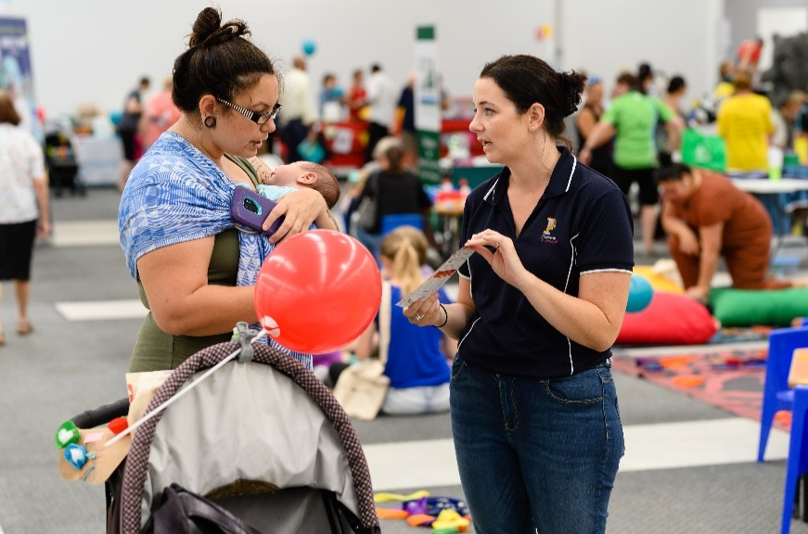Bringing about change

Over time the Deception Bay community has implemented many programs and initiatives in order to connect with families to provide support and improve outcomes for children in the early years. In 2005, the Deception Bay Communities for Children (CfC) program, a federally funded place-based initiative, was established to support the development of children from 0-12 years of age. The CfC initiative aims to build the capacity of local services in order to meet the needs of families in the Deception Bay community and to coordinate the efforts of these services. To date, this has involved mapping services across the community, linking families to appropriate support and developing a strategic plan for the community. The parent and family voice and relevant community data, including AEDC data assisted in determining priorities for the Deception Bay community.

The Deception Bay CfC program values a co-design approach and has developed several projects and programs that have been designed with community voice integral. The CfC program collaborates with agencies and organisations across the community and broader region, an example being the Child and Family Alliance (approximately 430 attendees from over 70 organisations), and contributes to both the Health Alliance (partnership with Children Health Queensland, feeding back to Caboolture Children’s Hospital) and the Moreton Bay Children’s Partnership.

The Deception Bay Schools Group, formed in 2010, has a focus on relationships, collaboration and sharing of quality practice across schools in the Deception Bay community. Alongside the Deception Bay Schools Group, the Hand in Hand Network was established with a key focus on considering AEDC data in planning and practice. The Hand in Hand Network focuses on family engagement, improved communication, and coordination of services between family support, early childhood services and schools. A range of professional development programs for staff have been delivered and the network utilises social media channels to provide information to parents and carers about local workshops and community activities.

A collaborative community approach and valuing the local parent and family voice to determine needs, contributed to an increase in evidence-based programs implemented over time. Many community service providers reflected that this approach led to a shared language, professional focus and commitment to a method of practice across Deception Bay. The Child and Family Alliance along with the Community of Practice, have organised community development sessions and train new practitioners entering the community. This has driven continued momentum and sustained action in the Deception Bay community, allowing for continuity of personnel, partnerships and increased capacity building across services and organisations.

Achievements and partnerships

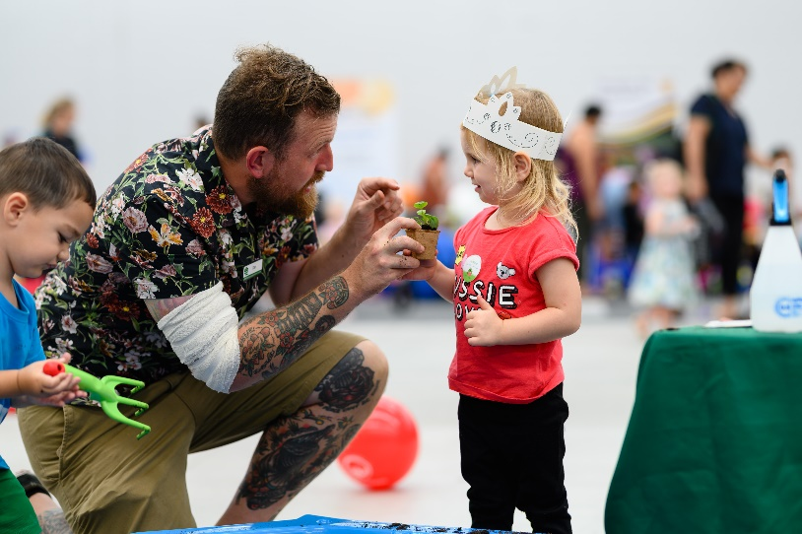Deception Bay community attribute the shift in AEDC data to working collaboratively and building strong partnerships across various agencies and services. This has led to a number of programs and initiatives being implemented in the community to support families while also improving exposure for services and agencies. The Deception Bay CfC program has built a strong relationship with Market Square Shopping Centre. This relationship began in 2011 with the shopping centre agreeing to host Young Parents’ morning tea, school holiday activity programs, and community events. In early 2019 CfC partners worked with shopping centre management to establish a community drop-in centre in a vacant shop space with a weekly schedule of programs with play-based and family support activities. Community partners have stated that regularly being in a public space builds familiarity and trust between services and families, this helps build and strengthen personal relationships.

The Community of Practice group, which includes four CfC partners, also takes an outreach approach, going to Deception Bay caravan parks to support families experiencing high levels of vulnerability. This involves a fortnightly barbeque in order to engage with families, along with activities and sessions that focus on assisting parents with practical support such as enrolling children in kindergarten or school and connecting families with financial assistance.

Outreaching services and events are considered a key opportunity to engage families. Settings are selected with this in mind, going to where families are already naturally gathering where possible. Non-threatening, soft entry activities have been successful in engaging families gently. One example is the Under 5’s Day, a successful event, boasting exceptional attendance by community services as well as families. Along with providing a fun day out and activities for children, this event is a welcome opportunity for families to interact with various services and organisations within the Deception Bay community.

All state schools in Deception Bay host a playgroup in addition to the multiple other playgroups that run across the community in various settings and locations. Strong relationships with local council and police have been integral in supporting playgroups and various other activities in the community. The Dad’s Playgroup in the park is an example of this partnership working to improve the safety and accessibility of shared spaces in the community, where previously the park was not a safe or inviting place for children and families.

Looking ahead

The Deception Bay community has successfully shifted AEDC data in the right direction impacting a large number of children in the community. This shift is a testament to the wealth of knowledge and experience that exisits within the community and the willingness to share across agencies to work towards common goals. The success is evident in improved AEDC data results over a decade and reflected in anecdotal evidence from those living and working in the community. Taking a strengths-based approach and utilising evidence-informed practice across various programs and initiatives has provided families with much needed support at the right place and time, improving their ability to give their children the best start.

The strong relationships developed with government and non-government agencies, services and organisations have helped this community to change policies and practices designed to address equity, access and safety for families. The ability to collaborate as a community and consistently reflect, reframe and strengthen practice has been very successful. Fundamental to this approach was the knowledge that while initiatives come and go, the value of the work is in continually building on the learnings from developing and implementing approaches together. The community prides itself on strong relationships and connections, which are assisted by various forms of leadership exisiting within and across organisations. Deception Bay continues to be a solution focussed community which is, as voiced by many community members – a lovely community to live and work in.

For more information contact

Madeline Hagon

State Coordinator, AEDC

Department of Education

Queensland Government

[aedc@qed.qld.gov.au](mailto:aedc@qed.qld.gov.au)

[www.aedc.gov.au](http://www.aedc.gov.au)