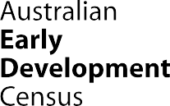

Our Children
Our Communities
Our Future

A Good Start to Life Belconnen

Australian Capital Territory 2025
About the Belconnen region in Canberra

The Australian Early Development Census (AEDC) is a national measure of early childhood development of children in their first year of full-time school. The AEDC collects data across 5 domains: physical health and wellbeing; social competence; emotional maturity; language and cognitive skills (school-based); and communication skills and general knowledge.
Belconnen in Canberra’s northwest is largely an established area including 26 suburbs. In the 2024 AEDC cycle, 1,158 children lived in Belconnen. Of these:
- 4.8% identified as Aboriginal and Torres Strait Islander children, higher than the ACT average of 3.7%.
- 29.4% had a Language Background Other than English, lower than the ACT average of 33.4%.
- Most children in Belconnen had strong early learning foundations:
- 97.9% attended preschool in the year prior to school.
- 95.8% were reported by teachers as adapting well to school.
- 94.5% had parents actively engaged in their learning.
- 85.3% were read to at home.

What did the 2024 results show?

In 2024, 30.1% of Belconnen children were developmentally vulnerable on one or more domains. This is a small improvement from 30.5% in 2021; however, the rate remains higher than both the ACT (28.1%) and national (23.5%) results.
The proportion of Belconnen children developmentally vulnerable on 2 or more domains was 15.6%, a small improvement from 16.7% in 2021. The rate also remains above ACT (14.9%) and national (12.5%) results.
In 2024, 40.2% of Belconnen children were developmentally on track across all 5 domains, remaining one of the lowest of the ACT regions. This figure is below the ACT average of 43.8% and well below the national average of 52.9%.
The results suggest Belconnen faces ongoing developmental challenges, reinforcing the need for coordinated, place-based strategies to support children’s wellbeing and early learning across the community.

Bringing about positive change

The AEDC played a pivotal role in the ‘Good Start in Life for Young Children’ research project (2019-2023) at the Health Research Institute, University of Canberra. Funded by the Medical Research Future Fund (MRFF), this project aimed to develop a program of support and connection for children (from birth to 5 years) and their families in the Belconnen community to address early childhood development.
Using AEDC data and trends from 2015 to 2018, the project identified 9 suburbs in the Belconnen District where early childhood development risk was highest (Aranda, Bruce, Charnwood, Evatt, Fraser, Hawker, Latham, McKellar and Scullin). These 9 ‘intervention’ suburbs were matched in a quasi-study design with comparator ‘control’ suburbs in Tuggeranong where there was also an increase in childhood developmental vulnerability over this time.
From 2019 to 2023 the Health Research Institute delivered and evaluated an Allied Health Outreach childhood development service (speech pathology and occupational therapy) across the 9 intervention suburbs for children from birth to 5 years. The service was delivered in a range of settings including community playgroups, public places such as the local Belconnen Westfield Shopping Centre, parks, early childhood education centres (ECECs), and school-based preschools (See Figure 1). The Allied Health Outreach service focused on the early detection of child developmental issues, family liaison and signposting and referral to appropriate supports. The service included inter-professional training to build capability of childhood educators to identify and address developmental needs.
Figure 1 – Good Start Allied Health Outreach Model
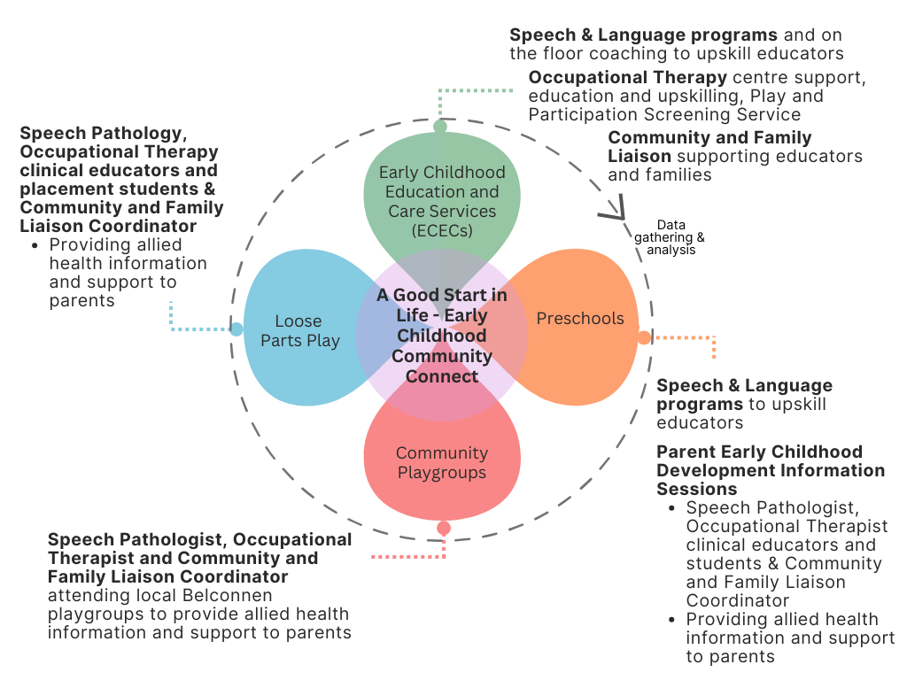

Achievements

The project delivered 7,273 occasions of service across 13 ECECs, 5 school-based preschools and 12 community locations (e.g., playgroups). This equates to around 1,649 hours of support and services. The Allied Health Outreach service was delivered to approximately 55% of the target population from 2019 to 2023 (note that the program was paused for 12 months during COVID 2020-2021).
AEDC census results from 2018 to 2024 shows a statistically significant improvement in child development outcomes in the Belconnen intervention suburbs. There was a 7.0% reduction in children identified as developmentally vulnerable on one or more domains, dropping from 36.8% in 2018 to 29.8% in 2024 (See Figure 2 and Table 1).

A Good Start to Life Belconnen
www.aedc.gov.au
Figure 2 – Percentage of children developmentally vulnerable on one or more AEDC domains

Table 1 – Percentage of children developmentally vulnerable on one or more domain 2018 to 2024

Developmentally vulnerable on one or more domain |  |  | Change
 | 2018 | 2024 | 2018 to 2024
Belconnen intervention suburbs | 36.8% | 29.8% | ↓ 7%**
Tuggeranong control suburbs | 37.3% | 33.2% | ↓ 4.1%

**Significant ‘critical difference’ (Gregory T & Brinkman S, 2016)

There was a 4.6% reduction in children in the Belconnen intervention suburbs identified as developmentally vulnerable on 2 or more domains, dropping from 21.1% in 2018 to 16.6% in 2024 (Figure 3).
Figure 3 – Percentage of children developmentally vulnerable on two or more AEDC domains

Between 2021 (36.1%) and 2024 (37.6%), the Belconnen intervention suburbs saw a small increase in the percentage of children developmentally on track across all 5 AEDC domains. In contrast, the Tuggeranong control group, Belconnen region, and the ACT experienced a decline in children being developmentally on track across all 5 domains (Figure 4).
Figure 4 – Percentage of children developmentally on track on five AEDC domains

Looking Ahead

Findings from the Allied Health Outreach service suggest this model of embedded and ongoing support and capacity building for educators, children and families is an effective strategy for mitigating the risk of developmental vulnerability in preschool aged children.
The study highlights the critical role of collaborative partnerships, led by Allied Health services, that deliver intervention services that enhance educational practices and support child development within early childhood settings. This approach helped increase early childhood educator skills and knowledge, enhance children’s language, increase parents’ knowledge of service providers and supports, and promote inclusive educational practices in the community.
Looking ahead, sustained efforts in research, advocacy, early childhood educator coaching, and community stakeholder engagement are essential to maximise the impact of integrated allied health outreach services in promoting equitable developmental outcomes for all children.


Since 2002, the Australian Government has worked in partnership with eminent child health research institutes, the Centre for Community Child Health at The Royal Children’s Hospital and the Murdoch Children’s Research Institute, and The Kids Research Institute Australia to deliver the Australian Early Development Census program to communities nationwide. The Australian Government continues to work with its partners and with state and territory governments to implement the AEDC.
For more information see Resource name or visit the AEDC website

