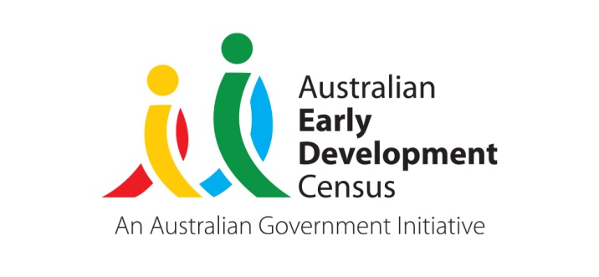 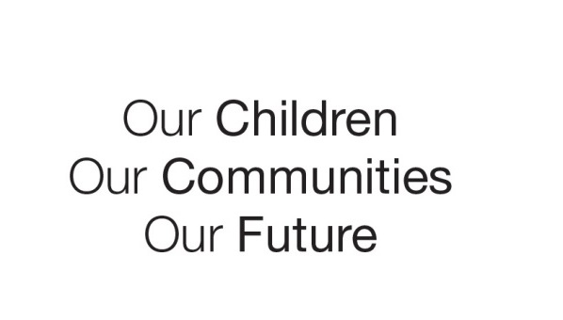

Australian Early Development Census

Jondaryan AEDC Community Story

Queensland 2021

**Building partnerships and providing outreach to support all families across the community**

About the Jondaryan community

The Jondaryan community is made up of the rural town of Oakey and its south-east and western surrounding areas, including townships such as Jondaryan, Biddeston, Mount Tyson, Linthorpe, Purrwaunda, Mount Irving, Westbrook, Wellcamp, Cotswold Hills and Umbiram. The community has a population of 7,585 people as at 2018 (ABS) and experiences transience between Oakey and the regional city of Toowoomba due to the close proximity of these locations. The main employment opportunities within this community are in agriculture, meatworks, coal mining operations and the Department of Defence.

What did the data show?

The Jondaryan community has faced a number of challenges over time, such as uncertain employment and redundancies in relation to mine extension approval, water contamination issues caused by firefighting foam, and variations in real estate value. There is also limited access to supports and services such as child care and health services, particularly in rural and remote areas of the community. Data from the Australian Early Development Census (AEDC) demonstrates that although these complex community factors exist, the level of developmental vulnerability for children has decreased consistently since 2009. Jondaryan community 2009 AEDC data showed 44.7% of children were developmentally vulnerable on one or more domain; however, this decreased to 28.3% in 2018, almost halving the rate over the past decade.

Bringing about change

Over the years, a number of programs and initiatives have been implemented across the Jondaryan community to connect with families and provide them with appropriate supports. Schools, early childhood services, council and health services have all been key players in these initiatives spanning early education, parenting and health.

Early education

Playgroups have a strong presence in the Jondaryan community. Various community organisations and agencies, such as Jondaryan State School, Mount Tyson State School and Goolburri Aboriginal Health Advancement Company facilitate the sessions. These services encourage parents and children to connect, play and learn. Oakey is a location that has attracted the establishment of several playgroups, including a targeted Aboriginal and Torres Strait Islander playgroup.

Parenting programs

Oakey Library, run by Toowoomba Regional Council, is well-established and runs a number of programs for families and children. Programs and sessions are adapted to cater to the age groups of families in attendance and ensure they are relevant. As part of the State Library’s First 5 Forever program, Oakey Library has a strong focus on parent messaging and continued learning at home. The library also provides access to information about community services to connect Oakey residents of all ages to relevant support services. Having a community service focus and complementing what is happening in the community is an important role of the library.

Health services

Several health services operate across the Jondaryan community and offer a variety of programs and support services to meet the needs of families. Goolburri Aboriginal Health Advancement Company has operated in Toowoomba for over 23 years. Goolburri offers health services to families of all cultural identities living in and around Toowoomba. Three key programs are offered to families with children in the early years. The Home Interaction Program for Parents and Youngsters (HIPPY) is an at home parent support program that promotes family interaction and parent engagement in their child’s education. Targeted to Aboriginal and Torres Strait Islander families the Bunji Burri to Gunadoos service provides parents with culturally appropriate antenatal and postnatal care. Goolburri also runs a playgroup with an emphasis on social engagement for parents.

Goondir Health Services began operating in Oakey in 2014. They provide health services for Indigenous and non-Indigenous families including consults with a doctor, yearly Aboriginal and Torres Strait Islander Health Checks, covering aspects of medical, social, family and education, and referrals to specialists as required. Goondir also offers telehealth services to provide specialist advice and give families living in rural and remote areas access to the same level of care as those living in larger towns or cities.

The Child Health Service, Oakey Hospital, offers a clinic for Mums and Babies as well as a home visiting service. Outreach clinics operate in smaller, more isolated areas surrounding Oakey, providing access to those living in rural and remote areas. Strong communication channels exist with Toowoomba hospital, which ensures the Child Health Service is notified of all new births in the area. The Community Health Nurse in Oakey sits on the Wellness Group, which is an initiative of the Oakey Community Care Group. This group has received significant financial investment since 2017–18 to develop community initiatives that promote health and wellbeing with a focus on social inclusion and engagement.

Achievements and partnerships

The community attributes improvements in the AEDC data to having a whole community focus and shifting perspectives to ensure services are providing supports for children and families when they are needed. The formation of partnerships has built on the strong service network, enabling collaboration between these services and agencies. This has resulted in the development of shared, inclusive practices that better support families. Importantly, key partnerships have been established within education networks.

Oakey State School participated in the Department of Education’s Step up into education 2017–2020 initiative. The initiative focused on supporting children’s transition to school and building ongoing relationships with early childhood services, parents and the wider community. Through this initiative the school established connections, partnerships and networks with various services and agencies across the community. A key network was the Oakey Early Years Network (a partnership with the council and St Monica’s Primary School).

The Oakey Early Years Network includes state and Catholic primary schools, various early childhood services, playgroup, library and Goondir Health Services. The network has a focus on establishing relationships with children and families prior to children attending school, as well as understanding how to best support them when they are transitioning into an early childhood service or school. Since the establishment of the network, there has been an increase in opportunities for sharing across organisations, particularly between schools and early childhood services, as well as an improvement in transition practices and the establishment of events to better reach children and families in the community. The network also established a partnership between Goondir and Vision Australia who are now working with schools in Oakey to offer free health checks for students.

St Monica’s Primary School and Oakey State School have a strong collaborative relationship within and outside of the Oakey Early Years Network. The schools share a common goal to work together to improve outcomes for all children in the local Oakey community. The schools co-host a combined Under 8’s day each year, which is held alternately at each school and involves other key partners such as the library and early childhood services. This culture of sharing and collaboration across the two schools has also extended into the respective high schools. Run by the council, the Oakey Local Level Alliance (LLA) involves police, schools, health services and various community organisations. The LLA has a whole-of-community focus and utilises the AEDC in planning to support youth in the local community. The group invests in connecting organisations and supporting collaborative work across the local community. As a result of the work of the LLA, the council and schools have formed strong partnerships, which has allowed for targeted support to families.

Looking ahead

Having an inclusive and collaborative approach has assisted the Jondaryan community to improve outcomes for children and families. Providing outreach services to families living in rural and remote areas, ensures geographically isolated families can access the supports they require and receive the same level of care as those living in larger towns and cities.

Success seen in the positive shift in AEDC data has been attributed to the drive of the community to work together, a focus on supporting children in the community, and understanding and valuing the importance of the early years. Engaging informally and developing connections and relationships with children and families early has helped to provide support and build trust. The community aims to add value, share practices and maintain consistent messaging in order to support families and empower them to provide their children with the tools they need to succeed in the future.

For more information contact

Madeline Hagon

State Coordinator, AEDC

Department of Education

Queensland Government

[aedc@qed.qld.gov.au](mailto:aedc@qed.qld.gov.au)

[www.aedc.gov.au](http://www.aedc.gov.au)