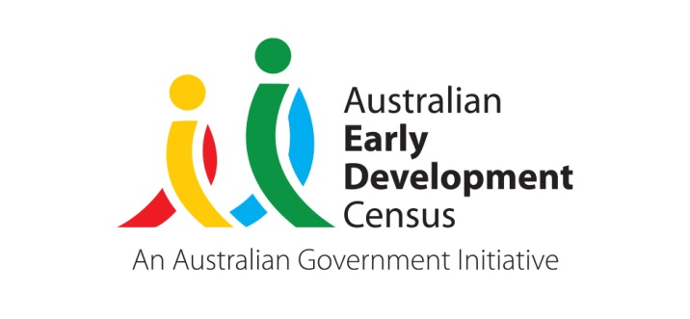 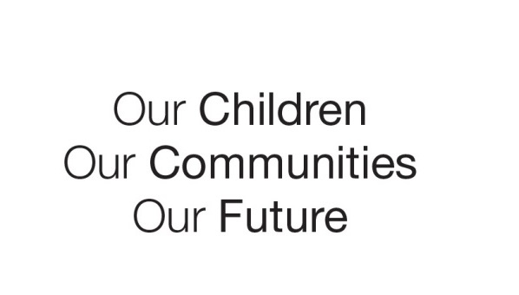

Australian Early Development Census

Community story

Breaking barriers

Kurri Kurri

NSW 2014

Setting the pace for improved physical health

About Kurri Kurri

Kurri Kurri is a small rural town surrounded by wineries and former coal mines in the Hunter Region, about 150 kms north of Sydney. It has almost 6000 residents. The town is part of the Cessnock local government area and it has high levels of socio-economic disadvantage (ABS Socio-Economic Index for Areas 2011).

What did the results show?

The Australian Early Development Census (AEDC) is a national measure of child development. It measures five key areas or domains when a child starts full-time school. The domains are: physical health and wellbeing; social competence; emotional maturity; language and cognitive skills (school-based); communication skills and general knowledge.

The 2009 results for Kurri Kurri and surrounds showed 18.5 per cent of children vulnerable on one or more domains, with 11.1 per cent of children in their first year of full-time school assessed as developmentally vulnerable in the physical health and wellbeing domain. By 2012, Kurri Kurri’s results in the physical health and wellbeing domain had improved significantly, with results showing that 4 per cent of children were developmentally vulnerable.

Overall, the 2012 results revealed 17.2 per cent of children were developmentally vulnerable on one or more domains – an improvement compared with the town’s 2009 results.

Bringing about change

In 2008, staff at the Kurri Kurri & District Preschool Kindergarten noticed a recent trend – that many more local children were starting preschool with poorly developed fine motor and gross motor skills. The town’s 2009 results confirmed their observations. Meanwhile Ms Jannelle Gallagher, the preschool’s Director had been working with the Hunter New England Health Service to develop a physical activity program to address the concerns.

The new program was called *I Move, We Move*. In 2010 it was rolled out to every preschool and early childhood service in the upper Hunter region via a series of workshops delivered by Ms Gallagher and the health service. “We’re trying to break down the barriers between education and health services,” Ms Gallagher said. “We’re engaging in conversations with our local hospitals, speech therapists and other health professionals, so that we’re all working together and what we do follows on when those children go through to full-time school.”

## Kurri Kurri preschool then used the results and other data to successfully apply for a grant to employ an occupational therapist at the preschool. The therapist devised fun activities to strengthen children’s physical skills. The initiative has been highly effective. Children’s motor skills have improved and staff have benefitted from the mentoring and skill development provided by the occupational therapist.

Partnerships

Kurri Kurri preschool’s occupational therapist has delivered presentations about the program to health sector conferences. The preschool has also invited paediatricians, GPs and other health professionals to community meetings to discuss child development issues.

It is also involved in a local network of early childhood services, including childcare centres and primary schools. The network members meet once every school term to discuss ways to strengthen programs for children.

The preschool is also embarking on changes to improve Kurri Kurri’s 2012 result for the domain of communication skills and general knowledge, in which 8.1 per cent of the town’s children were shown to be developmentally vulnerable. It is working on a research project with Newcastle University to enhance the questioning and critical thinking skills of children.

Teachers are focusing on extending children’s vocabulary, conversation and observational skills in the preschool’s programs and activities. “When we go on a walk to the shops we ask the children to look at the buildings, we ask them what might be happening inside the buildings, how it might have got there. By asking them to think and question, a lot of learning goes on,” Ms Gallagher said.

Achievements

The preschool was recently rated by the Australian Government’s National Quality Framework as exceeding national quality standards in all areas assessed under the national standards system. Ms Gallagher said the preschool’s use of the data to enhance its programs was one of the factors that helped it achieve the rating.

She said she and other early childhood and health professionals in Kurri Kurri believed that their decision to implement the *I Move, We Move* program and other initiatives had helped contribute to the town’s improved 2012 results in the physical health and wellbeing domain.

For more information contact

Jannelle Gallagher, Kurri Kurri & District Preschool Kindergarten

Email: [kurripreschool@bigpond.com](mailto:kurripreschool@bigpond.com)

|  |
| --- |
| *“The AEDC informs what we are doing. It makes us think about how we can extend the children’s learning and challenge them further.”*  Jannelle Gallagher, Teaching Director, Kurri Kurri & District Preschool Kindergarten |