 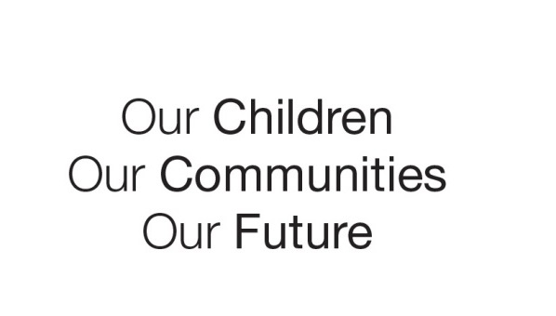

Australian Early Development Census

Community story

AEDC in action – Families as First Teachers

Remote communities

NT 2014

Simple ways to lift learning for Indigenous children

About Families as First Teachers

In 2009 the Northern Territory government launched a program called Families as First Teachers (FaFT) an early childhood and family support initiative for remote Indigenous communities across the Northern Territory. The program, delivered in schools by the Territory’s Department of Education, provided early learning playgroups and parenting programs on child development and health to enhance children’s early learning and prepare children for successful entry to full-time school. Early childhood professionals, and local Indigenous family liaison officers and playgroup leaders, deliver the programs to families.

By 2010, the initiative had been established in 21 remote communities. The quality, consistency and delivery of the programs varied widely between each remote community, according to evaluations by the Northern Territory Department of Education.

“As participation in FaFT grew, we could see we needed a more explicit tool to enhance interactions between parents and children and provide a more consistent, high quality early learning approach,” said Ms Averill Piers-Blundell, director of the department’s early childhood programs.

What did the results show?

The Australian Early Development Census (AEDC) is a national measure of child development. It measures five key areas or domains when a child starts full-time school. The domains are: physical health and wellbeing; social competence; emotional maturity; language and cognitive skills (school-based) and communication skills and general knowledge.

In 2009, the results for Indigenous children starting full-time school in the Territory’s very remote communities revealed a very high proportion of children vulnerable in one or more domain. The FaFT programs were established in these communities soon afterwards, giving the Department of Education a broad comparison point from which to measure the policy’s impact in the communities.

Bringing about change

In 2010, Professor Joe Sparling, a child development expert from the United States, was a guest speaker at an education conference in Alice Springs. The Northern Territory government invited Professor Sparling to work with it to adapt his internationally famous approach to early learning called the Abecedarian Approach. “Abecedarian” means the learning and teaching of something basic – as in “A-B-C-darian”. It has four key pillars: language priority, learning games, conversational reading and enriched care-giving.

Professor Sparling worked in the Territory’s remote communities and tailored the Abecedarian approach to suit the needs of Indigenous families. The new version is called 3A – Abecedarian Approach Australia. It has been embedded into the FaFT program as a practical strategy for FaFT staff to use in their remote communities. More than 80 FaFT staff received Department of Education training on how to use 3A. It includes:

* The Conversational Reading (See, Show, Say) strategy - an interactive approach to using books with very young children to support their language development.
* LearningGames®. This is a series of adult child interactions to promote quality early learning experiences. A NT version of the 200 games has been produced, using photos and simple English text to guide parents or care-givers to use with children aged 0-5 years.
* Language Priority acknowledges the pivotal role of language in the young child’s development and encourages adults to use language with children with intention. Notice, Nudge, Narrate provides a strategy for adults to surround spontaneous events with rich language.
* The fourth element, enriched care giving, has yet to be implemented in the Northern Territory.
* In 2013, about 2160 children and 2030 adults in remote communities took part in the 3A programme.

Achievements

Since FaFT has been operating, the proportion of Indigenous children in very remote communities assessed as developmentally vulnerable in one or more domains has fallen by 5.7 per cent, according to the Department of Education’s analysis of the 2012 results.

Significant improvements have been recorded in children’s social competence, emotional maturity, language and cognitive skills, communication skills and general knowledge.

A 2012 survey of school principals from many remote schools revealed children entering the classroom were better prepared than those in previous years. Many of the schools also recorded an initial spike in Indigenous student enrolments and attendance. Anecdotal evidence from preschool teachers about the 3A programme suggests it is already producing marked improvements in children’s early literacy skills, learning behaviours and general school readiness.

Looking ahead

The Territory’s education department has partnered with the University of Melbourne to evaluate FaFT and 3A’s effectiveness over the next three years. The research project has been funded by an Australian Research Council grant.

The Department of Education will share the FaFT and 3A resource materials, free of charge, with other states and non-government organisations that offer non-profit services to Indigenous children, Ms Piers-Blundell said. The Department is developing a secure website to enable government departments and non-profit organisations to have online access to the material.

For more information contact

NT AEDC Coordinator │ Phone: 08 899 93514 │ Email: earlychild.det@nt.gov.au

|  |
| --- |
| *”The beauty of the 3A programme is that it’s really simple and you don’t need to be literate yourself to use it and help your child learn.”*  **Averill Piers-Blundell, the Department of Education’s director of early childhood programmes.** |