 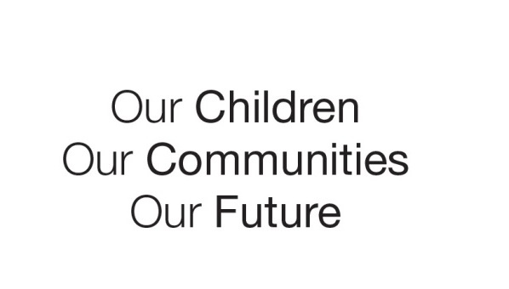

Australian Early Development Census

School story

Longreach State School

QLD 2013

Primary School partners with kindergarten services to improve outcomes for children

About the community

The remote farming community of Longreach lies in central west Queensland. The r**esidential population is** 3,630 with 348 children aged 0 to 5 years. (ABS 2011)

What did the results show?

The Australian Early Development Census (AEDC) is a national measure of child development. It measures five key areas or domains when a child starts full-time school. The domains are: physical health and wellbeing; social competence; emotional maturity; language and cognitive skills (school-based); communication skills and general knowledge.

The 2012 results showed 5.1 per cent of children in the Longreach community were developmentally vulnerable in the domain of language and cognitive skills. This was a significant improvement in results when compared with the 2009 results which showed there were 19.4 per cent of children vulnerable in the domain.

Bringing about change

In response to the 2009 results and other early development assessments, the Longreach State School principal met with the town’s two kindergarten and child care services to discuss strategies to improve developmental outcomes for children.

An inaugural partnership agreement was made between all parties in 2012. Families were informed of the partnership through an information session and updates in regular newsletters.

Through the partnership educators agreed to share professional development opportunities and build a collegiate teachers network. They worked together to look at specific ways to introduce pre-literacy and pre-numeracy skills to help children in readiness for Prep, the first year of full-time schooling. Parents were also asked for their assistance and their input. The children were included in the partnership agreement by sharing their stories.

**Step into Prep challenges:**

* keep shoes and socks on all day
* be independent with lunch box
* when the bell rings – form two lines and walk together.

Achievements

Educators developed a range of initiatives and some of those implemented are described below.

‘Step into Prep’ was introduced to children in the final few weeks of kindergarten. This consisted of three challenges for children – wearing shoes and socks all day, bringing a lunch box with food ready to eat and knowing what to do when the bell rings. This helped children settle into Prep.

To gain family support and understanding, a letter was composed and signed by stakeholders of the partnership agreement to explain requests made of families around assisting children to become school ready.

Interactive whiteboards were purchased for kindergartens so they could share the same technology with the school.

Since the kindergarten services implemented the strategies:

* children have shown greater independence
* time taken to settle in to the school routine has reduced from one month to one week
* families have become more involved through information sharing and a library borrowing scheme which encourages reading at home
* families have an increased awareness of their child’s progress through the creation of a literacy and numeracy scrapbook which each child creates to include samples of their work at kindergarten and at home
* the principal reported children were more prepared and more at ease when they began school in 2013.

For more information contact

(07) 4652 6333.

Vicki Rayner, Principal, Longreach State School

|  |
| --- |
| *“Children could recite or sing the alphabet but many couldn’t recognise the letters out of order or didn’t know their sounds. We agreed in the partnership to include Jolly Phonics, a method of teaching children to recognise letters and know sounds”*  **Vicki Rayner, Principal, Longreach State School.** |