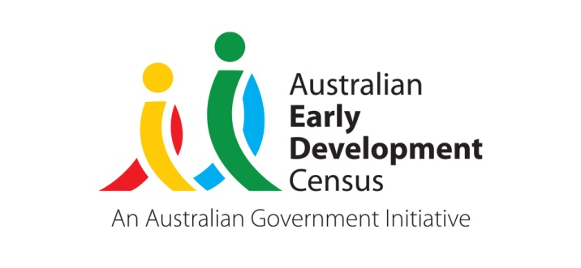 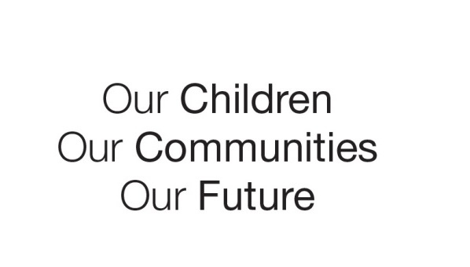

Australian Early Development Census

Community story

Mid Murray Family Connections

A collective of 60+ partners achieving improvement in children’s development

South Australia 2020

About the Mid Murray community

The Mid Murray Council is a local government area in South Australia. It covers 6,273 square kilometres from the Riverland through the Murraylands to the eastern slopes of the Mount Lofty Ranges. It has a population of 8,983 residents, with 792 children aged 0-9 years old (PHIDU Social Health Atlas of Australia, 2020).

The major employment in the region is linked to primary production (broad acre grains, livestock, horticulture, fruit, nuts and wine grapes), tourism and hospitality, health and community services, construction and building, education, light manufacturing and business services.

In 2016, the Socio-Economic Indexes for Areas (SEIFA) for Mid Murray Council area was 923, indicating a relatively high level of disadvantage compared to other regions in South Australia.

What the results showed

The Australian Early Development Census (AEDC) is a national measure of early childhood development at the time children commence their first year of full-time school. The AEDC collects data relating to five key areas of early childhood development referred to as ‘domains’. The domains are: physical health and wellbeing; social competence; emotional maturity; language and cognitive skills (school-based); communication skills and general knowledge.

The AEDC results for the Mid Murray community showed an increase in developmental vulnerability on 1 or more domains from 32.8% in 2009 to 43.2% in 2012.

Bringing about change

In response to the 2012 data, the Mid Murray Council led the formation of the [Mid Murray Family Connections (MMFC)](https://www.midmurrayfamilyconnections.com.au/about/)Collective Impact Initiative. MMFC is a network of government and non-government agencies, community groups, schools, businesses, and citizens living and working in the Mid Murray region, working together to improve the wellbeing of children in the area.

Since 2013, MMFC has worked with 60+ partner organisations to support children’s early learning development and wellbeing. Their work focuses on children from 0 to 8 years and their families, aiming to support children’s early years to promote better outcomes in their future. As the region covers such a large geographical area, individual working groups have been set up throughout the region to assist with identifying individual community needs and tailoring solutions.

MMFC focused their efforts towards targeting the emotional maturity AEDC domain to reduce the number of children classified as developmentally vulnerable in their first year of full-time schooling across the region, with the vision that the other domains would be impacted positively along the way.

The suite of services and programs put in place includes:

* delivering wellbeing and resilience courses
* providing infant and child mental health workshops
* connecting Child and Family Health Services to families and promoting developmental checks
* setting up new playgroup programs
* raising awareness of domestic violence and its impacts on families
* supporting literacy programs
* connecting families through social media via a support and information page
* advocating for services and assisting them to provide support within the region
* promoting maternal wellbeing
* providing a website where families can access valuable tools, resources and information relevant to the region
* connecting families and community through fun engaging events
* promoting the importance of play for learning and encouraging outdoor nature play activities for all families

In 2016, the [Community Accountability Plan](https://www.mid-murray.sa.gov.au/__data/assets/pdf_file/0031/168907/Community-Accountability-Plan.pdf) was launched. It reflects the commitment of the MMFC to support families so children are provided with the best start in life. This document guides the work of the MMFC Collective Impact initiative and has four focus areas:

1. Children and their caregivers share strong attachment (age conception – 2 years)
2. Children are emotionally resilient (ages 2 – 5 years)
3. Children are engaged learners (ages 5 – 8 years)
4. Children and their caregivers are safe and supported (age conception – 8 years and their families)

Achievements and partnerships

Following implementation of the MMFC Collective Impact initiative, the Mid Murray community AEDC results have improved. The community AEDC results show a significant decrease in developmental vulnerability on one or more domains from 40.60% in 2015 to 25.30% in 2018, and a significant decrease in developmental vulnerability on two or more domains from 18.8% in 2015 to 10.7% in 2018.

In 2017, MMFC was awarded the ‘National Association for Prevention of Child Abuse and Neglect’ (NAPCAN) Award for South Australia, with the theme “Play Your Part”. This was a recognition of all partners who have been working towards positive outcomes for children in the region.

In both 2018 and 2019, the MMFC was invited to present on the journey of the network at the National ChangeFest Place Based Collective Impact Conference.

In 2019, the MMFC Collective Impact initiative won the community Partnerships and Collaboration Award at the Local Government Professionals Australia - SA Annual Leadership Excellence Awards.

Looking ahead

The MMFC keeps working diligently to improve children’s wellbeing and development. A [MMFC website](https://www.midmurrayfamilyconnections.com.au/) is available as an easy to access resource for families across the region. It provides valuable information, tools, and a community services directory.

The [MMFC Community Accountability Plan](https://www.mid-murray.sa.gov.au/__data/assets/pdf_file/0031/168907/Community-Accountability-Plan.pdf) is a living document that outlines the framework for the network now and in the future. This Accountability Plan is currently being reviewed, to ensure that MMFC is continuing to work towards the aims and goals as set out in the plan and to evaluate and reflect on the progress that has been made, identifying any improvements that may be required.

The Mid Murray Council has supported the network and contributed to its success. Eventually, the network will be functioning independently without this backbone support and will continue strengthening forces with community partners.

In partnership with Baptist Care SA and Mannum Community Church the network has been exploring the possibility of establishing a family wellbeing centre within the region or building on existing supports. A number of partners have contributed funds towards completing a feasibility study and further discussions are being held with partners to decide on the future model.

For more information contact

Myléne Warman   
State Coordinator, AEDC

Department for Education  
South Australian Government

**Email:**[Education.AEDCTeam@sa.gov.au](mailto:Education.AEDCTeam@sa.gov.au)   
**Web:** [www.AEDC.gov.au](http://www.aedc.gov.au/)

|  |
| --- |
| *“Combatting the vulnerability rate for children in the region was a huge challenge as it was a multifaceted problem. There were concerns around health, mental wellbeing, physical activity, education and safety and all of these issues needed individual, tailored solutions.”*  Amy Loechel, Mid Murray Council’s community services director |