 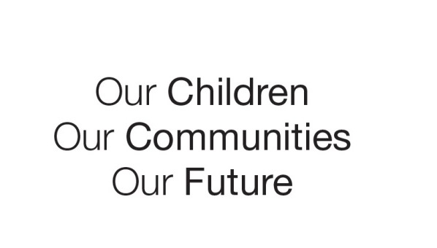

Australian Early Development Census

School Story

Portside Christian College

SA 5015

**“Learning is the key factor on which a new way of teaching should be based, becoming a complementary resource to the child and offering multiple options, suggestive ideas and sources of support.”** <https://www.reggioaustralia.org.au/teacher-as-researcher>

About the school

Portside Christian College is a co-educational Early Learning Centre (ELC) - Year 12 independent and interdenominational Christian school in the north-western suburbs of Adelaide.

Families represent a multicultural, diverse socio-economic school community.

The ELC has been in operation as a Long Day Care Centre since 2012, offering a student attendance of 60 places per day.

What did the results show

The Australian Early Development Census (AEDC) is a national measure of child development. It measures five key areas or domains when a child starts full-time school. The domains are: physical health and wellbeing; social competence; emotional maturity; language and cognitive skills (school-based); communication skills and general knowledge.

The 2012 results highlighted developmental vulnerabilities in social competence and emotional maturity, language and cognitive skills as well as communication skills and general knowledge.

|  |
| --- |
| Our vision  “Equipping students for life” underpins our pedagogical approach, requiring us as a community to engage in active research that supports professional performance and development to improve learning outcomes for students. |

Bringing about change

The AEDC data provided Portside Christian College with a lens to understand the needs of their school community. Their response to the data began a learning journey in 2014 aimed at addressing children’s developmental vulnerabilities before they transitioned to school.

The College’s Early Learning Centre (ELC) began by unpacking what learning entails for young children; the different ways that children learn and the factors that impact upon learning. They then explored foundational mathematical concepts, how to create inviting and intentional learning experiences and how to analyse children’s strengths and vulnerabilities.

This initial effort led ELC staff to deepen their understanding about how language is developed in early childhood. Hanen Project training supported this work. Parents enthusiastically partnered with staff to participate in coffee mornings to explore and discuss the value of reading and conversation as well as the role of language in children’s social and emotional development. This included exploring components from [KidsMatter](https://www.kidsmatter.edu.au/). In this way, a shared understanding was developed at the school in response to the AEDC domains in focus and additionally parent engagement was strenghtened.

Soon after, Portside joined the [Reggio Emilia Australia Information Exchange](https://www.reggioaustralia.org.au/) network group, that supported the ELC around the Reggio principles, which helped embed a new way of learning and thinking for staff. This innovation lead to ongoing interrogation of practices, processes and the ELC’s physical, social and spiritual learning environments where staff constantly search for better ways to engage and interact. For example, training with Claire Warden deepended pedagogical understandings and provided tools to venture into nature where engagement, interaction and wellbeing evolved into rich learning experiences.

Partnerships

Partnerships were at the heart of Portside ELC’s learning journey, which began with a strong collaboration between the school, the ELC and the parent community.

Consistent with Portside Christian College’s vision, explicit professional development was sought by the ELC in reponse to developmental vulnerabilities highlighted in the AEDC data, including through:

* [The Hanen Project](http://www.hanen.org/Home.aspx)
* [KidsMatter](https://www.kidsmatter.edu.au/)
* [Reggio Emilia Australia Information Exchange](https://www.reggioaustralia.org.au/)
* [Claire Warden](http://www.claire-warden.com/)
* [Prelit](http://www.multilit.com/programs/prelit-program/)

Achievements

As part of the ELC learning journey, the leadership structure now includes a Head of Early Years to oversee a connected approach to learning for all children from ages three to eight.

Documentation and analysis of learning is now a driving force in improving learning outcomes for children.

Transition to school has subsequently been strengthened into a positive start for children and families, with ELC children starting the Foundation year at Portside Christian College with stronger language, cognitive, social and emotional skills.

For more information contact:

Rina Visser, Head of Early Learning Centre

[rina.visser@portside.sa.edu.au](mailto:rina.visser@portside.sa.edu.au)