 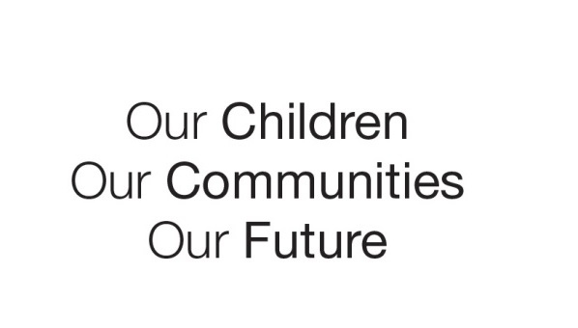

Australian Early Development Census

School Story

Ringarooma Primary School

Tasmania 2017

Play-based movement improves gross motor and language skills

About the School

Ringarooma is a small rural community in North East Tasmania. The Ringarooma Primary school is the focal point of the community with many community events and functions intertwined with the school community or hosted in the school’s hall. A small school in comparison to many others in Tasmania, Ringarooma caters for students in Kindergarten to Year 6 with approximately 86 students enrolled.

What did the results show?

The Australian Early Development Census (AEDC) is a national measure of early childhood development. It measures five key areas or domains when a child starts full-time school. The domains are: physical health and wellbeing; social competence; emotional maturity; language and cognitive skills (school-based); communication skills and general knowledge.

The 2015 results for Ringarooma highlighted developmental vulnerabilities in more than 10% of children across all five of the domains. The highest levels of vulnerability were identified as being in the social competence and language and cognitive skills (school-based) domains with 15.8% of children identified as vulnerable in both of these areas.

Bringing about change

Ringarooma Primary School Principal, Christine Edmunds was new to the role of Principal at Ringarooma when she took a look at the AEDC data to get some insight into her school and the community. Christine is passionate about early years development for children aged birth to 8 years and though she could see Ringarooma Primary had a well-established focus on reading, the data showed the primary school was not achieving great gains in this area.

The data demonstrated the community was vulnerable with delays in the area of language development and typical social skills development. Christine noted that in three of the five domains Ringarooma and its surrounds were considered at risk.

Christine worked with teachers and the *Launching into Learning (LiL)* Coordinator to develop an early years program encouraging movement and play-based physical activity. The idea was to develop gross-motor skills and social skills which are the catalyst for the development of language skills and a healthy brain.

*LiL* is a free program where families with young children aged birth to 4 years are able to connect with their local school community and learn essential skills for the early years of life (ages birth to 5 years). *LiL* is offered at all Tasmanian Government Schools and Child and Family Centres.

The *LiL* program gives children experiences in their earliest years that are important for ongoing development including activities that develop their talking, reading, physical, social and emotional skills in an atmosphere of fun and creativity.

In response to the AEDC data the Ringarooma *LiL* program purchased purposeful equipment to help children develop both gross and fine motor skills and engage the brain in new and different ways. Using the equipment means climbing, crawling through tunnels, trying weight bearing activities and engaging different parts of the body.

Christine says that whilst her community is rural with many children coming from farms the opportunities to get physically active are not always there. “Children may be outside with their mum’s and dad’s whilst they do work on the farm but they might be sat in the tractor for hours whilst dad or mum plows a paddock for example. It is a different type of activity. For Ringarooma Primary it is about getting our children to move in different ways. We know that improving physical movement leads to an improvement of oral language and other facets of language development.”

Teacher Jess Stagoll runs the Ringarooma *LiL* play-based learning sessions. She says that during sessions she creates a relaxed environment where parents are welcome to come in and work around the room with their children. The children are encouraged to go to the area they are most drawn to and engage in an activity of their choosing.

Jess can plan for her student’s needs better because the AEDC data helps inform her of their development and areas of need. “I can support them developmentally and ultimately enable them to engage in their world and flourish.” The knowledge the data has provided to the *LiL* program has really allowed the planning of activities and acquisition of resources that best support the needs identified in the data.

Partnerships

The *LiL* program works in close partnership with the local Ringarooma Playgroup to ensure a consistent approach. They share data and developmental understandings about Ringarooma’s young children. Playgroup Coordinator Carolyn says that many years ago the difficulties that children were experiencing were not as frequently identified. “It is great that children with specific challenges are being diagnosed at a younger age… and have activities structured to their needs so they are not left behind.”

Achievements

Since the purchase of the new equipment and change in activity structure everyone involved in the Ringarooma *LiL* has noticed a lot more confidence in both the children and their parents. Teacher Jess says the difference is really noticeable. “I have seen a lot more confidence in both the children and their parents. They are able to come in and explore the activities together and have the confidence to use the equipment together. They manipulate it and explore and investigate with it.”

Word of mouth about the program and the fantastic benefits it is having for the children has really spread throughout the community. The positive word of mouth has created an increase in the number of program participants. At the beginning of the year, when the new program began, about 12 families were engaging in *LiL* regularly. That number over the first year grew to an enrolment of 20 families who regularly participated.

Hollie is a parent who regularly attends the *LiL* program at Ringarooma. Hollie previously attended other playgroups nearby but was really impressed by *LiL*. She has stayed with the program and is an active member of the *LiL* community. “The program is run so well and there is something for all children up to 5 years of age. Even newborns are catered for and the whole atmosphere is just really relaxed and open.” Hollie says that often in regional communities there are not a lot of ways for people to connect. The program helps to get both parents and children out and about and socialising. “I’ve made great friends through the program and I have brought new people along, even people who have just had a baby, it is great for them too.”

Ringarooma Primary school has been able to forge strong partnerships not just with students but parents and the whole community. The *LiL* program has been an important part of their community focus creating a space for children and their parents to thrive. Hollie says that she has noticed the huge difference the program makes, particularly if children begin participating from an early age, “if kids start attending from birth it makes a big impact on their social skills and confidence. It helps them to come out of their shell and it helps parents make connections.” “There is a great feeling of being welcome and the children have freedom in the space. I am also thrilled that I am able to help other new parents who are coming through for the first time. It builds a sense of community.”

For more information contact

AEDC Tasmanian State Coordinator, Department of Education, Tasmania  
Email: [aedc@education.tas.gov.au](mailto:aedc@education.tas.gov.au)

|  |
| --- |
| “Word of mouth in the community has shown that we have got this great equipment and a great program running that is really purposeful and really helping the children. The AEDC data gives you good beginning points for your teaching that can be combined with other data like the Kinder Development Check.”  Christine Edmunds, Principal, Ringarooma Primary School |