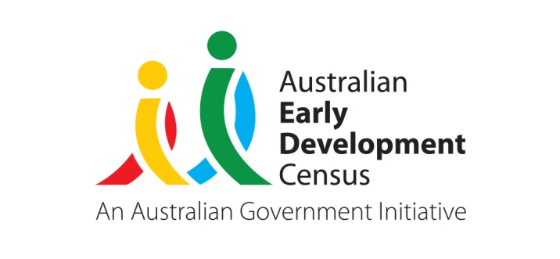 

Australian Early Development Census

The predictive validity

of the Early Development Instrument (EDI): Predicting later cognitive and behavioural outcomes

Background

Predictive validity refers to how well an instrument predicts later outcomes, in this case, how well does the Early Development Instrument (EDI) predict the later literacy, numeracy and other cognitive and behavioural outcomes of children. The EDI is the teacher completed survey used to measure child development within the Australian Early Development Census programme. It is important to determine if the EDI has enough predictive validity so that it can be confidently used as a population measure of early childhood development. If the EDI misclassifies too many children in a community or population group with developmental vulnerabilities, these communities or population groups may be needlessly targeted with early childhood and parenting support programmes on the basis of their results. Early childhood and parenting support programmes should be implemented on the basis of robust population data.

Aims

This Research Snapshot reports results from two independent research studies. These research studies investigate how well the EDI predicts a child’s later literacy, numeracy and other cognitive and behavioural outcomes.

Key Points

• The National AEDC progress measure (developmentally vulnerable on one or more domains of the EDI) appears to be the strongest summary indicator.

• Analyses show that the EDI performs as well or better than commonly used instruments when aiming to predict later academic and behavioural outcomes.

• A child’s development when they enter school has a strong and persistent relationship to how well they continue through primary school. With the AEDC being conducted across the country as a developmental census once every three years we can now also look to the EDI as an evaluation tool to further improve our knowledge around what are good investments to make in the early years.

Key findings

Results from Study 1:

All five of the EDI domains predicted later literacy and numeracy outcomes for children as measured by the National Assessment Program—Literacy and Numeracy (NAPLAN) in Years 3, 5, and 7. Of the five AEDC domains, the “Language and Cognitive Development” and the “Communication Skills and General Knowledge” domains were the best predictors of scores on the NAPLAN assessments. The strengths of these relationships were very stable over time despite the continuing development of the children. The strength of the relationship between the AEDC scores and Year 3 scores on both numeracy and reading was similar; however, as the children got older, there was some evidence that the EDI was a better predictor of reading scores than of numeracy scores.

The research also indicated that children who were “vulnerable on one or more” of the EDI domains at age 5 were more likely to be in the bottom 20% of all students’ scores on the NAPLAN assessments in Years 3, 5 and 7 than children who were not vulnerable on any EDI domains. A child who was developmentally vulnerable on one domain of the EDI was more than twice as likely to have been in the bottom 20% of students for reading skills in Year 7 than a child who was not developmentally vulnerable on any domains of the EDI. Children who were developmentally vulnerable in four or five AEDC domains were much more likely to have difficulties in reading and numeracy through primary school than those without vulnerabilities. For each additional domain that a child was vulnerable on in pre-primary there was an incremental increased percentage of children with low reading and numeracy scores in Year 7. (See Figure 1)

**Figure 1. Linkage of EDI to Year 7 NAPLAN**

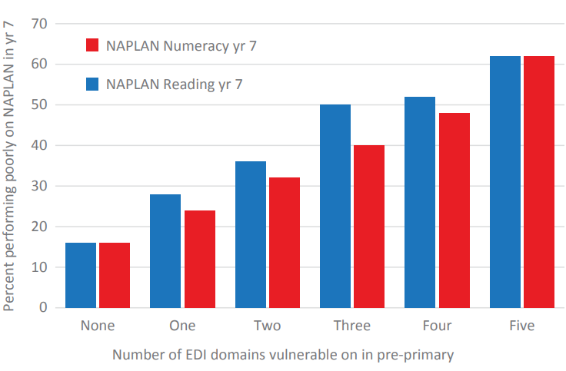

Results from Study 2:

In a second study, where the EDI was used, we further investigated the predictive validity of the instrument. In 2004 the Longitudinal Study of Australian Children (LSAC) included the EDI in a nested sub-sample of their 4 year old cohort. This sample contained children who were all between 4 and 5 years of age, which is on average a year younger than the standard use of the EDI in Australia (i.e. the first year of full time schooling). The LSAC collected information about children’s development using many instruments, for example the Strengths and Difficulties Questionnaire (SDQ), the Peabody Picture Vocabulary Test (PPVT), the Who Am I, the Parents Evaluation of Developmental Status (PEDS) and the Paediatric Quality of Life Inventory (PedsQL) assessments.

The results showed that the five domains of the EDI measured at age 4 perform well in comparison to the other assessments of child development in predicting age 8 mathematical thinking, language and literacy and behavioural outcomes. The discrimination of each of the domains of the EDI was measured relative to the other EDI domains and the other measures of a child’s development. Discrimination in this context refers to the ability of an instrument to correctly differentiate between children who are doing poorly on a certain outcome from those that are doing well. In particular, the Language and Cognitive Development domain demonstrated moderate discrimination in mathematical thinking outcomes. When predicting the Language and Literacy Scale on the Academic Rating Scale at age 8, the EDI Social Competence, Communication Skills and General Knowledge and the Language and Cognitive Development domains at age 4 demonstrated moderate discrimination. The EDI Social Competence domain, and the Language and Cognitive domain show moderate discrimination of the age 8 Strengths and Difficulties Questionnaire (behavioural outcome) total score.

Implications

For policy and practice

The results suggest that it would be advantageous to couple a universal population approach with selectively targeting areas showing high numbers of children who are developmentally vulnerable on one or more of the EDI domains. This approach with a combination of a universal platform is likely to be of greater value than highly indicated/targeted interventions. Just targeting geographical regions or population groupings identified on the basis of the EDI will indeed miss many children that could benefit from additional developmental supports.

Government departments of health, education, community development as well as non-government agencies have traditionally worked independently in their delivery of early childhood care. From this research it is evident that the overall health and development of Australian children has implications for their success at school, with a need for greater interagency collaboration to reduce the gap in service delivery between birth and school.

For research

This is the first study to investigate the relationship between the EDI and NAPLAN assessments as well as other cognitive and behavioural outcomes. The inclusion of the EDI into the national data linkage networks means there is increased opportunity to investigate the efficacy and efficiency of early child development and education interventions through pragmatic trials.

Study Details

**Study 1**

The data for the NAPLAN analyses came from the use of the EDI across 121 primary schools in the North Metropolitan Health Service in Western Australia in 2003 resulting in a sample of 4,420 children. These children have since undergone NAPLAN assessments in Years 3, 5 and 7.

**Study 2**

In a separate study, the EDI was embedded in a nested sample of 720 participants in the 4 year old cohort of the LSAC in 2004. LSAC is a nationally representative sample of two cohorts of Australian children: infants and four year olds. LSAC data collection involves an interviewer spending time in a child’s home obtaining information from a parent or caregiver regarding their child. As part of this visit, the interviewer conducts direct measurement of the child via a number of instruments. For this nested sample, teachers were also asked to provide some information on the child, including completion of the EDI. These children were subsequently followed up, allowing us to investigate which instruments measuring four year olds (including the EDI) best predicted later cognitive and behavioural outcomes at age 8.

*“Combining a universal population approach alongside targeting those areas with high numbers of developmentally vulnerable children is most advantageous”*

*“All five of the EDI domains predicted later literacy and numeracy outcomes for children as measured by NAPLAN”*

For further information

**Details of the research paper**

These articles have been submitted to journals and are currently under review. If you would like any further details about this work in the meantime, please contact [Sally Brinkman](mailto:sally.brinkman@telethonkids.org.au)[1].

Brinkman, S., Gregory, T., Harris, J., Hart, B., Blackmore, S, & Janus, M (2013). Early development index (EDI) at age 5 predicts reading and numeracy skills four, six and eight years later. *Child Indicators Research*, 6 (4), 695-708.

Brinkman, S., Zubrick, S., & Silburn, S. *Predictive validity of a school readiness assessment on later cognitive and behavioral outcomes.*

**Further reading**

Cavanaugh, D. A., Lippitt, J., & Moyo, O. (2000). Resource guide to selected federal policies affecting children’s emotional and social development and their readiness for school. In off to a good start: Research on the risk factors for early school problems and selected federal policies affecting children’s social and emotional development and their readiness for school (pp. 95-221). Chapel Hill, North Carolina: University of North Carolina, FPG Child Development Centre.

**About research snapshots**

AEDC Research Snapshots provide a brief and accessible overview of research being undertaken in relation to the AEDC. The AEDC program is funded by the Australian Government. For further up-to-date information consult the [AEDC website](http://www.aedc.gov.au)[2] and its many resources**.**

**About the organisation**

The Telethon Kids Institute is one of the largest, and most successful medical research institutes in Australia, comprising a dedicated and diverse team of more than 500 staff and students. Established in 1990, the Institute was among the first to adopt a multidisciplinary approach to major health issues: clinical research, laboratory sciences and epidemiologists all under the one roof, to tackle complex diseases and issues in a number of ways. At the Telethon Kids Institute, we are committed to ensuring that the benefits of our research are translated into real therapies and policies to improve the health and wellbeing of children.

Copyright and other information

Since 2002, the Australian Government has worked in partnership with eminent child health research institutes, Centre for Community Child Health, Royal Children’s Hospital, Melbourne, and the Telethon Kids Institute, Perth to deliver the Australian Early Development Census program to communities. The Australian Government continues to work with its partners, and with state and territory governments to implement the AEDC nationwide.

1. sally.brinkman@telethonkids.org.au
2. www.aedc.gov.au