 

Australian Early Development Census

Understanding AEDC community boundaries

AEDC geographic boundaries are defined for the whole country to ensure that the data is reported in the most useful way possible, but still align with commonly understood geography, such as suburbs. Those boundaries enable AEDC results to be reported at four different geographic levels: Local Community, Community, State/ Territory and National[1]

Figure 1 – AEDC Community and Local Community

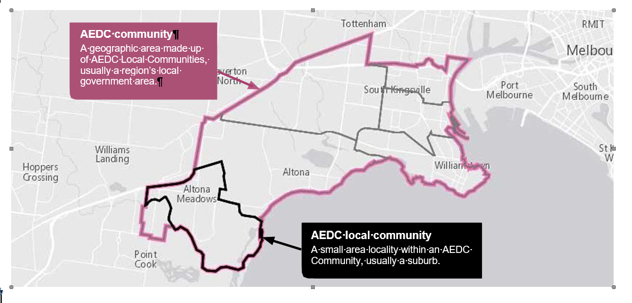

Changes to the AEDC geography

The AEDC geography was updated in order to match the Australian Statistical Geography Standard (ASGS) released by the Australian Bureau of Statistics (ABS) in 2021.

Revised boundaries were used for the 2021 collection and applied retrospectively to all previous collections in order to allow trend analysis over all four cycles. Individual children in each collection were assigned to a revised local community and the AEDC publishing rules (suppressions) were reapplied to the resulting data. This means that the data may have changed for some communities.

Many 2021 Local Communities and Communities have the same name as in previous collections even though the geographical area covered has changed. As a result, in many cases, scores for Local Communities and Communities will be different from previously published AEDC data.

In order to allow accurate comparison of AEDC and socio demographic data from the ABS, the AEDC boundaries are based on SA1 (Statistical Area 1) building blocks in most cases[2]. The Local Community boundaries were kept as similar to the previous boundaries as possible, however when Local Community boundaries have been altered, consideration has been given to population, geography, socioeconomic status and service provision. Any changes to boundaries have been made following consultation and advice from state and territory governments and, where possible, community representatives.

See the [ABS website](http://www.abs.gov.au)[3] for more information on ASGS.

Criteria for releasing results

It is imperative that the confidentiality of children and the reliability of the data is maintained. Therefore, domain results can only be reported when a minimum of 15 children with valid scores and two teachers have contributed to the data collection.

Scores are flagged as invalid and not reported for children who have been in the class for less than one month, are less than four or over seven years old or where teachers complete less than 75 per cent of the items in any given domain.

Communities and Local Communities must have valid domain scores for at least eighty per cent of the overall number of instruments completed. This is to ensure the results appropriately reflect the community.

Reported results include demographic data for all children included in the AEDC. Domain scores are reported only from children with valid scores, and for those who do not have any diagnosed special need.

Searching for Communities

Use the [AEDC Data Explorer](http://www.aedc.gov.au/data)[4] to search for Communities and Local Communities.

Comparison of previous AEDC results

Previous AEDC collection data has been aligned to the new geography with some marginal changes to the AEDC boundaries anticipated for the next collection. This is to ensure that the AEDC geography is closely aligned with the ASGS and allow for AEDC Community results to be compared over time alongside ABS data.

To assist in making informed decisions on whether there has been a large enough change in the percentage of children considered developmentally on track, at risk or vulnerable over time to be considered significant, a method described as the critical difference has been developed.

To compare changes over time for your Community and Local Community, use the ‘compare years’ function on the [AEDC Data Explorer](http://www.aedc.gov.au/data)[5], which automatically calculates the critical difference and indicates whether a change is significant or not for your search area (www.aedc.gov.au/data).

For more information on the calculation of the critical difference, refer to the [AEDC technical report Calculation of the Critical Difference](http://www.aedc.gov.au/trcd)[6].

Copyright and other information

© 2022 Commonwealth of Australia

Since 2002, the Australian Government has worked in partnership with eminent child health research institutes,   
The Centre for Community Child Health at The Royal Children’s Hospital, Melbourne, and the Murdoch Children’s Research Institute, Melbourne, and the Telethon Kids Institute, Perth to deliver the Australian Early Development Census program to communities nationwide. The Australian Government continues to work with its partners, and with state and territory governments to implement the AEDC.

Stock code: AEDC-2203-002-1

1. AEDC data is also available publicly at other geography levels such as LGA, SA2, SA3, SA4, GCCSA and Remoteness via the additional data products on the AEDC website.
2. Some AEDC boundaries are at the mesh block level in Western Australia
3. [www.abs.gov.au](http://www.abs.gov.au/)
4. [www.aedc.gov.au/data](http://www.aedc.gov.au/data)
5. [www.aedc.gov.au/data](http://www.aedc.gov.au/data)
6. [www.aedc.gov.au/trcd](http://www.aedc.gov.au/trcd)