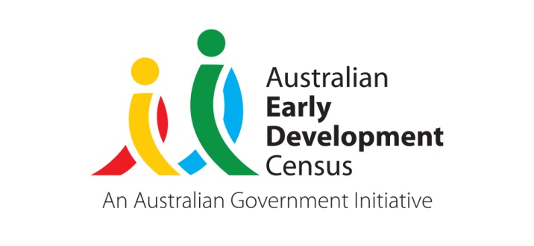 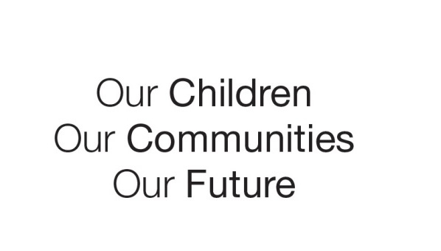

Australian Early Development Census

Community story

Seeds of change

Whittlesea

VIC 2014

Forum triggers local action

About Whittlesea

Whittlesea is on Melbourne’s outskirts about 20 kms from Melbourne’s CBD. It is a large municipality covering urban growth areas and rural areas. It is the third fastest growing municipality in Victoria, with more than 170,657 residents. Between 2013 and 2014, its population grew by 8,358 residents or 160 people per week.

Whittlesea has low income and middle income suburbs within its local government boundaries. Doreen, a growth area, has low levels of socio-economic disadvantage compared with nearby suburbs of Lalor and Thomastown, which have high levels of socio-economic disadvantage (ABS Socio-Economic Index for Areas 2011).

What did the results show?

The Australian Early Development Census (AEDC) is a national measure of child development. It measures five key areas or domains when a child starts full-time school. The domains are: physical health and wellbeing; social competence; emotional maturity; language and cognitive skills (school-based); communication skills and general knowledge.

The 2012 results for Whittlesea showed 21.3 per cent of children vulnerable on one or more domains, compared with 22 per cent of all Australian children starting school. However, in two of Whittlesea’s suburbs - Lalor and Thomastown - the percentage of children assessed as vulnerable on one or more domains was 33.9 per cent and 30 per cent respectively.

Bringing about change

The local government authority, The City of Whittlesea, held a forum about the in 2013 called ‘The state of Whittlesea’s children’. About 50 representatives from local groups and service sectors attended the forum. They included representatives from sectors such as early childhood education and care, primary school, early intervention, community health, child and family support and the Victorian government. Staff from various City of Whittlesea departments, such as Family and Youth, Planning and Health, also took part.

Small group discussions enabled the forum participants to analyse and understand their neighbourhood and local government area results. They saw how the results related to other local data and identified barriers that often hampered their ability to address the areas of developmental vulnerability for local children.

Feedback and Achievements

All of the participants who gave feedback about the forum said they will use the information in their day-to-day practice - by reporting back to their agencies and raising awareness, informing strategic planning and advocacy, and building relationships and collaboration with other services.

The feedback, coupled with notes from the small group discussions, has been made available to service providers to help them integrate and strengthen their service systems in Whittlesea. The following are some examples of the ‘take-home’ messages:

*“The needs of families are very complex and go beyond the capacity of one organisation.”*

These comments related to the difficulty families with complex needs have in navigating the service system and the time they spend waiting for services. There was an implied need for services to be flexible, visible and integrated.

*“We need to get more creative about how we do things in a tight fiscal environment.”*

The need to think differently about the operation of local service systems came through very strongly.

*“We need to build bridges between services and work together across the municipality and within local places/areas.”*

Although it was recognised that a lot of good work was going on across the municipality, participants felt there was a need for greater communication, coordination and partnership between services to clarify such things as referral pathways and processes, better awareness of other services and better local networking.

*“What parents do is more important than who they are.”*

There was a strong recognition of the pressures families are facing and the need to promote the social factors affecting their health, such as working with families to improve the home learning environment and attendance at playgroups.

*“We need to use ‘on the ground evidence’ that we have at our fingertips.”*

Data and research and other local evidence, is readily available to enhance service provision and planning.

Ms Jen Lorains, the City Of Whittlesea’s Early Years & Family Strategic Planner, said the results provide great local evidence base to inform projects and service delivery. She said a partnership which focuses on supporting children with additional needs (created from an earlier local research project) has used the AEDC results and other local data to inform their framework ‘Integrating and Strengthening Service Systems’.

Unexpected benefits

The comprehensive nature of the data as a measure of children’s development in the early years has led the City of Whittlesea to be concerned about the lack of data about how children are faring in their ‘middle years’ (children aged 8-12 years). Hence the City of Whittlesea decided to take part in an Australian pilot of the Middle Years Development Instrument (MDI), a population-level, self-report survey for children aged 9-14 developed in Canada and being used in parts of South Australia and Victoria.

The City of Whittlesea and the Local Learning and Employment Network hosted a forum to present and discuss the local MDI data. In partnership with local Early Years and Youth networks, the groups will use this data to inform a Middle Years strategy for Whittlesea. The strategy is aimed at ensuring children aged 8-12 and their families are effectively supported because the ‘middle years’ is a key developmental phase for children.

For more information

[www.aedc.gov.au](http://www.aedc.gov.au).

For more information contact

Catherine Nolan  
Victorian AEDC Coordinator  
Phone: 03 9651 3539  
Email: Nolan.catherine.m@edumail.vic.gov.au

|  |
| --- |
| ‘*Since the forum, it is evident that local service organisations are very much on board. The results are already being used in funding applications and advocacy, as well as service planning’.*  **Jen Lorains, City of Whittlesea** |