 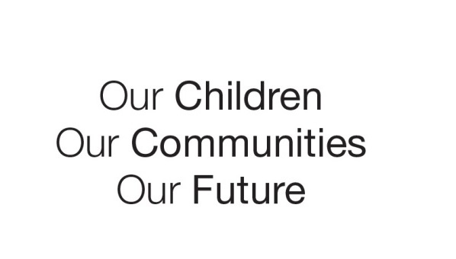

Australian Early Development Census

School story

Bass Valley Primary

VIC 2013

Ready, set, go! How Bass Valley used the results to give kids a flying start

About the school

Bass Valley Primary School is in a rural farming area in Gippsland’s Bass Coast community, about 110 kms south-east of Melbourne. It is an area of high socio-economic disadvantage. (ABS Socio-Economic Index for Areas 2011).

Most of the school's 170 students travel to school by bus from the surrounding Western Port townships and rural settlements. Apart from the kindergarten which is next door to the school, there are no other buildings or services nearby.

What did the results show?

The Australian Early Development Census (AEDC) is a national measure of child development. It measures five key areas or domains when a child starts full-time school. The domains are: physical health and wellbeing; social competence; emotional maturity; language and cognitive skills (school-based); communication skills and general knowledge.

The 2009 results for Bass Coast showed 22.4 per cent of children developmentally vulnerable on one or more domains. By 2012, the proportion had increased to 26 per cent, a figure much higher than the national result of 22 per cent.

The results also revealed high levels of developmental vulnerability among children starting full-time school from the Western Port townships area. In 2009 half of the children from this area were developmentally vulnerable on one or more domains. By 2012, the proportion had risen to 52 per cent.

In 2009, 38.5 per cent of children from the townships area were developmentally vulnerable in the communication skills and general knowledge domain. By 2012 the proportion developmentally vulnerable in this domain had climbed to 46.4 per cent.

Bringing about change

The results confirmed the concerns that Bass Valley Primary School teachers had about children starting full-time school, especially their concerns about student’s communication skills and general knowledge. The school’s data from early NAPLAN literacy and numeracy data (first measured when students are in grade three) along with internal benchmarking results showed children were not doing well on language tasks in their junior school years.

The school’s principal, Leanne Edwards and her team of teachers noticed many children entering prep (the first year of full-time schooling) lacked word knowledge. Teachers were spending up to six months expanding students’ vocabulary before being able to work with sounds.

Teachers also knew of parents who were unable to send their children to kindergarten because of the financial costs involved. Many children had auditory processing problems which were not being identified until they arrived at school.

It became clear children needed more exposure to language in the preschool years free of charge to parents. Ms Edwards approached the kindergarten staff next door and they worked together to develop the Ready, Set, Go! program.

About Ready Set Go!

Ready, Set, Go! aims to improve children’s readiness for school by enriching language and literacy exposure in the early years in a way that supplements kindergarten. Since the program began in 2010 teachers have noticed improvements in their students.

Each year the school offers free classes to around 25 kindergarten students. The classes run for two half days per week for the six months prior to children starting full-time school. It is staffed by an experienced prep and early years’ teacher and an education support staff member from the school.

“A really important aspect of the program is that it allows staff to establish a relationship with parents and carers who drop their children off here,” Principal Edwards said, “because once children start school at Bass Valley, 95 per cent of them travel by bus and parents are not normally seen.”

Each week teachers provide parents with free ‘Talk and Play’ bags which contain quality picture books and items based on a theme. Teachers show parents how to use the items to excite children’s interest and share stories, for example by pointing to the pictures and asking questions such as ‘What is Johnny holding? – a bucket!’

For parents unable to drive their children to school for the program, other parents, community members and even teachers help out with transport.

While at the school, children become familiar with the school environment and routines. “Having the children ‘on site’ for six months before they start full-time school also allows us to identify and intervene early with different services such as speech therapy,” Principal Edwards said.

Achievements

The Ready, Set, Go! program was awarded the Gippsland Education Excellence award in 2012. It has provided high quality kinder-to-prep transition and prepared children socially, emotionally and academically for a positive start to full-time school.

For more information contact

Leanne Edwards, Principal, Bass Valley Primary School 03 5678 0208

|  |
| --- |
| *“The parents report how much they love the weekly ‘Talk and Play’ bags.”*  **Leanne Edwards, school principal.** |