 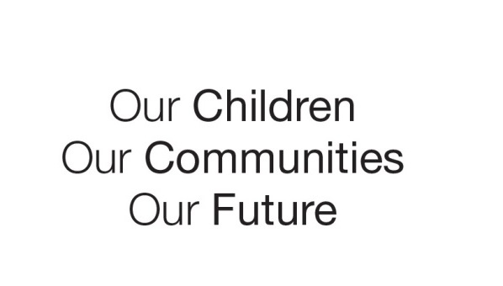

Australian Early Development Census

Community story

KindiLink

Western Australia

WA 2015

KindiLink is a new play-and-learn initiative for three year old Aboriginal children who attend with a parent/carer at 37 selected schools.

About Western Australia

Western Australia is virtually the size of Western Europe which has a diversity of people and languages. There is similar diversity among traditional Aboriginal language and cultural groups in Western Australia.

The 2011 Australian Bureau of Statistics (ABS) estimates that there were 88 000 Aboriginal people living in Western Australia, nearly 4 per cent of the State’s population. This represents the third largest Aboriginal population in the country. Aboriginal children represent 6.8 per cent (18 757) of all children 0-8 years in Western Australia, and 20 per cent of the total population of Aboriginal people in the State.

Aboriginal children and families have a rich and complex culture and kinship system and live across a broad range of geographical areas – from the Perth metropolitan region, to very remote WA.

What did the results show?

AEDC results showed that many Aboriginal children in Western Australia were doing well, with the level of developmental vulnerability declining from 52 per cent in 2009 to 48 per cent in 2015. The census also highlighted that Aboriginal children were twice as likely to be developmentally vulnerable than   
 non-Aboriginal children (2009: 52 per cent compared to 23 per cent and in 2015: 48 per cent compared to 20 per cent). Aboriginal developmental vulnerability in Western Australia was reported to be higher than the national average.

Bringing about change

In recognition that there is a need to do more for young Aboriginal children in Western Australia, and that high quality early learning programs for children, before they start school, involving their parents, is an effective way to improve child outcomes, the State Government is piloting a new initiative - *KindiLink*.

KindiLink aims to boost young Aboriginal children’s development in the year before they start Kindergarten, and to forge strong and supportive links between home and school. The teacher and Aboriginal and Islander Education Officer (AIEO) work alongside families to help them support their own children for success at school.

The program provides six hours a week of high quality play-and-learn sessions for children and parents/carers at the participating schools. Sessions are planned and delivered by an early childhood teacher and an AIEO using evidence-based programs and practices, including the Early Years Learning Framework. Families are supported to be actively involved in the sessions to help inform their child’s learning at home, through everyday fun activities and games.

A major focus of the program is to build collaborative links between schools, the community and families, and as such, each KindiLink program reflects their local community and culture.

Achievements

The KindiLink program commenced in 2016 and is being piloted in 37 schools across Western Australia.

The implementation of the program is another step on the continuum of provision to ensure a more effective and culturally sensitive approach to improve outcomes.

Partnerships

The KindiLink program provides opportunities for schools to work in partnership with Aboriginal parents and families, and the local Aboriginal community in a culturally sensitive capacity to improve outcomes for Aboriginal children.

Looking ahead

KindiLink is part of the State’s broader early years strategy to ensure that more Aboriginal children and their families are supported through productive home-school relationships.

The initiative is being piloted over three years, with an independent evaluation to inform future direction.

For more information contact

AEDC Coordinator Gail Clark

Department of Education

Western Australia

Gail.clark@education.wa.edu.au

[www.aedc.gov.au](http://www.aedc.gov.au)

|  |
| --- |
| ***KindiLink focuses on working alongside families, as their child’s first and most influential teachers*** |