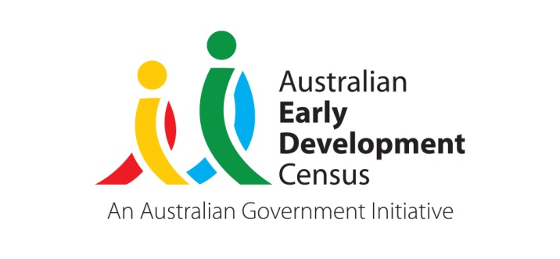 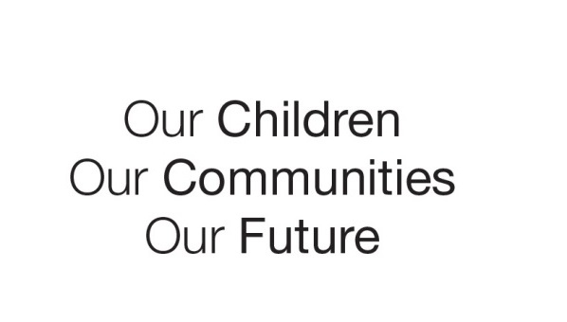

Australian Early Development Census

Early childhood programs in Woden and the Molonglo Valley

Australian Capital Territory 2020-2021

About Woden and the Molonglo Valley

The Australian Early Development Census (AEDC) is a national measure of child development. It measures five key areas or domains when a child starts school. The domains are: physical health and wellbeing; social competence; emotional maturity; language and cognitive skills (school based); communication skills and general knowledge.

The Woden region

Woden is an established ACT region in Canberra’s inner south that is currently undergoing an increase in new development and high-density housing. Of the 507 Woden children included in the 2018 AEDC cycle, 3.4% were Aboriginal and Torres Strait Islander, while 25.4% had English as a second language.

The vast majority (95.8%) of Woden children attended preschool in the year prior to school. Kindergarten teachers reported that most children in Woden (95.8%) were adapting to school and had parents actively engaged in supporting their child’s learning (94.8%).

The Molonglo Valley region

The Molonglo Valley is a new and rapidly developing region in Canberra’s south west. Of the 117 children included in the 2018 AEDC cycle, 4.4% were Aboriginal and Torres Strait Islander, while 34.2% had English as a second language.

The vast majority (97.3%) of Molonglo Valley children attended preschool in the year prior to school. Kindergarten teachers reported that most children in Molonglo Valley (98.3%) were adapting to school and had parents actively engaged in supporting their child’s learning (98.3%).

This community story will examine the AEDC results for Woden and Molonglo Valley and compare them to the ACT average, allowing further exploration of how these cohorts of children have developed in the years before starting school.

What did the results show?

In 2018, Woden had a similar percentage of children developmentally vulnerable on one or more domains (24.3%) when compared with the ACT average (24.6%). The percentage of children developmentally vulnerable on two or more domains in Woden was slightly lower (11.1%) than the ACT average (12.4%). The 2018 results showed that 118 (24.3%) of children were developmentally vulnerable on one or more domains and 54 (11.1%) on two or more domains.

When compared to the ACT average, Woden generally displayed a similar percentage of children developmentally vulnerable across all domains. However significant increases between 2015 and 2018 in the percentage of Woden children developmentally vulnerable on the social competence and language and cognitive skills (school based) domains demonstrates a rising need for supports in these developmental areas for the children of Woden.

In 2018, Molonglo Valley had a lower percentage of children developmentally vulnerable on one or more domains (20.5%) compared to the ACT average (24.6%). The percentage of children developmentally vulnerable on two or more domains in Molonglo Valley was similar (12.5%) to the ACT average (12.4%). When compared to the ACT average, the percentage of children developmentally vulnerable across all the domains was lower in the Molonglo Valley with no significant changes between 2015 and 2018. As Molonglo Valley is a newly established area of Canberra and had low numbers of children in 2015 and 2018, some caution is required when interpreting the results. As Molonglo continues to grow, greater numbers of children will reside in this region and schools and early childhood services are currently being built to accommodate the increasing population.

Bringing about change

In 2019, Woden Community Service (WCS) received a grant for an AEDC Community Partnership project as part of an ACT AEDC initiative aimed at improving early childhood development outcomes in the Woden and Molonglo Valley areas. WCS undertook a range of initiatives using this funding that targeted improving early childhood development and family support in the region. Due to the nature of the COVID-19 pandemic, initial plans for the activities in 2020 were adapted to allow them to continue in a COVID safe way and meet the evolving needs of the communities.

Woden Community Service delivered a series of programs including:

**Paint and Play programs**

* In 2020, WCS established four new free drop-in style outdoor Paint and Play playgroups, for families with children aged 0-5 years. Approximately 28 families attended these playgroups. Two playgroups were located at schools, Evelyn Scott School and Lyons Early Childhood School, and two were located at community facilities within the suburbs of Denman Prospect and Coombs. WCS reviewed AEDC results in Woden and Molonglo Valley suburbs and used this to inform the location of these playgroups.
* The Paint and Play playgroups were facilitated by experienced child development workers with several visiting community services providing families with extra support. The playgroups provided a large range of activities including painting, singing, books, craft, construction and sensory/messy play.

**Bush Play Connections in Molonglo Valley**

* Bush Play Connections began in April 2021 as a semi-structured weekly family playgroup for children aged 0-4 years with a focus on nature play and connection to earth and country. Interwoven into the program was modelling developmentally appropriate language, strategies and foundational skills to scaffold competence over time and learning across the five AEDC domains.

**Circle of Security Parenting Program**

* The WCS Family Case Management Team started a Circle of Security Parenting course for a group of six families. There were four sessions that ran during September and October 2020 for three hours each and covered topics such as:

Understanding children’s emotional world by learning to read emotional needs;

Supporting children’s ability to successfully manage emotions;

Enhancing the development of children's self-esteem; and

Honoring the innate wisdom and desire for children to be secure.

**Multicultural Coffee Conversation group**

* The Multicultural Coffee Conversation group has been running regularly online since February 2021 and engages 10 parents of children aged 0-4 years split into smaller groups to facilitate engagement. The groups act as informal support groups aiming to reduce parenting stress and strengthen social bonds. The groups ran with a facilitator weekly during terms one and two then with support in alternating weeks and finally in term four without support. Culturally and linguistically diverse (CALD) mothers who are unable to reach any family support agencies were invited to join.

Achievements

Together the four initiatives implemented by WCS successfully promoted early childhood development and supported families in the region. The Paint and Play playgroups provided an opportunity for families to make connections with others in their local community and spend time with their children in a safe and stimulating environment.

The Bush Play Connections program engaged with 36 families with children aged 0-4 years in the Molonglo Valley. This unique program offered many families in the area the opportunity to foster their children’s development and form connections within their community, with referrals made to services where appropriate.

The Circle of Security Parenting program effectively engaged participants as they were able to reflect on their own parenting and how they were parented. Participants provided many examples of how they have started to implement what they had learnt throughout the course.Throughout the program, facilitators were able to speak with participants about the Family Case Management program and how Circle of Security could align well in identifying longer term family goals for participants. The role of Family Case Management is to work with parents to identify strength-based goals that can be worked towards with the support of a case manager, reviewing along the journey to ensure the best outcomes are made achievable for each family. As a result of the program, four of the families engaged in Family Case Management support to assist with identified goals.

The Multicultural Coffee Conversation group successfully built community connections and provided an opportunity for isolated mothers to develop independence and confidence. One of the groups has continued on with supporting one another and have been able to connect in person for the benefit of their children’s social development.

Looking Ahead

WCS continues to prioritise supporting early childhood development in the Woden and Molonglo Valley areas. All Paint and Play playgroups are ongoing with support from grants and internal WCS support. The Circle of Security Parenting program continues to run twice per year and the Multicultural Coffee Conversation Group has expanded and the original group is now self-sustaining, run by a group member.

For more information contact

ACT AEDC Coordinator

Phone: 02 620​5 ​3542  
Email: aedc@act.gov.au  
Web: [http://www.children.act.gov.au](http://www.children.act.gov.au/)