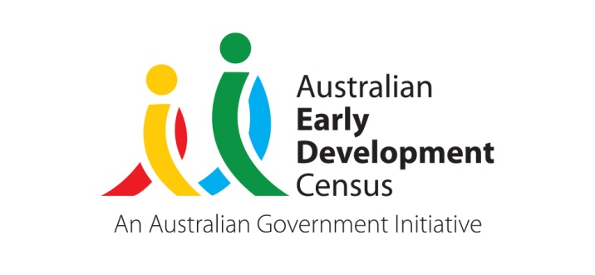 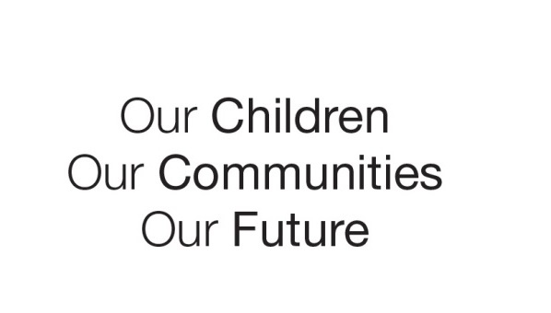

Australian Early Development Census

Early years collaborative partnership in Jervis Bay

Australian Capital Territory 2021-2022

About Jervis Bay

The Australian Early Development Census (AEDC) is a national measure of early childhood development. It measures 5 key areas, referred to as domains, when a child starts school. The domains are physical health and wellbeing; social competence; emotional maturity; language and cognitive skills (school-based); and communication skills and general knowledge.

Jervis Bay has a unique context, located in Jervis Bay Territory, which is part of the Australian Capital Territory. Jervis Bay is surrounded by the Shoalhaven region of NSW.

Jervis Bay School is an authentic community school located in the heart of Booderee National Park and on the outskirts of the HMAS Creswell Naval College Grounds. It is a small government school with a close connection to Wreck Bay and Jervis Bay village communities.

Jervis Bay School offers a 3-year-old Koori preschool program, a 4-year-old preschool program and classes from kindergarten to year 6. The school has a strong connection to local community and has a high Aboriginal student enrolment, currently sitting at around 90%. This is the highest proportion of Indigenous enrolment of all ACT schools.

The vast majority of Jervis Bay School children attended preschool in the year prior to school and several also accessed day care and or grandparent/relative care.

What did the results show?

The AEDC results for the Jervis Bay community are not publicly available due to privacy considerations with too few children or teachers in the community participating in the AEDC. However, the Jervis Bay School uses the AEDC results provided in their school profile to track changes in children’s development over time within their school community. Between 2018 and 2021 there was a decrease in developmental vulnerability across four of the five AEDC domains for kindergarten children at Jervis Bay School. There was also a corresponding decrease in the percentage of children vulnerable on one or more and two or more domains.

Bringing about change

Over the 3-year period from 2018-2021, Jervis Bay School undertook a series of strategies to improve preschool student outcomes. Of significance, given the cultural context of the school within the community, it was important to ensure that a local and well-respected staff member was always in the preschool. In 2019, this role was the preschool teacher, and from 2020 onwards a local Indigenous preschool assistant has filled this role. This has strengthened community trust, engagement, and communications, as well as having a significant impact on attendance rates and cultural safety.

Cultural safety and connection to Country and community is an essential component of the curriculum at Jervis Bay therefore the Aboriginal Education Officer was also allocated a significant role in the preschool from 2019, facilitating art, dance and on-Country learning with both preschool groups. The Aboriginal Education Officer also co-developed a ‘Bush School’ each week, often collaborating with the Booderee National Park Junior Rangers, to engage students in on-Country learning experiences. This has since expanded, following a new partnership with an external cultural program provider and mentor from *djiriba waqagura,* a local cultural company, now engaged to work with all students and teachers from preschool to year 6.

The school has a long-standing partnership with Noah’s Early Intervention Service (Noah’s), and the intense support offered to students and families with identified needs has been increased during this period, with a rise in hours dedicated to speech pathologists, occupational therapists and behavioural therapists working with an increased number of students. The referral process is usually initiated by trained staff at the school who are systematically screening students and conferencing with Noah’s.

Through the school’s partnership with Noah’s, Jervis Bay School was able to train all early childhood staff in a special program called SWAY (Sounds, Words, Aboriginal language, and Yarning). SWAY is a play-based, oral language and early literacy program based on Aboriginal knowledge, culture and stories and was developed by speech pathologists and educators at the Royal Far West School and has significantly benefited the students in a culturally relevant way. The program is also used in the kindergarten.

In addition, in 2020 the school employed a full-time speech pathologist who also had significant knowledge and experience in occupational therapy. Sixty percent of the speech pathologist’s role was dedicated to support and intervention in the 3 and 4-year-old preschool settings. This included some universal strategies for all students, targeted small group work and 1-to-1 (tier 3) support for up to 12 students three times per week. In addition, as the speech pathologist was fully embedded in the school staff, significant professional learning opportunities were developed for all staff across the school, further enhancing capacity to meet oral language and literacy needs.

Intense behaviour support through 1-on-1 social skills sessions and oral-language support during play times, was modelled by the speech pathologist and greatly upskilled educators in the rooms as well as increasing the students’ ability to communicate with their peers and develop social competencies. The school also placed an additional support assistant in the room for 2020 after identifying high levels of need. This made the ratio of educators to students a minimum of 1:4.

Preschool students are included as part of the whole school and therefore participate in all cultural programs, language sessions and on-Country excursions and begin transitioning gradually into the kindergarten space as early as September of their preschool year. This continuity improves children’s ability to manage the change, by fostering a sense of belonging to their community and developing the children’s relationship with educators in their new setting before they transition.

Achievements

The many recent preschool initiatives at Jervis Bay School have come together to improve children’s development and assist in their transition to school. Between 2018 and 2021 there was a decrease in developmental vulnerability across four of the five AEDC domains for kindergarten children at Jervis Bay School. There was also a corresponding decrease in the percentage of children vulnerable on one or more and two or domains over this time.

Having a dedicated local Indigenous preschool assistant since 2020 has strengthened community trust, engagement, and communication. This has had a flow on effect, improving attendance rates and feelings of cultural safety.

Preschool students are now making a much more seamless and successful transition to kindergarten as they are included in whole school programs and begin visiting the kindergarten space in Term 3 of their preschool year.

The new strategies including partnering with NOAHs Early Intervention Service, employing a full-time speech pathologist at the school who provides intervention and professional learning for educators has made a real difference to student outcomes. Preschool students are now receiving the speech pathology, occupational therapy and behavioural early intervention they need while in the 3- and 4-year-old settings before transitioning to kindergarten.

Looking Ahead

At the end of 2020, Jervis Bay School sought approval to increase the hours of access to free preschool from 15 to 18 hours per week to further improve outcomes for students and approval was granted. From the beginning of 2021 all 4-year-olds were accessing three full days each week and 3-year-olds were engaging in one day per week, in addition to their time at the local early education and care centre in Wreck Bay. Assessment in kindergarten shows that school entry levels have been improving but are still significantly below the national average. As a result, the school has now implemented an *InitiaLit* program taught by the preschool teacher, in a play-based approach, to directly teach pre-requisite skills and strive for all students to begin their school years on an equal playing field.

Jervis Bay School are yet to gather longitudinal evidence as to the impact of the most recent strategies for improvement; however, they are confident that their positive impact will continue to become increasingly evident over time.

For more information contact

ACT AEDC Coordinator

Phone: 02 620​5 ​3542  
Email: aedc@act.gov.au  
Web:  <https://www.communityservices.act.gov.au/ocyfs/children/australian-early-development-census>