 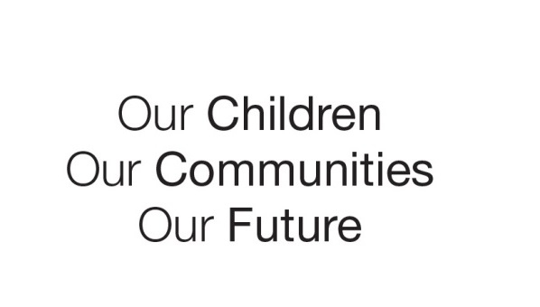

Australian Early Development Census

School story

Newport Public School

NSW 2013

How the AEDC is leading to improved student performance

About the school

Newport Public School (PS) is a primary school in Newport, in the Pittwater area of Sydney. It is about 30 kilometres from Sydney’s CBD. Pittwater has 57,173 residents including 4,596 children aged 0-5 years.

Pittwater is a relatively wealthy area, with low levels of socio-economic disadvantage (ABS Socio-Economic Index for Areas 2006).

What did the results show?

The Australian Early Development Census (AEDC) is a national measure of child development. It measures five key areas or domains when a child starts full-time school. The domains are: physical health and wellbeing; social competence; emotional maturity; language and cognitive skills (school-based); communication skills and general knowledge.

Teachers at Newport PS examined the school’s results and were concerned at the number of children shown to be developmentally vulnerable in social competence and emotional maturity.

Bringing about change

The results were the catalyst for the school to embark on a journey of learning and improvement.

Firstly, the school looked for other sources of data to help provide more information about the developmental issues revealed by the results. Data from the school’s Learning Support and Student Welfare team confirmed that one third of their referrals were for children’s social and emotional problems.

Staff did a literature search and found a body of evidence about how social and emotional wellbeing has a positive influence on a student’s academic performance. They also learned how explicit instruction in social and emotional skills can benefit learning.

The school discovered KidsMatter, a mental health and wellbeing framework for primary schools and early childhood education and care services.

They received support and resources from KidsMatter, as well as funding from Families NSW, to introduce the *You Can Do It* program. The program is aimed at strengthening the social and emotional skills of children starting school at Newport PS. The program is a component of a larger project developed by the school, called Quality Behaviour. It includes:

* social and emotional lessons with students
* professional learning sessions for staff
* parent sessions on social and emotional learning in children.

Achievements

After the Quality Behaviour project was introduced, data was collected from 85 parents of children starting school. It revealed high levels of satisfaction among parents about the school meeting their needs and their children’s needs. High parental satisfaction was also reported about the teaching and learning experiences provided to prepare children for school.

Qualitative data collected from the school’s teachers strongly supported the effectiveness of the social and emotional wellbeing elements of the Quality Behaviour project.

As a values-based program, it made sense to also implement the full *You Can Do It* program in all other year levels in the school. Social and emotional wellbeing is now an important part of the parent education program at Newport PS.

The school includes relevant articles in newsletters, conducts parent information sessions and continues to expand the social and emotional wellbeing section in the library for parents, staff and students.

About You Can Do It

The core purpose of *You Can Do It* is the development of young people’s social and emotional capabilities, including: Confidence (academic, social), Persistence, Organisation, Getting Along and Emotional Resilience. The program provides curriculum and teacher support tailored to early childhood through to secondary school.

Professor Michael E. Bernard is the Founder and Executive Director of You Can Do It! Education. It is one of the resources that KidsMatter [www.kidsmatter.edu.au](http://www.kidsmatter.edu.au) provided to the school.

For more information contact

Suzie Gorman, NSW AEDC Advisor

Phone: (02) 9244-5032

|  |
| --- |
| *‘When one of our kindergarten boys was faced with a challenging situation in the playground and overcame his fears, he proudly announced, ‘Look, I'm being like Pete Persistence and I'm coping”*    Natalie Baldi, Deputy Principal |