 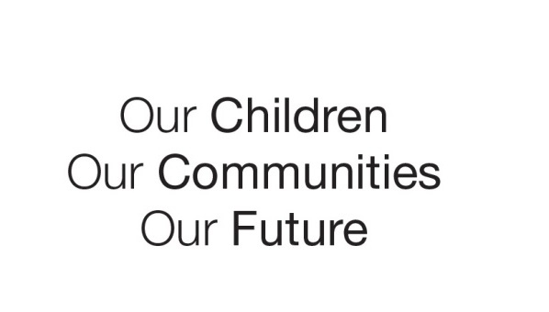

Australian Early Development Census

School story

Everton Park State School

QLD 2014

Everton Park State School streamlines school transitions

About the school

Everton Park is a suburb in Brisbane’s northwest, about 15 kms from Brisbane’s CBD. It is in an area of low socio-economic disadvantage (ABS Socio-economic Index for Areas 2011).

Everton Park is part of a larger region, known as the North West Outer Brisbane community, which has 340,333 residents, including 27,673 children aged 0 to 5 years.

What did the results show?

The Australian Early Development Census (AEDC) is a national measure of child development. It measures five key areas or domains when a child starts full-time school. The domains are: physical health and wellbeing; social competence; emotional maturity; language and cognitive skills (school-based); communication skills and general knowledge.

The results for 4,897 children starting school in the North West Outer Brisbane community showed 25 per cent of children developmentally vulnerable on one or more domains. This figure is higher than the national figure of 22 per cent.

The 2012 results for Everton Park revealed almost one in four children (24.7 per cent) in the suburb were developmentally vulnerable on one or more of the domains and 16.3 per cent were vulnerable on two or more domains.

Bringing about change

Everton Park State School used the school data from 2009, combined with the 2012 results, to connect with local early childhood education and care services and discuss what the results revealed about children’s needs in the neighbourhood.

The school organised meetings with these services to share professional learning around children’s common needs identified in the data. The groups who attended the meetings discussed issues about early phase learners and pedagogical strategies.

Everton Park State School decided to improve children’s transition to school by employing a Prep Transition Officer.

The officer plays a crucial role in developing and implementing research based practices and strategies to build a shared understanding of school readiness with early childhood services, parents and children.

The school and early childhood services in the local area have also connected with community facilities, community groups and the school’s Parents and Citizens Association to run extra-curricular activities to improve communications with families, especially those who do not often use kindergarten services. The school and early childhood services have also created a Facebook page for the same purpose.

Partnerships

The data provided a starting point for the school to connect with early childhood education and care services and the wider community to create shared goals and a united focus. These groups now have a strong partnership, largely due to their shared understanding of community vulnerabilities for children and the important work being done to address local needs.

Achievements

This closer relationship between parents and service providers has been reflected in an improvement in the results from 2009 to 2012. Anecdotal feedback from parents and community members also reveals improved reading achievement levels for the school’s Year 1 students may be due to the school readiness preparations.

Looking ahead

Everton Park State School, local early childhood services and the broader community are strongly committed to using more AEDC data to inform their initiatives aimed at improving learning outcomes for neighbourhood children.

For more information contact

Everton Park State School on 07 3550 2222. *bt this gives children the greatest opportunity for a successful start to their primary believe that this gives children the greatest opportunity for a successful start to their primary sing…”*A teacher from Everton Park State School

- A teacher from Everton Park State School

|  |
| --- |
| *‘We believe that this gives children the greatest opportunity for a successful start to their primary schooling…”*  **A teacher from Everton Park State School**  *‘The AEDC provided an evidence base to make ‘meaningful connections’ with kindergarten and pre-Prep services in the area’*  **Mr Brad Clark, Everton Park State School** |