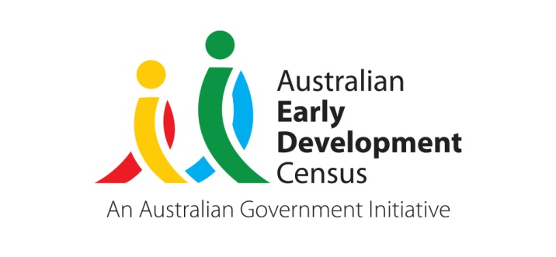 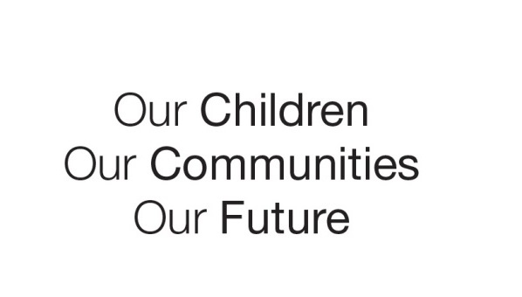

Australian Early Development Census

School Story

**Preschool and school leaders focus on early literacy**

South Australia 2020

Focussing on early literacy is achieving change in the Port Augusta-Quorn Education Partnership

About the community

The Port Augusta and Flinders Rangers (Quorn) communities are located around 300km north of Adelaide in regional South Australia. The combined residential population is estimated at 15,949 of which approximately 19% are Aboriginal and/or Torres Strait Islander (ATSI) people and 1,123 are children aged 0-5 (Australian Bureau of Statistics, Census 2016). The region experiences relatively high levels of disadvantage at SEIFA rating of 889 for Port Augusta and 935 at Flinders Ranges.

Department for Education local partnerships are groups of geographically defined preschool and school sites and the communities they serve. There are 31 partnerships across South Australia (SA) led by local education teams made up of an education director, early childhood leader, principal consultant and administration officer, who work with preschool and school leaders in the group. Partnerships manage the improvement of children and young people’s learning and wellbeing outcomes through a networked approach to learning.

The Port Augusta-Quorn Partnership spans the Port Augusta Community and Quorn/Hawker local community in the Flinders Ranges.

What did the results show?

The Australian Early Development Census (AEDC) is a national measure of early childhood development at the time children commence their first year of full-time school. The AEDC collects data relating to five key areas of early childhood development referred to as ‘domains’. The domains are physical health and wellbeing; social competence; emotional maturity; language and cognitive skills (school-based); communication skills and general knowledge.

2015 AEDC results showed the percentage of children developmentally vulnerable on one or more domains in Port Augusta community was 45.3% and in Quorn/Hawker 26.7%. Port Augusta is a much larger community, with 1021 children aged 0 to 5 years compared to 102 in Flinders Ranges (Quorn/Hawker) (Australian Bureau of Statistics, Census 2016). The highest levels of developmental vulnerability by domain for Port Augusta were 24% in the Social competence and 22.4% in the Communication skills and general knowledge domains.

Bringing about change

In direct response to an array of data sets, the Port Augusta-Quorn Partnership (the partnership) identified a need for change to support improved outcomes for children in the area, with a focus on early literacy development.

During 2017, the partnership focused on improving early years’ pedagogy and practice through targeted professional learning. This included staff learning forums with personnel from feeder preschools also in attendance to support bridging the gap between support services, enhancing continuity of learning, and establishing strong links with parents, carers and the wider community.

Key activities that were implemented included:

* A focus on strengthening oral language in the early years by:
  + improving consistency of practice in partnership with support services personnel
  + establishing an early years professional learning community (PLC) involving preschool site staff teams and assigned speech pathologists working within these preschool sites
  + establishing a reference group, comprising a senior speech pathologist, an early childhood leader and two preschool directors, to formulate the PLC agenda - ensuring it was targeted towards providing professional learning opportunities focussed on literacy and addressed needs based on the site’s qualitative and quantitative data
  + focussing professional learning on elements of practice such as use of picture books to create conversations, effective ways of reading books to children, auditing literacy practices and creating engaging reading spaces
  + developing an action plan for each site to enact change and reviewing the plan each term to determine achievements and next steps.
* Developing and implementing an oral language project led by speech pathologists from support services to improve communication skills of preschool aged children by:
  + utilising informal pre and post screening of children’s oral language skills administered by preschool staff
  + employing intervention strategies including intentional teaching of vocabulary, modelling and expansion, scaffolding, thinking aloud and wondering
  + monitoring and tracking results to review the outcomes at a site level and to identify targeted intervention strategies
  + developing a suite of resources based on current research and distributing these to each site for easy reference
  + encouraging services to have informal conversations, distribute information and sharing success stories with parents to foster parental involvement.
* Engaging with the *Principals as Literacy Leaders* professional learning to:
  + ensure leaders developed a knowledge base for instructional leadership in literacy and how to lead literacy learning
  + increase leaders’ knowledge of developmentally appropriate practices
  + increase leaders’ understanding of the importance of reflective practices using effective systems to track and monitor children’s learning.

The partnership also had a focus on Aboriginal children’s early literacy improvement supported through:

* three preschools in the community with high enrolments of 3 year old Aboriginal children under the department’s early entry to preschool policy, qualified to receive additional staffing allocation as part of the Aboriginal Family Literacy Strategy (AFLS)
* implementation of the Aboriginal Reading Project building on the requirement for the AFLS teacher to lead a structured inquiry to improve Aboriginal children’s literacy outcomes at the preschool, resulting in:
  + establishing a termly forum, led by department Learning Improvement Division, involving early years educators within preschools and local schools to engage in discussions about reading practices.
  + sharing of quality practice beyond the local context into the early years of schooling
  + successful practices being embedded and shared widely including:
    - the benefits of smaller group experiences
    - strength based approaches
    - being clear about the educational purpose when providing learning experiences
    - utilising community based experiences
    - leaders ensuring effective practices are consistently implemented.

As a result of the partnership’s actions and reflections, a continuity of learning forum was established involving representatives from each primary school and preschool in the partnership with a strong focus on sharing practice and pedagogy covering:

* mandatory curriculum frameworks within the early years
* successful strategies to aid transition to school

assessment and reporting practices and available resources.

Achievements

Staff, children, families and the wider community are benefitting from the Port Augusta–Quorn education partnership embedding these activities and programs in four focus areas:

* professional learning communities and consistency in professional practice
* oral language and use of screening and evidence to inform tailored interventions
* regularly reviewed transition procedures
* Aboriginal children’s early literacy.

The 2018 AEDC results for Port Augusta and Quorn/Hawker communities both showed an improvement in outcomes for children. The percentage of children developmentally vulnerable on one or more domains for Port Augusta decreased from 45.3% in 2015 to 30.5% in 2018 and for Quorn/Hawker the percentage decreased from 26.7% in 2015 to 11.8% in 2018. Port Augusta community also showed a significant decrease in the percentage of children developmentally vulnerable in the Social competence domain from 24% in 2015 to 18.1% in 2018 and in the Communication skills and general knowledge domain from 22.4% in 2015 to 9.6% in 2018.

A deeper look at the Port Augusta-Quorn Partnership schools’ data showed even more positive results for ATSI children with a decrease from 71.2% in 2015 to 41.5% in 2018 of children developmentally vulnerable on one or more domains.

Looking forward

All preschool sites within the partnership are:

* utilising the AEDC as a data set to help them determine learning goals represented in the Preschool Quality Improvement Plan (PQIP)
* collecting and analysing evidence of children’s learning to set learning goals for improvement represented in the PQIP
* implementing the Oral Language Project including pre and post screening assessment, intervention strategies and resources

building stronger connections with feeder schools for all children to experience a succesful transition to school.

These approaches are aligned with the South Australian Department for Education aim to seek growth for every child in every setting.

**For more information contact**

Myléne Warman   
State Coordinator, AEDC

Department for Education  
South Australian Government

**Email:**[Education.AEDCTeam@sa.gov.au](mailto:Education.AEDCTeam@sa.gov.au)

**Web:** [www.education.sa.gov.au/aedc](http://www.education.sa.gov.au/aedc)

|  |
| --- |
| ***“Using the AEDC data allowed a more collaborative approach within the partnership - working closely with preschools and the early years sectors of schools”.***  Kerry Moosha, Preschool Director, Flinders Children’s Centre (Tji Tji Wiltja) |
| ***“The AEDC data is critical, and our response to it is a critical element in our improvement agenda which has a clear focus on improving social, emotional and achievement outcomes for the children in our care. Central to this improvement work is an absolute focus on early intervention particularly in critical foundational learning domains of literacy and numeracy.”.***  Robin Harkin, Education Director, Port Augusta-Quorn Education Partnership |