 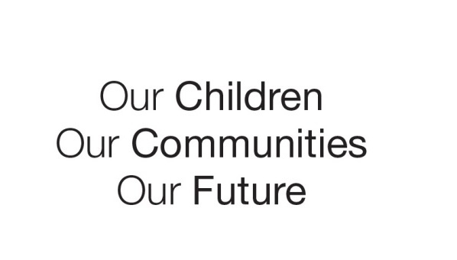

Australian Early Development Census

School story

Independent schools

TAS 2012

Educators take classes in mental health to improve children’s development

About Tasmanian schools

In Tasmania all kindergartens are co-located in schools and are registered by the Schools Registration Board. All kindergarten teachers are university qualified and registered by the Teachers Registration Board.

What did the results show?

The Australian Early Development Census (AEDC) is a national measure of child development. It measures five key areas or domains when a child starts full-time school. The domains are: physical health and wellbeing; social competence; emotional maturity; language and cognitive skills (school-based); communication skills and general knowledge.

In 2012, the results showed 21.5 per cent of Tasmanian children starting full-time school were developmentally vulnerable on one or more domains compared to the national figure of 22 per cent. However 8.1 per cent of Tasmanian children were developmentally vulnerable on the emotional maturity domain, which is higher than the national figure of 7.6 per cent.

Bringing about change

In response to the results and other data, Independent Schools Tasmania (IST), the education authority for independent, non-government schools, applied for funding to help kindergarten to year 2 educators develop and deliver strategies to enhance student’s mental health and wellbeing.

In 2013 IST received funding from the Tasmanian Coordinating Committee and used some of its own funds to employ a project officer to facilitate and monitor a one year ‘Early Years Wellbeing Project’. It used the KidsMatter Early Childhood service and framework on the project. KidsMatter provides learning tools and support to help educators work with parents/carers, health services and the wider community, to nurture happy, balanced children.

While many aspects of this project were available for access byall Independent schools, the target population comprised schools and students meeting the criteria of *‘disadvantaged’*. The schools included Northern Christian School, Bridgewater Christian School, Emmanuel Christian School, Hilliard Christian School, Seabrook Christian School and Calvin Christian School.

Achievements

Early years educators from six schools accepted an invitation to participate in the Early Years Wellbeing Project. Schools were supported to develop school-based implementation/action teams. The project officer also provided information sessions for parents and community members. This included the KidsMatter parenting program ‘Tuning Into Kids’which helps parents increase children’s emotional awareness and regulation.

Looking ahead

The project was designed to sustain ongoing action in mental health. The schools had ownership of the project by developing their own ‘action’ group and conducting their own evaluation.

Educators have ongoing access to KidsMatter online resources and KidsMatter trained staff at IST. In addition, an ongoing collegial network group connects and supports educators from participating schools.

For more information contact

Terese Phillips. Email: tphillips@independentschools.tas.edu.au

|  |
| --- |
| “Teachers have enhanced their capacity and confidence to develop, deliver, monitor and maintain appropriate and targeted evidence based social and emotional learning and support for all students and their families, including those who may be experiencing mental health difficulties.”  **Rosa Connell,** |