 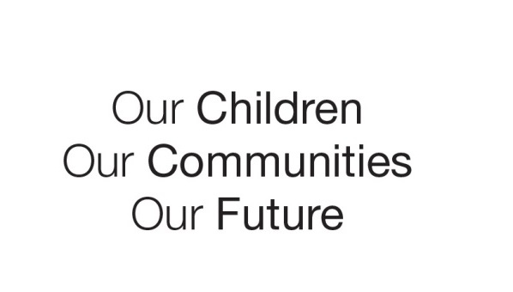

Australian Early Development Census

Duncraig Primary School

Western Australia 2018

About the school

Duncraig Primary School is an independent public primary school situated in Duncraig; part of the northern suburbs of Perth, Western Australia. The school began operations in 1975 and has an enrolment of over 400 children from Kindergarten to Year 6. Duncraig is an area that offers extensive community facilities and attracts families, many of whom are the second generation to live in the area, with grandparents and other family members living close by. Parents are generally employed with a significant number having higher education qualifications.

What did the results show?

The Australian Early Development Census (AEDC) is a national measure of early childhood development. It measures five key areas or domains when a child starts full-time school. The domains are: physical health and wellbeing; social competence; emotional maturity; language and cognitive skills; communication skills and general knowledge.

Following the 2015 data collection, Duncraig Primary School reviewed their AEDC School Profile results and identified three domains where there were higher levels of developmental vulnerability compared to the community and state results. These were: physical health and wellbeing, social competence and emotional maturity.

A further concern was that there was a higher percentage of children arriving at school vulnerable on two or more of the AEDC domains compared to the local community and state averages.

Bringing about change

To gain a better understanding of how children were developing in the local area, the school reviewed the AEDC results for the last three data cycles to identify any emerging trends. This revealed that the level of developmental vulnerability has increased since 2009 in the physical health and wellbeing, and emotional maturity domains. While there was an improvement in the area of social competence from 2009 to 2012, the percentage of children vulnerable increased in 2015.

In response to the results, the school recognised the need for early childhood to be added as a priority in its strategic planning. As a starting point, the school pinpointed two key focus areas.

1. **Early Childhood Leadership**

The establishment of an early childhood leadership group was considered an important first action and was achieved by:

• assigning a deputy principal with early years knowledge and experience

• creating a distributed leadership structure, which included appointing an early years’ teacher leader

• strengthening the school’s student services team to include two deputy principals, school psychologist, chaplain and education assistant leader

• participating in a research project on the National Quality Standard (NQS) as part of Principal’s Master of Leadership studies.

**2) Early Intervention**

An early intervention strategy, developed through the leadership group, was incorporated into the school’s Business Plan and included:

• developing an operational plan to address key areas identified by the AEDC, and that align to the NQS, Early Years Learning Framework, and the Curriculum

• building teacher knowledge and understanding of evidence-based and quality early years practice

• supporting physical and academic development and learning through the implementation of a specialist teacher program in Pre-primary

• redesigning outdoor play spaces to incorporate natural and built play spaces

• enhancing children’s social development during break times through the support of a student services education assistant

• establishing a playgroup to support children’s transition to school and to assist with the early identification of children who may require additional support

• offering parent workshops focussed on early child development and learning

• offering a diverse range of out of school hours programs for families through the P&C and other external providers (these programs focussed on creating physical, social and academic opportunities for children and included social board games, running club and gross motor skill development).

Partnerships

Working alongside the community is a key part of the school’s early intervention strategy. Key partners comprise:

1. parents

2. the school board working party, consisting of staff and parents: established to implement a student wellbeing ‘classroom to community’ program with focus on social and emotional development

3. community health nurse

4. speech pathologists

5. other external agencies.

Looking ahead

Following a review of the next AEDC results, the school is looking to strengthen and build on the work undertaken over the past three years. As part of this work the school is planning to:

• extend its community partnerships to include the local high school and the community library though programs such as Better Beginnings

• working alongside neighbouring schools to develop shared understandings and address developmental needs as identified by the AEDC

• schedule regular meeting times so early childhood teachers and the leadership team can participate in shared planning sessions to develop a cohesive and connected approach across the early phase of schooling

• develop an early years philosophy to embed a connected approach across the early phase of schooling.

For more information contact

Department of Education

Western Australia

Contact [Gail Clark](mailto:Gail.clark@education.wa.edu.au)[1] – Western Australian State and Territory Co-ordinator

Visit the [AEDC website](http://www.aedc.gov.au/)[2]

1. Gail.clark@education.wa.edu.au
2. www.aedc.gov.au