 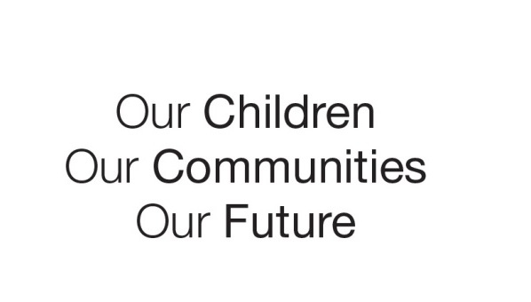

Australian Early Development Census

School Story

Westfield Park Primary School

Western Australia 2015

Community development, early intervention and student services feed into full service and extended school model to lower childhood vulnerability

**About the school**

Westfield Park Primary School serves a highly transient and fractured low socio-economic community in Perth’s south-east corridor. The school caters for children from Kindergarten to Year 6 and has approximately 260 children enrolled. One quarter of families are from culturally and linguistically diverse backgrounds. A high level of need and low level of service uptake has historically presented challenges to the school.

**What did the results show?**

The Australian Early Development Census (AEDC) is a national measure of child development. It measures five key areas or domains when a child starts full-time school. The domains are: physical health and wellbeing; social competence; emotional maturity; language and cognitive skills; communication skills and general knowledge.

The results showed that children living in Camillo (formerly Westfield) had a very high level of developmental vulnerability in 2009 (72.0 per cent) - nearly three times the state (24.7 per cent) and national (23.6 per cent) averages. Since then, there has been a significant improvement in the proportion of children identified as being developmentally vulnerable falling to 34 per cent in 2012 and 26 per cent in 2015.

**Bringing about change**

In response to the 2009 results and other early development assessments, Westfield Park Primary School placed itself at the heart of its local community with the purpose of creating change for families and young children and reducing the proportion of children entering school developmentally vulnerable.

As part of its approach, the school implemented the following three key strategies:

Community Development

The school recognised the importance of building strong connections with its community, and enhancing the capability and confidence of families to provide enriching experiences for their children prior to school. To achieve this, the school: engaged a community development worker to help build strong partnerships between the home, school and community; established two parent-led playgroups; hosted adult education programs; and extended educational and recreational activities for children out of school hours.

Early Intervention

The school undertook a range of early intervention and prevention strategies to provide support for families and children most in need. Strategies include school-based intervention and/or referral to an external agency. They introduced screening in the playgroup which extends up until Year Two.

Strong Student Services Team

The school strengthened its Student Services team to include a Students’ at Educational Risk Coordinator, a School Psychologist, the Principal and School Counsellor. The team collaborates to remove barriers to learning by working with staff and families to:

* develop a holistic view of the child developmental needs
* build the capacity of teaching staff to support children experiencing difficulties with speech and language, trauma, attachment issues and/or learning disabilities
* provide referral pathways for children and families
* engage external agencies to provide services at the school.

**Achievements**

Westfield Park Primary School has been an important catalyst to bring about change for families with young children, and reduce developmental vulnerability. It used the AEDC data alongside other evidence to partner with key agencies and increase its service provision based on the needs of local children and families. This included:

* establishing two parent led playgroups
* extending educational and recreational activities for children out of school hours
* offering adult education programs aimed at building the capabilities of parents to support their children’s early learning and development prior to school e.g. ‘Sing & Grow’, Positive Parenting Program, Healthy Eating Program
* adopting the principles of a full service extended school by facilitating out of school hours activities for children
* building the capacity of teaching staff to work with children experiencing speech and language difficulties, trauma, attachment issues and/or learning difficulties
* encouraging service providers to use school facilities for their point of delivery.

Since 2009, the proportion of developmentally vulnerable children in Camillo has fallen from 72 per cent to 26 per cent in 2015.

**Partnerships**

Over the last four years Westfield Park Primary School has built and maintained strong links with its partner organisations. This has helped the school to develop a more coordinated and targeted approach for its families. Key partners included:

* Camillo Early Learning Centre
* Camillo Local Policing Team
* City of Armadale
* Communicare
* Community Health Nurse
* Department of Child Protection and Family Support, Armadale Family Support Network, Health Services (Speech and Language, Occupational Therapy)Parkerville Children & Youth CareSave the Children and
* Sporting Schools (previously Active After School Sports).

**Looking ahead**

Westfield Park will continue to build and sustain its full service extended school model - by providing free access to school facilities to not-for-profit agencies (managed through an MOU), and low cost access to commercial organisations which enhance the provision of activities to children and families out of school hours.

Westfield Park’s status as an Independent Public School and flexibilities provided by the Student Centred Funding Model have contributed to a level of autonomy which has enabled the school to more effectively meet the needs of the community. This process will be further enhanced as the school and community explore strategies that draw more service providers together to work in a cohesive way to ensure children in the community have access to the support that will benefit their learning and developmental outcome. In addition, methods that will balance the conflicting issues of privacy and data sharing and the transition of this between agencies will be further explored.

**For more information contact**

Department of Education

Western Australia

Gail.clark@education.wa.edu.au

www.aedc.gov.au

|  |
| --- |
| **“*There is no debate or doubt that early intervention is a child’s best hope for the future.”*** |